Last Revision: 13MY2010
1969 THROUGH 1982 CORVETTE TILT & TELESCOPING STEERING COLUMN DISASSEMBLY & REPAIR INSTRUCTIONS

PAPER #1

Disassembly and Repair Instructions Addressed in this Paper
Difficulty Page
CHECK FOR LOOSE PIVOT PINS, SUPPORT SCREWS, Easy 2 & 3
AND/OR LOCK SHOES
ADJUST TELESCOPE LEVER Easy 3, 4, & 10
REMOVE STRG WHEEL AND HORN PARTS Easy 4 & 5
REMOVE TILT & TURN SIGNAL LEVERS Easy 5 & 6
REPLACE THE IGNITION LOCK CYLINDER Easy 7 & 8
LOST IGNITION KEY - INSTALL NEW LOCK CYLINDER Easy 8
REPLACE THE KEY WARNING BUZZER SWITCH Easy 9

How the Papers are Setup
This is the first of three papers that address various repairs that can be made on the Corvette C3 tilt and telescoping (T&T) steering column. The first pages of each paper concern the disassembly and replacement procedures. The last pages concern reassembly of the column. There are some fairly easy tests that can be performed on your column that are addressed in this paper. Subsequent papers address increasingly more difficult service procedures.

The papers make reference to three pages of line drawings. They are entitled Corvette C3 Tilt & Telescoping Steering Column Disassembly Instruction Pics #1, #2, & #3.
There is a schematic drawing entitled 1969-76 Corvette Tilt & Telescoping Steering Column Blowup. Also there is another schematic entitled Tilt Steering Column w/Key Release & Dimmer Blowup Pic (similar to 77-82). This drawing does not show the telescoping upper shaft but it does show the dimmer and key release parts. For the most part I will use the callouts from the 69-76 Blowup Pic. The papers and pics are all available from the author or from the host websight. You will find these pictures and descriptions to be most helpful.

Types of C3 Adjustable Steering Columns Addressed in these Papers
There were several different iterations of adjustable steering columns that were produced for the C3 Corvette from 1968 through 1982.
1969 through 1976 - T&T Corvette Energy Absorbing (EA), Function Locking (FL) Steering Column
1977 - T&T Corvette EA, FL Steering Column with wash/wipe switch and headlamp dimmer, ignition key release lever, & optional cruise control in the tilt lever.
1978 through 1982 - Corvette EA, FL Steering Column with headlamp dimmer, ignition key release lever, & optional cruise control in the turn signal lever.
You may note that the 1968 telescoping only model is not addressed. The telescoping 1967-68 Corvette steering columns are addressed in another paper available at the host websight.
Terminology and Background
Starting with the 1969 model year, General Motors made two changes to their passenger cars that greatly affected the steering column. These design changes were to meet federal motor vehicle antitheft standard (FMVSS 114). Up until that time, nearly all ignition lock cylinders and ignition switches were one unit and attached to the instrument panel.

The first change was to separate the ignition lock cylinder from the ignition switch and move both components to the steering column. The lock cylinder was placed in the steering column head and the ignition switch was relocated on top of the steering column jacket (placing it up under the brake support bracket and difficult to access.) The second change was to lock the steering and the transmission shift functions with the ignition key.

The following definitions will help to identify the components. The ignition lock cylinder is the mechanism in the steering column head where you insert your ignition key. It is a purely mechanical device and works through a small gear and rack to push and pull a rod that actuates the ignition switch. The ignition switch is the electrical switching device that is mounted to the steering column down under the dash.

Unfortunately, making it more difficult for the car thief also makes the servicing of the steering column more complicated for the person(s) doing the servicing. Hopefully, this paper (and several others that I have authored) will assist your working on the Saginaw steering column and make the whole procedure less frustrating.

HINT: As much as I have tried to make these papers as complete as possible, nothing beats good digital pictures of the column and parts during your disassembly activities. I strongly recommend that you take many pictures to assist you in the reassembly process.

A word of caution: DISCONNECT THE BATTERY. With the steering column disassembled it is possible to inadvertently move the ignition switch to the “Start” position.

Steering Column Tests

Checking for Loose Support Screws, Pivot Pins, and/or Lock Shoes

If the reason that you downloaded these papers is to fix a “loose” feeling steering wheel and/or steering column, the following are some simple tests that you can try. They should help identify the source of any looseness before you begin disassembling your steering column.

First of all, make sure that your steering column is properly and securely attached to the vehicle. Are the vertical underdash attaching bolts (or nuts) torqued to specification? Are the attachments of the steering column to the floor pan secure?

Check for Loose Support Screws (inside the steering column)
Adjust your tilt mechanism to the straight ahead position. Grasp the steering wheel and try and rock it in an up and down and then rock it in a side to side motion. Is the steering wheel and the entire column head loose in both up and down and side to side directions?

If this is the case, you most likely have loose support screws. This problem has a straight forward fix (just Locktight® and tighten the screws.) The bad news is that you must disassemble the entire steering column head in order to reach the loose screws. You will require this paper plus D&R papers #2 and #3. Also you will find that it is much easier to work on your steering column if you remove it from your car to correct this condition.

Check for Loose Lock Shoes
Tilt your column head to the full “up” position and grasp your steering wheel and try and rock it with a vertical up and down motion. Do you feel any looseness just in this direction. Now adjust your tilt mechanism to all of the other tilt positions and do this test again. Do some positions feel loose and others feel tight? Or are all of them tight (or loose?) This is a check for loose tilt shoes. There are a pair of shoes inside the column head. They alternate locking your column in the various tilt positions. If you have alternating loose and then tight positions you probably have one bad shoe or a lock shoe pin that is worn in one position.

Check for Loose Pivot Pins
Grasp the steering wheel and now try to rock it with a side to side motion. When you conduct this check, do you only notice a looseness in a side to side direction and not in an up and down direction? If this is the case, you most likely have loose pivot pins. You will require all three papers and you will need to remove the steering column from your car in order to disassemble the column and correct this condition.

Telescope Lever Adjust
The following pictures may be helpful when working on the horn, telescoping lock, and steering wheel parts. The drawings are all available at the host websight.

Corvette C3 69-75 T&T Steering Wheel and Horn Parts
Corvette C3 76 T&T Steering Wheel and Horn Parts
Corvette C3 77-82 T&T Steering Wheel and Horn Parts

If you rotate your telescope locking lever all the way clockwise and your steering shaft does not lock securely in that position, it is possible that the lever just requires adjustment. (Refer to the Blowup pic.) The hollow upper steering shaft is locked and prevented from telescoping by a wedge #43 and a rod #40 that is inside the shaft. The rod is pushed down by a special "star" screw. The "star" screw is attached to the locking lever that is just under the horn button. (Refer to the Steering Wheel and Horn Parts drawing.)

Telescope Lever Adjust (Continued)

Carefully pry the horn cap assembly from the steering wheel using a small, thin bladed screwdriver. If you merely yank on the horn cap it can be damaged. The cap assembly consists of three pieces that are all staked together. At this time, you might want to check that the three stakes are secure. You may even want to add some JB Weld to the stakes for insurance.

Unfasten the three screws that hold the upper horn contact in place and remove it along with the loose shims that are right under it. With the horn cap removed, you will see that the telescope lever is attached to the special “star” screw with two small phillips head screws. Remove the two screws. The locking lever will be loose but trapped under the “star” screw.

You can now remove the “star” screw and check to insure that the lock rod #40 is in place. You may need a small magnet to pull it out of the upper steering shaft #41. You will not be able to remove the lock wedge #43 at this time. Reinstall the rod and the “star” screw. Using a large phillips head screwdriver, rotate the “star” screw clockwise until it is tight. This should cause the telescoping feature to lock in place. Position the locking lever under the “star” screw such that the thumb tab is approximately at the 1 o’clock position. Attach the locking lever to the “star” screw with the two small screws. (The telescope lever has numerous tapped holes in it, allowing it to be attached in multiple positions.)

Try applying and releasing the telescope feature several times using the locking lever. It should telescope freely with the thumb tab on the lever at the 11 o’clock position. It should be locked securely in place when you rotate the tab to the 1 o’clock position. If it is operating correctly, replace the shims and fasten the upper horn contact in place with three screws. Note that the upper horn contact has a leg that extends down from it. The contact must be oriented so that the leg sits on the horn contact sticking through the steering wheel hub. Snap the horn cap assembly into place. Reconnect the battery, you are done!

Removing the Steering Wheel and Horn Parts
Remove the horn cap assembly with a thin screwdriver. Note the comments under Telescope Lever Adjust – above. Next, remove the three screws securing the upper horn contact and remove the contact. Remove the shim(s). Remove the two screws securing the telescope lock lever to the center “star” screw. Remove the “star” screw, telescoping lock lever, and spacer. (Note that the 1976 T&T steering wheel does not have a spacer).

CAUTION: The telescope lock rod #40 is down inside the upper steering shaft #41. With the “star” screw removed, the rod can just fall out if the column is tipped after being removed from the car. The rod can go unnoticed and you won’t know why your telescoping feature will no longer lock when you put it back together.
1969-1976 Locking Rod - 4.30 inches x 0.22 diameter
1977 Locking Rod - 3.4 inches x 0.22 diameter
1978-1982 Locking Rod - 3.7 inches x 0.22 diameter

Removing the Steering Wheel and Horn Parts (Continued)
On all but 1976 models, the steering wheel and the extension can now be detached from the hub by removing six screws. Otherwise, you can leave them together and remove them as a unit with the hub. (The 1976 steering wheel and hub are one unit.)

Pry off the retainer clip from the end of the steering shaft (1975 and later columns) and remove the nut. You should be able to see a small indentation on the end of the column shaft and aligned with it a matching indentation on the steering wheel hub. They will allow the parts to be aligned properly when you reassemble the steering wheel hub to the column. If you can’t find the markings, use a crayon or chalk to make your own marks.

Next, using a steering wheel puller, remove the steering wheel and hub. Since the upper steering shaft has internal threads to accept the “star” screw, you might try placing a metal spacer on top of your steering shaft to prevent the puller from damaging the threads.

The lower horn contact (with the long coil spring) should come with the hub. The spring, eyelet (pin with upset head), and insulator (plastic bushing) should be part of this horn contact and hub assembly.

Removing Turn Signal and Tilt Adjuster Levers
All 1969 through 1976 turn signal and tilt adjuster levers assemble to the steering column by screwing the levers into tapped holes in the T&T steering column. There are two small flats near the ends of the levers. Use a 7/32 open end wrench to tighten them.

Some 1977 tilt levers are very unique in that they contained a switch with a button on the very end of the lever to engage the cruise control. This lever was used in 1977 only. The lever has a wire and electrical connector that extends down through the steering column. This requires that you feed the connector and wire back up and out of the column as you remove the lever. You should attach a tracer wire or string to the connector so that the wire can be more easily routed back down through the column when you reassemble it.

On 1977 through 82 columns the turn signal lever actuates the headlamp dimmer function by pulling rearward on the lever. This lever plugs into a pivot assembly that is part of the steering column head. The turn signal lever has as a round shaft with a groove and a bullet nose on the end. When the lever is inserted into the column pivot, a spring loaded pin engages the groove on the lever and it is held securely in place. Grip the lever firmly and pull straight out to get it to disengage from the column pivot.

Inside the 1977 through 1982 steering column head there is an arm assembly that moves with the dimmer pivot and attaches to the turn signal switch with a screw. (You need to remove the locking plate in order to reach the screw.) This screw has a tendency to loosen. I suggest that you use Locktite on the threads and tighten it to 15 inch-lbs. Typically you lose the ability to actuate a left turn as the screw begins to loosen.

The 1977 turn signal lever is unique in that it also is used to turn on the windshield wipers. Make sure that the wiper switch is OFF when installing or removing the lever.
Removing Turn Signal and Tilt Adjuster Levers (Continued)
1978 through 1982 turn signal levers may also have a cruise control switch on the end. These levers have a wire and a connector that must be fed up and through the steering column before removing the lever from the pivot. Attaching a tracer wire or string to the connector will be a big help in routing the wires back inside the column upon reassembly.

The 1977 through 1982 turn signal levers have a very annoying tendency to break. This can leave a broken stub that is flush with the dimmer pivot. There is a paper with suggestions along with a drawing of two very simple tools that can greatly assist in the removal of the stub from the pivot without tearing the column apart. Go to the host websight and download: Turn Lever Stub Removal – 1977-82

Removing and Replacing the Ignition Lock Cylinder and/or Key Warning Buzzer

Remove the C-Clip and Shaft Lock Plate – Shown On Instruction Pic #1
Remove the spacers, the bumper (it could be a piece of hose with a clamp), and the c-clip retainer #1. Please note that most plastic c-clip retainers have become very brittle with age and will most likely break when removed. It will have to be replaced. Although it is called a retainer, it also functions as the horn electrical ground path insulator. Without it, you will find that the telescoping spring that is part of the lower horn contact will touch the metal shaft lock plate #3 and your horn will blow continuously. The c-clip retainer can be obtained from several suppliers such as:
GM dealers - Part #7808385 - Retainer

Zip Products - Part #SC-517 - 69-82 Cancelling Cam Plastic Retainer
On a further note, the 1969 T&T column does not have a plastic retainer. The shaft lock plate is insulated with a rubber disc that is glued to the plate.

The easiest way to remove the c-clip #2 from the upper shaft is to use a special bridge tool that compresses the shaft lock plate #3. This special tool can be purchased or borrowed from most automotive stores. In order for the bridge tool to work, the upper steering shaft must be prevented from telescoping. You must place the shaft in its shortest position and lock it in place by reinstalling the locking rod #40 and then tightening the “star” screw. Also note that some of the special bridge tools may interfere with the “star” screw. If this is the case with your tool, you will need to install and tighten a 5/16-18 UNC set screw (#20 Allen screw) in place of the “star” screw. Now, compress the shaft lock plate just enough to remove the c-clip. If you used a set screw, be sure to remember to remove it from inside the upper steering shaft when you are done! You won’t be able to unlock the telescope function if it is left behind.

Remove the shaft lock plate #3, horn contact carrier #4, and the upper bearing preload spring #5.

Moving the Turn Signal Switch Up and Out of the Way – Instruction Pic #1
If you are only going to replace the lock cylinder and/or the key warning buzzer switch #13 all you need to do is just pull the turn signal switch #7 out of the column far enough to gain access to work on them.
Moving the Turn Signal Switch (Continued)
Push in the hazard warning knob and remove the knob and screw. Remove the three turn signal switch screws #6. You will need to place the turn signal switch in “right turn” to access the upper right screw. Unscrew and remove the turn signal lever 1969-76 models.

The 1977 through 82 turn signal levers do not have to be removed in order to remove the turn signal switch. However, there is a lever arm inside the column head that connects the pivot to the turn signal switch. It is held in place by a screw. The screw is roughly at the 10 o’clock position. You do have to remove the screw and the lever arm.

Go under the dash and remove three screws that secure the instrument panel trim cover under the steering column. You will find that a stamped crossbar that holds the headlamp vacuum switch comes with it. Unfasten the retaining screw and remove the air conditioning duct as well. Now pull down the turn signal switch connector out of the bracket on the column. Unplug the turn signal body harness from it. Remove the plastic wiring protector #8 (if applicable). It has a slit along its entire length so you can remove it from the wires.

Pull the switch up and out of the column just far enough to have access to the lock cylinder and/or the key warning buzzer switch #13.

Removing Lock Cylinder – Instruction Pic #1
When removing the lock cylinder from the turn signal housing, most shop manuals recommend inserting the ignition key and turning the lock cylinder to the “Run” position. However, the lock cylinder can also be removed without the ignition key being inserted.

The 1969 thru early 1979 lock cylinders are held in place by a metal spring tab that sticks out of the lock cylinder. This tab engages a narrow, rectangular slot in the turn signal housing. Looking straight into the housing, this slot is vertical, right on the centerline of the lock cylinder and located 1.75 inches from the underside of the chrome wings on the lock cylinder. By the way, the screwdriver shown is probably too big to be inserted into the slot to depress the lock cylinder tab.
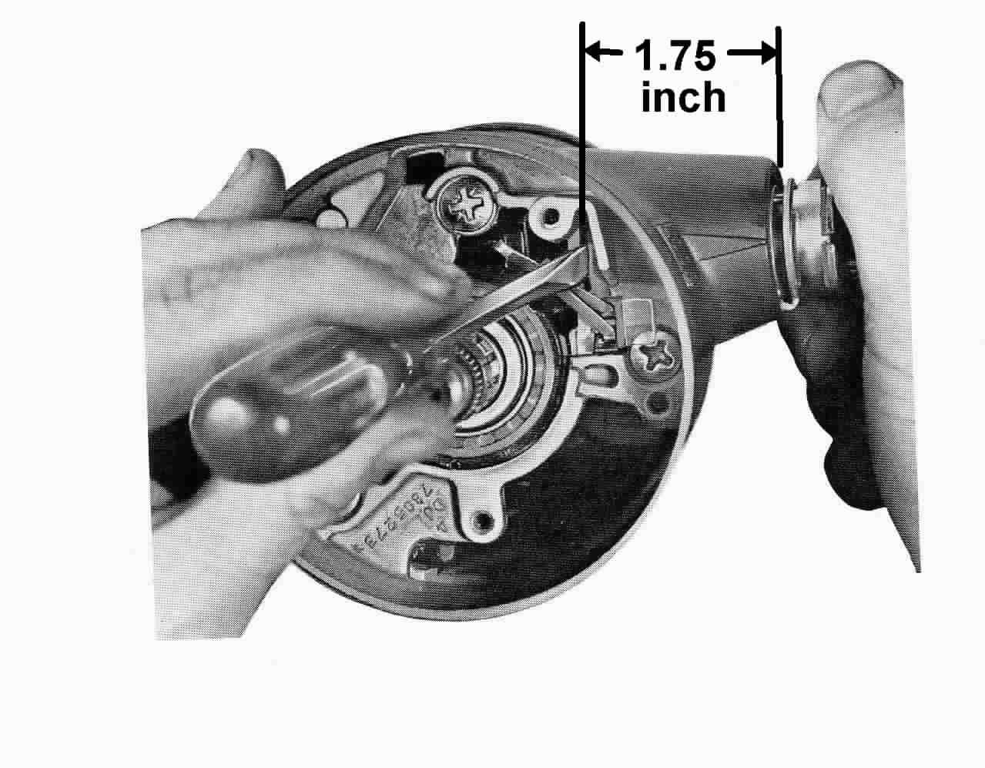
Fig. 1 Removing Lock Cylinder
1969 through Early 1979 T&T Steering Columns
Removing Lock Cylinder (Continued)
If the lock cylinder has never been replaced, there will be a thin metal membrane from the die casting process covering the slot in the turn signal housing. Keeping a thin bladed tool to the right side of the slot, break the housing flash. Now depress the spring tab. The lock cylinder should slide right out. Also I have found that if you don't push the spring tab pretty much in the center it will not release the lock cylinder because it tends to rock side to side. Don't be tempted to pry on the lock cylinder wings to get the lock cylinder moving. The wings will pop off and can't be put back on.
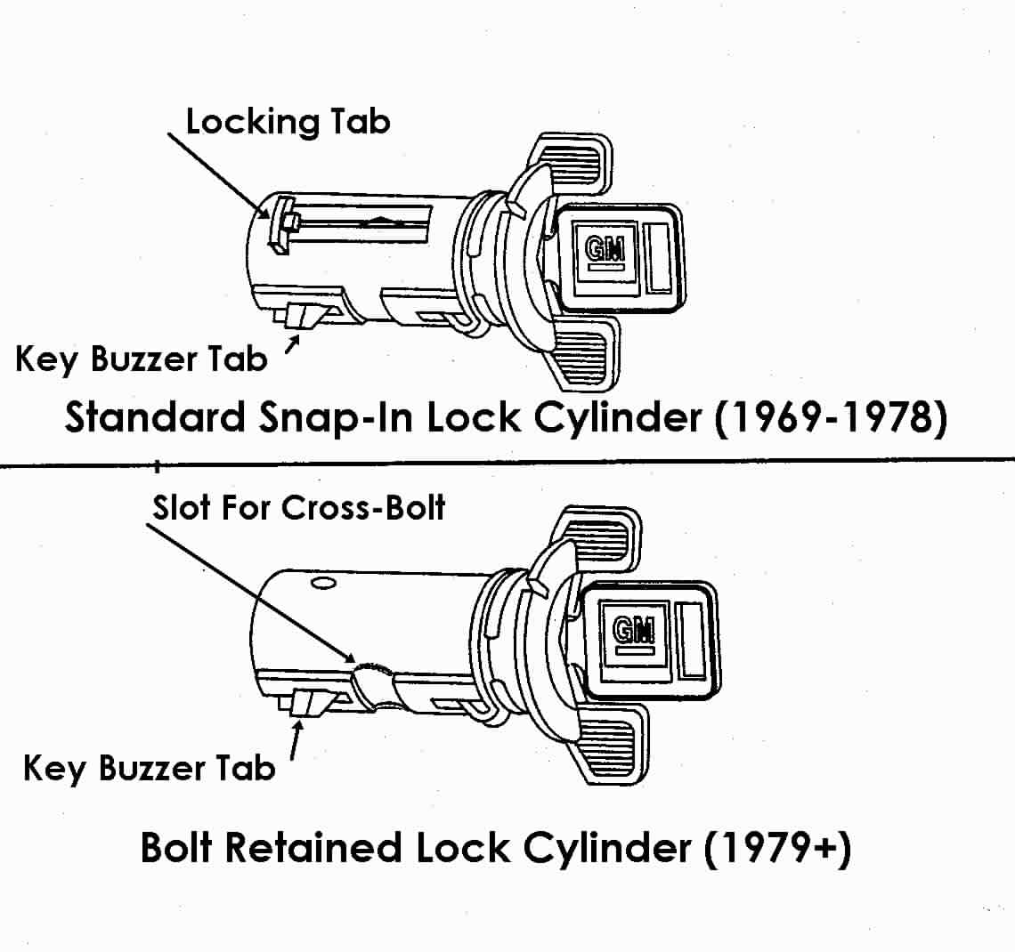
During the 1979 model year security was improved with the introduction of a allen head screw that assembled into the turn signal housing and passed through a notch on the lock cylinder. This design more securely held the lock cylinder in place and eliminated the metal spring tab. The screw is located at about the 2 o'clock position in the housing. It is right above the torks head housing screw that is at the 3 o'clock position. Remove that allen head screw and the lock cylinder should come right out.

There is one method that is sometimes used to remove a lock cylinder that I do not approve. Some people screw a slam-puller into the lock cylinder and slam it out of the column (usually shearing the spring tab.) The slam-puller shocks are very hard on the column housing and your instrument panel.
Lost Ignition Key
If for some reason you do not have the ignition key, you can still disassemble your steering column to the point where you can depress the metal spring tab (or remove the allen head screw) and remove the lock cylinder. You can then have a locksmith make new keys for that original lock cylinder or install a new one. Replacement lock cylinders are readily available from GM dealers as well as most automotive supply stores. Remember that 1969 through 1978 and some 1979 vehicles require a lock cylinder with a locking spring tab. Starting in late 1979, and all years after, Saginaw steering columns require the lock cylinder with a notch.

Removing Key Warning Buzzer Switch – Instruction Pic #1
The key warning buzzer switch #13 has a metal retaining clip #14 holding it in place. Insert the ignition key and turn the lock cylinder to the “Run” position (or turn to off-lock and remove the key.) Take a piece of stiff wire and bend a hook about ¼” from the end and insert the hook into the exposed loop of the clip. Pull up and out on the wire to remove both the clip and the switch. Caution: Be very careful that you don’t lose hold of the clip and let it fall back into the steering column. It can be quite difficult to extract.

If further disassembly of the column is necessary, please download and proceed with papers #2 and #3 to continue your repairs.

The following procedures address reinstalling the key buzzer switch, the ignition lock cylinder and reassembling the steering column.

Reassembly - Key Warning Buzzer Switch
Assemble the buzzer switch with the formed end of the clip under the end of the switch and the clip bowed away from the switch on the side opposite the contacts. Push the clip and switch into the cover to the step with the contacts toward the lock cylinder bore. If the lock cylinder is in place, make sure that the key is removed or if the key is in the lock cylinder it must be in the Run position.

Reassembly - Ignition Lock Cylinder
Insert the ignition key into the lock cylinder. Now, hold the case of the lock cylinder and rotate the ignition key all the way clockwise against the stop. (This would normally be the Start position.) You should be able to retract the plastic key buzzer tab and the metal spring tab should retract easily with slight pressure as well.

There is a keyway in the housing. Align the key on the lock cylinder (not the ignition key but the raised section on the lock cylinder case) with the keyway in the housing and push the cylinder into the housing until it hits the sector. Now rotate the ignition key counterclockwise maintaining a light push on the lock cylinder until the drive section of the cylinder mates with the sector. Push in until the locking wedge snaps into the housing and the lock cylinder is secure (on 1979 and later columns assemble the allen head screw to retain the lock cylinder).

Reassembly - Turn Signal Switch
Tilt the head so that it is straight. Pull the wiring down through the housing. Be sure it feeds under the mounting bracket. For 1976 and earlier columns, before seating the switch inside the column cover, make sure that the stamped hazard knob lever #11 is installed into the underside of the switch. Note, this hazard lever is mislabeled as Hazard Bearing Race on the blowup picture.

Reinstall the plastic cover on the switch wires and clip the connector onto the bracket on the steering column jacket. Snap the vehicle wiring harness onto the turn signal switch “harmonica” connector.

Reassembly - Turn Signal Switch (Continued)
Note: It has been reported that sometimes if you have a new turn signal switch, the new switch connector may not snap onto the original wiring connector in your vehicle. It will be close but still will not snap correctly. If you have this problem, take the connector from your original switch and swap it onto the wires of your new switch. Use the wire from a heavy paper clip and insert it into the "harmonica" connector from the contact side to disengage each wire and contact. There should be a small molded square channel in the connector that will guide you to a metal tang on the contact that holds it in place. Once you depress the tang and pop the wire and contact out of the connector, you should take a small knife blade and bend the tang back out so that it will engage the old connector correctly. Make sure you install the wires in the correct order. The wiring order is the same for all C3 harmonica connectors regardless of year.

Install the three switch mounting screws. Install the switch lever (or the lever arm on 1977 and later models) and the hazard warning knob. Make certain that the turn signal switch is in the neutral position and that the hazard knob is out.
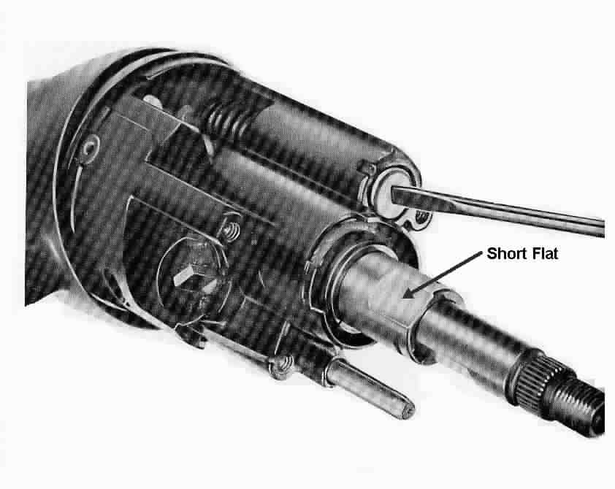

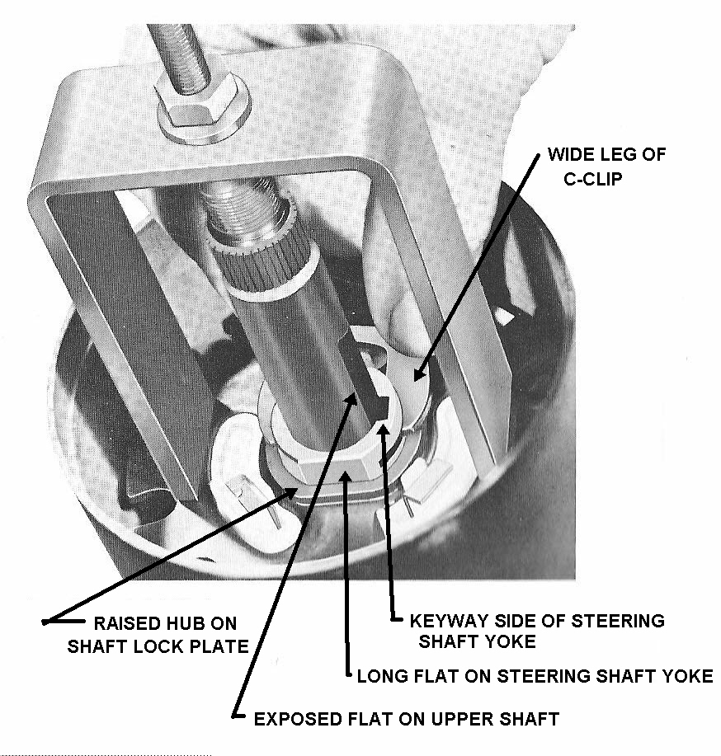 Fig. 2 Flats on Shaft Yoke Fig. 3 C-Clip Installation

Reassembly - Horn Contact & Shaft Lock Plate
Place the upper bearing preload spring #5, the horn contact carrier #4, and the shaft lock plate #3 onto the upper end of the shaft. Note, the steering shaft yoke #44 has two flats on opposite sides of the open end. The flats are not equal in length. Assemble the flat on the horn carrier so that it matches the long flat on the shaft yoke assy. Note the location of the long flat with respect to the keyway shown in Fig 3 above. Also, the hub on the shaft lock plate is raised on one side. The raised hub must be pointing toward the steering wheel as the shaft lock plate is assembled on the shaft yoke (See Fig 3.)

Reassembly – C-Clip
Reinstall the locking rod #40 and the “star” screw/set screw. Telescope the upper shaft #41 inward so that the bridge tool can be installed. There must still be some exposed flat on the upper shaft. Tighten the “star” screw with a phillips screwdriver (or the set screw with an allen wrench) to lock the shaft in place. Now compress the shaft lock plate with the special bridge tool or by hand. Install the c-clip with the wider leg of the clip on the keyway side of the steering shaft yoke (See Fig 3.)

Caution: The c-clip is a critical safety part. If it is omitted or not engaged properly, the entire steering wheel and the upper steering shaft will be able to be pulled right out of the steering column at any time.
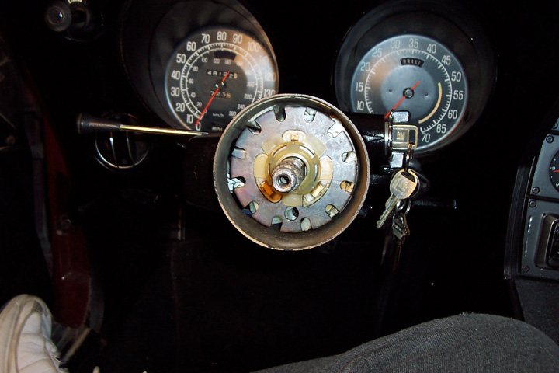
Reassembly C-Clip Retainer
Now, remove the “star” screw/set screw so that you can install the c-clip plastic retainer #1 with the single tab opposite the small lobe on the carrier #4. Snap the retainer over the c-clip. (On 1969 T&T columns a plastic retainer is not used and there is an insulating cover on the shaft lock plate.)

Install the Bumper and Spacers
Note some people omit the bumper and spacers. This will allow the steering wheel to telescope forward (away from the driver) another ¼ inch or so. With the rubber bumpers removed there will be a metallic clunk at the end of travel.

Reassembly – Steering Wheel and Horn Contacts

Align the markings on the steering shaft and steering wheel hub. Reassemble the steering wheel, extension, steering wheel hub and lower horn contact assembly to the steering shaft. Make sure that the end of the coil spring sits squarely on the horn contact carrier assembly that is sticking through the shaft lock. (If the coil spring is cocked and touches any metal part of your column, your horn will blow continuously). Assemble the steering nut and torque to 30 ft-lbs. Reattach the retainer clip if so equipped.

Adjusting Telescoping Lever
Place the spacer on the steering wheel hub. Set the telescoping locking lever on top of the spacer (with the steering wheel straight ahead, the finger tab part of the lever should be in the 12 o’clock quadrant). Screw in the special “star” screw. Now, use a phillips screwdriver to tighten the “star” screw until you can no longer telescope the steering shaft. Place the finger part of the locking lever at about the 1 o’clock position. Secure the locking lever to the “star” screw in that position with the two small screws. You can now test the effort required to lock and unlock the telescoping feature. Readjust the locking lever to suit your preference.

Reassembly of Upper Horn Contacts
Place the shim(s) and the upper horn contact on the spacer. Note that the upper horn contact has a leg that extends down and must sit on the horn contact sticking through the steering wheel hub. Attach the contact to the hub with three screws. Snap on the horn cap. Reconnect the battery. You are done!!!

Final Words of Caution:
To maintain the energy absorbing function of the steering column, always replace screws, bolts, and nuts with identical fasteners as specified.

If a steering column assembly is removed from the car, special care must be taken as you handle it. A sharp blow on the end of the steering shaft, leaning on the column, or dropping the column could shear the plastic fasteners inside the column which maintain steering shaft and column rigidity. Remember, plastic parts that are over 25 years old can be very brittle! Handle your steering column parts with care.

Replacement Parts

For tips on obtaining replacement parts for your Corvette steering column, you might consider obtaining my paper CORVETTE C3 UPPER STEERING COLUMN & SWITCH REPLACEMENT PARTS available at the host websight or contacting me at JIML82@aol.com. List prices quoted in this paper were current as of early 2005. I suggest that you check the prices yourself so that there are not any surprises.

Another helpful hint to make this job a bit easier. Take a large towel and roll it up the long way. Leave a short tail. Stuff the towel up between the windshield and dash pad. Let the short tail hang over the instrument cluster forming a table. As you disassemble the column, place the small retainers, screws, plates, etc up on the towel from left to right in the order that you remove them. The towel forms a nice no-slip table and prevents the small parts from dropping down your defroster ducts and becoming a permanent part of your air distribution system. When you go to reassemble the column, your parts are all handy and in the correct order for reinstallation. Do this in conjunction with digital pictures!

Jim Shea
JIML82@aol.com
T&TColumnD&R#1Rev13MY2010

