Last Revision: 09JA2010
1969 THROUGH 1976 GM A & F-CAR TILT STEERING COLUMN DISASSEMBLY & REPAIR INSTRUCTIONS

PAPER #1
Disassembly and Repair Instructions Addressed in this Paper
Degree of Difficulty Page
CHECK FOR LOOSE PIVOT PINS, SUPPORT SCREWS Easy 2 & 3
AND/OR LOCK SHOES
REMOVE STRG WHEEL AND HORN PARTS Easy 3 & 4
TIGHTEN TURN SIGNAL LEVER Easy 4
REPLACE THE IGNITION LOCK CYLINDER Easy 5 & 6
LOST IGNITION KEY - INSTALL NEW LOCK CYLINDER Easy 6
REPLACE THE KEY WARNING BUZZER SWITCH Easy 6

How the Paper is Setup
This is the first of three papers that address various replacement and adjustment procedures that can be performed on the GM A & F-car tilt steering column. The first pages of each paper concern the disassembly and replacement procedures. The last pages concern reassembly of the column. There are some fairly easy steering column service procedures that are addressed in this Paper #1. Subsequent papers address increasingly more difficult service procedures.

This paper makes reference to Descriptions #1, #2 and #3. They are included on a page of line drawings entitled GM A & F-Car Tilt Steering Column Page #1.

Also there is a drawing entitled GM A & F-Car Tilt Steering Column Blowup. Most steering column parts will be called out with the names and numbers from this blowup.

There is also an additional page entitled GM A & F-Car Steering Column Parts and Mounting which contains pictures of two types of steering wheels (Fig. A & B). It also contains drawings of the steering column attachment in the vehicle that will be useful if you proceed to Papers #2 and #3.

The drawings are all available from the author or from the host websight. You will find these pictures and descriptions to be most helpful.

Types of GM A & F-car Tilt Steering Columns Addressed in these Papers
This paper addresses the second generation, function locking, tilt adjustable steering columns produced by Saginaw Division for the GM A & F-cars during the years of 1969 through 1976. There were three different iterations of tilt steering columns that were manufactured. They were column shift, floor shift, and manual shift models. Even though the muscle car era ended in 1972 the steering columns are interchangeable between 1969 and 1976.

A word of caution: DISCONNECT THE BATTERY when working on the column.

Terminology and Background
Starting with the 1969 model year, General Motors made two changes to all of their passenger cars that greatly affected the steering column. The changes were to meet federal motor vehicle antitheft standard (FMVSS 114) which was going into effect in January 1970. Up until that time, the ignition lock cylinder and the ignition switch were one unit and were attached to the instrument panel.

The first change was to separate the ignition lock cylinder from the ignition switch and move both components to the steering column. The lock cylinder was placed in the steering column head and the ignition switch was relocated on top of the steering column jacket (placing it up under the brake support bracket and difficult to access.) The second change was to lock the steering and the transmission shift functions with the ignition key.

The following definitions will help to identify the components. The ignition lock cylinder is the mechanism in the steering column head where you insert your ignition key. It is a purely mechanical device and works through a small gear and rack to push and pull a rod that actuates the ignition switch. The ignition switch is the electrical device that is mounted to the steering column down under the dash.

Unfortunately, making it more difficult for the car thief also makes the servicing of the steering column more complicated for the person(s) doing the servicing. Hopefully, this paper (and several others that I have authored) will assist your working on the Saginaw steering column and make the whole procedure less frustrating.

HINT: As much as I have tried to make these papers as complete as possible, nothing beats good digital pictures of the column and parts during your disassembly activities. I strongly recommend that you take many pictures to assist you in the reassembly process.

Checking for Loose Support Screws, Pivot Pins, and/or Lock Shoes

If the reason that you downloaded these papers is to fix a “loose” feeling steering wheel and/or steering column, the following are some simple tests that you can try. They should help identify the source of the looseness.

First of all, make sure that your steering column is properly and securely attached to the vehicle. Are the vertical underdash attaching nuts (or bolts) torqued to specification. Are the attachments of the steering column to the floor pan secure?

Check for Loose Support Screws (inside the steering column)
Adjust your tilt mechanism to the straight ahead position. Grasp the steering wheel and try and rock it in an up and down and then rock it in a side to side motion. Is the steering wheel and the entire column head loose in both up and down and side to side directions? If this is the case, you most likely have loose support screws. You will require all three D&R papers and it will be easiest if you remove the steering column from your car. You must disassemble the entire steering column head so that you can apply Locktite® to the threads and retorque the four screws.

Check for Loose Lock Shoes
Adjust your tilt mechanism to the full “up” position and grasp your steering wheel and try and rock it with a vertical up and down motion. Do you feel any looseness just in this direction. Now adjust your tilt mechanism to all of the other tilt positions and do this test again. Do some positions feel loose and others feel tight? Or are all of them tight (or loose?) This is a check for loose tilt shoes. There are a pair of them. They alternate locking your column in the various tilt positions. If you have alternating loose and then tight positions you probably have one bad shoe or a lock shoe pin that is worn.

Check for Loose Pivot Pins
Grasp the steering wheel and now try to rock it with a side to side motion. When you conduct this check, do you only notice a looseness in a side to side direction and not in an up and down direction? If this is the case, you most likely have loose pivot pins. You will require all three papers and you will need to remove the steering column from your car in order to disassemble the column and correct this condition.

Remove the Steering Wheel and Hub
First of all, as mentioned on the first page, disconnect your battery. With the steering column disassembled it is possible to inadvertently move the ignition switch to the START position.

There are several different types of A/F-car steering wheels. Each is a little different to disassemble. They are as follows:

Regular Production Steering Wheel
Review Fig. A for assistance. Remove the steering wheel horn shroud screws on the underside of the steering wheel. Lift the steering wheel shroud and horn contact lead from the steering wheel. Remove the steering wheel shaft nut #1.

You should be able to see a small indentation on the end of the column shaft and aligned with it a matching indentation on the steering wheel hub. They will allow the parts to be aligned properly when you reassemble the steering wheel hub to the column. If you can’t find the markings, use a crayon or chalk to make your own alignment marks.

Use a steering wheel puller to remove the hub from the steering shaft. Thread the anchor screws into threaded holes provided in the steering wheel. Turn the center bolt of the tool clockwise (butting against the steering shaft) to remove the steering wheel. Do not hammer on the puller while turning.

Cushioned Rim Wheel
Review Fig. B. Pry off horn button cap. Remove steering wheel shaft nut #1 and remove three screws that secure the upper horn insulator. Remove insulator, receiver,
and belleville spring. Check for alignment marks and use a puller as described under Regular Production Steering Wheel.

Corvette Type Sport Wheel
Pry off horn cap. Remove contact assembly attaching screws and remove contact assembly.

You can now just remove the steering wheel from the hub by removing six screws.
Or you can leave the steering wheel on the hub and remove them together as one unit.

Remove the steering wheel shaft nut #1. Check for alignment marks and use a puller as described under Regular Production Steering Wheel to remove the hub or the steering wheel and hub assembly.

Tighten Turn Signal Lever – Description #1
Remove the three cover screws and lift the metal shaft lock cover #2 off the shaft. The cover screws have plastic retainers on the back of the cover so it is not necessary to completely remove the screws. Later columns have a plastic cover that is snapped in place. Pry off the plastic cover with a screwdriver.

There should be a hole in the shaft lock that will allow access to the turn signal lever screw which is located at about the 10 o’clock position in the column. You will probably need to turn the steering shaft to align the hole with the screw. If all you want to do is tighten the turn signal lever, you are done! Go to pages 6 & 7 to button up. Otherwise, you can wait until further in the process to remove the screw and lever.

Remove Shaft Lock – Description #1
The spring, eyelet, and insulator can now be removed from the tower on the canceling cam #5.

Place the Shaft Lock Compressing Tool (J-23653) on the end of the steering shaft. Now, compress the steering shaft lock plate #4 using the steering wheel shaft nut #1. Pry the round wire lock plate retaining ring #3 out of the shaft groove with two thin bladed screwdrivers.

Without the compressor tool it is possible to have another person press down on the shaft lock (that person needs strong thumbs, the preload spring has a lot of force) while a second person digs the ring out of the groove.

Don’t distort the ring. If you do, you must purchase a new ring. Some service manuals recommend using a new ring each time one is removed. The GM part number for the ring is 5694191. It is available from any GM dealer.

Lift the shaft lock, cancelling cam, and bearing preload spring #6 off the shaft. On 1969 tilt columns there is a large nylock nut directly under the spring that preloads the upper column bearing. Unscrew the nut. Remove it and the bearing inner race seat.

Moving the Turn Signal Switch Up and Out of the Way – Description #2
Push in the hazard warning knob and remove the knob and screw.

Remove the three turn signal switch screws #7. You may need to place the turn signal switch in “right turn” to access the upper right screw.

Remove the turn signal lever. It has a single retaining screw.

Go down under the dash and remove the instrument panel trim cover under the steering column. You may have to remove a air conditioning duct as well.

Now pull down the turn signal switch connector out of the bracket on the column. Unplug the plastic “harmonica” signal switch wiring connector from the body harness.
Next you will need to loosen the two nuts that hold the column bracket to the dash. Then loosen all four bolts that hold the bracket to the steering column. Remove two of the bolts on the right side. This should allow you enough room to feed the turn signal switch wire harness up and allow the turn signal switch to be moved aside.

If you are only going to replace the lock cylinder and/or the key warning buzzer switch #13, you can just pull the turn signal switch #8 out of the column far enough to work on them. It is far easier than pulling the switch with its wires completely out of the column. Proceed to Description #3.

If you are planning on a more complete disassembly of the steering column, you will need to remove the turn signal switch completely from the column. Go to Paper #2 for tips on removing the steering column as well as further column disassembly instructions.

Removing Lock Cylinder - Description #3
When removing the lock cylinder from the column, most shop manuals recommend inserting the ignition key and turning the lock cylinder to the RUN position. However, the lock cylinder can also be removed without the ignition key being inserted. Either way will prevent damage to the key warning buzzer switch.

The 1969 thru 1976 lock cylinders are held in place by a metal spring tab that sticks out of the lock cylinder. This tab engages a narrow, rectangular slot in the column housing. Looking straight into the column housing, this slot is vertical, right on the centerline of the lock cylinder, and located 1.75 inches from the underside of the chrome wings on the lock cylinder. See picture on next page.

If your steering column has never had the lock cylinder replaced, there will be a thin die casting metal membrane covering the slot. Keeping a thin bladed tool to the right side of the slot, break the housing flash. Now depress the spring tab. Also I have found that if you don't push the spring tab pretty much in the center it will not release the lock cylinder because it tends to rock side to side.
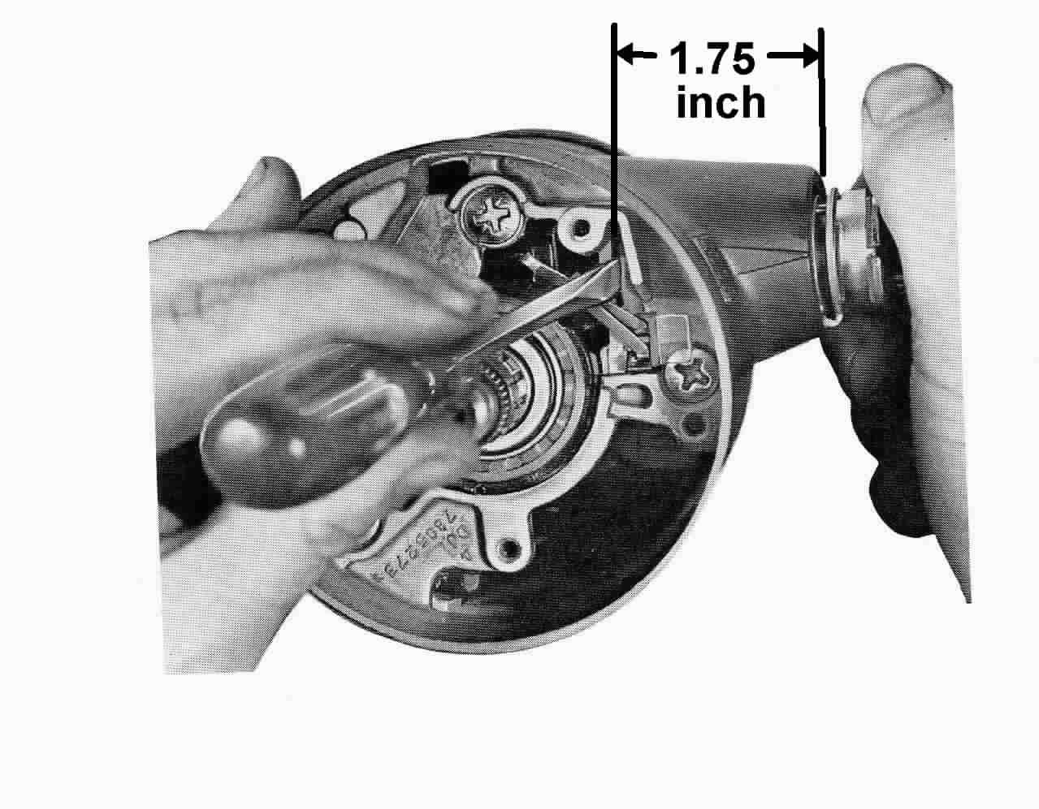
Don't be tempted to pry on the lock cylinder wings to get the lock cylinder moving. The wings will pop off and can't be put back on. The lock cylinder should slide right out.

There is one other method that is sometimes used to remove a lock cylinder that I do not approve. Some people screw a slam-puller into the lock cylinder and slam it out of the column (usually shearing the spring tab.) The slam-puller shocks are very hard on the column housing and your instrument panel.
Lost Ignition Key
If for some reason you do not have the ignition key, you can still disassemble your steering column to the point where you can depress the metal spring tab and remove the lock cylinder. You can then have a locksmith make new keys for that original lock cylinder or install a new one. Replacement lock cylinders are readily available from GM dealers as well as most automotive supply stores.

Removing Key Warning Buzzer Switch - Description #3
The key warning buzzer switch has two long copper contacts coming over the top of the lock cylinder. It has a switch clip #14 holding it in place. Insert the ignition key and turn the lock cylinder to the RUN position (or turn to off-lock and remove the key.). Take a piece of stiff wire and bend a hook about ¼” from the end and insert the hook into the exposed loop of the clip. Pull up and out on the wire to remove both the clip and the switch. Caution: Be very careful that you don’t lose hold of the clip and let it fall back into the steering column. It can be quite difficult to locate and extract.

Note: All of the previous service operations can be performed with the column still in the car. To remove any further parts from the upper end, the column should be dropped and removed from the car. Please download and proceed with Papers #2 and #3 to continue your repairs.

If replacing the lock cylinder and/or the key warning buzzer is all that was required, proceed directly to the following reassembly instructions.

The following procedures address reinstalling the key buzzer switch, the ignition lock cylinder and reassembling the steering column.

Reassembly - Ignition Lock Cylinder
Insert the ignition key into the lock cylinder. Now, hold the case of the lock cylinder and rotate the ignition key all the way clockwise against the stop. (This would normally be the START position.) You should be able to retract the plastic key buzzer tab and the metal spring tab should retract easily with slight pressure as well.

There is a keyway in the turn signal housing #15. Align the key on the lock cylinder (not the ignition key but the raised section on the lock cylinder case) with the keyway in the housing and push the cylinder into the housing until it hits the sector. Now rotate the ignition key counterclockwise maintaining a light push on the lock cylinder, until the drive section of the cylinder mates with the sector. Push in until the spring tab snaps into the housing and the lock cylinder is secure

Reassembly – Key Warning Buzzer Switch
Assemble the buzzer switch with the formed end of the clip under the end of the switch and the spring bowed away from the switch on the side opposite the contacts. Push the clip and switch into the cover with the contacts toward the lock cylinder bore. If the lock cylinder is in place, rotate it to the RUN position or a better procedure is to always remove the key, this will insure that the plastic tab on the lock cylinder is retracted.

Reassembly - Turn Signal Switch
Adjust the tilt head so that it is in the straight position. Reinstall the turn signal switch as follows: Pull the connector and wires back down through the housing. Clip the connector onto the bracket on the steering column jacket. Snap the vehicle wiring harness onto the turn signal switch “harmonica” connector.

Note: It has been reported that sometimes if you have a new turn signal switch, the new switch connector will not snap onto the original wiring connector in your vehicle. It will be close but still will not snap correctly.

If you have this problem, take the connector from your original switch and swap it onto the wires of your new switch. Use the wire from a heavy paper clip and insert it into the "harmonica" connector from the contact side to disengage each wire and contact. There should be a small molded square channel in the connector that will guide you to a metal tang on the contact that holds it in place. Once you depress the tang and pop the wire and contact out of the connector, you should take a small knife blade and bend the tang back out so that it will engage the old connector correctly. Make sure you install the wires in the correct order.

Install the three switch mounting screws. Assemble the hazard warning knob. Install the turn signal lever. Position the lever through the side of the column housing into the switch slot. Tighten the attaching screw.

Reassembly - Washer, Spring, Cancelling Cam, Shaft Lock, and Retaining Ring
On 1969 tilt columns install the upper bearing seat and the nylock nut on the steering shaft. Torque the nut to 5-15 inch ounces.

Later columns do not have a nut. Place the thrust washer, upper bearing preload spring, and the cancelling cam onto the upper end of the shaft. Make sure that the two lobes on the cam are centered between the springs on the turn signal switch. Make certain that the turn signal switch is in the “neutral” position and the hazard warning plunger is out. The switch assembly may be damaged if you don’t follow these instructions!

Compress the shaft lock with the special tool or by hand and install the round wire retaining ring. Make sure it is fully seated. If you distort the ring you will have to purchase a new one from your local GM dealer.

These assembly operations are common for all types steering wheels:

Reassembly - Shaft Lock Cover, Steering Wheel, and Horn Contact
Place the cover on the shaft lock and drive the three screws or snap the cover in place.

Make sure that the horn lower insulator, eyelet, and spring are in place in the horn contact tower. Align the markings on the steering shaft to the steering wheel hub and assemble the steering wheel. Torque the steering wheel nut to 30 ft-lbs. Caution: Do not over-torque the shaft nut or the steering wheel hub may rub on the column housing.

The following reassembly sequences are unique to each steering wheel:

Regular Production Steering Wheel

Place the steering wheel shroud onto the steering wheel while guiding the horn contact lead into the directional signal cancelling cam tower. Install the shroud attaching screws on the underside of the steering wheel. Reconnect the battery ground cable.

Cushioned Rim Steering Wheel
Install the belleville spring, receiver and horn upper insulator and secure with three screws. Install horn button cap. Connect battery ground cable.

Corvette Type Sport Wheel
Attach steering wheel to the hub with six screws. Place the horn contact on steering wheel and attach with three screws. Snap horn button in place. Reconnect the battery.

Final Words of Caution:
To maintain the energy absorbing function of the steering column, always replace screws, bolts, and nuts with identical fasteners as specified. If a steering column assembly is removed from the car, special care must be taken as you handle it. A sharp blow on the end of the steering shaft, leaning on the column, or dropping the column could shear the plastic fasteners inside the column which maintain steering shaft and column rigidity. Remember, plastic parts that are 30+ years old can be very brittle! Handle your steering column parts with care.

A helpful hint to make this job a bit easier. Take a large towel and roll it up the long way. Leave a short tail. Stuff the towel up between the windshield and dash pad. Let the short tail hang over the instrument cluster forming a table. As you disassemble the column, place the small retainers, screws, plates, etc up on the towel from left to right in the order that you remove them. The towel forms a nice no-slip table and prevents the small parts from dropping down your defroster ducts and becoming a permanent part of your air distribution system. When you go to reassemble the column, your parts are all handy and in the correct order for reinstallation. Do this in conjunction with digital pictures!

TiltColumnD&R#1Rev09JA2010
JIML82@aol.com

