Last Revision: 15JA2010

1969 THROUGH 1976 GM A & F-CAR TILT AND STANDARD STEERING COLUMN DISASSEMBLY & REPAIR INSTRUCTIONS

PAPER #2

Disassembly and Repair Instructions Addressed in this Paper
Degree of Difficulty Page

DROP OR REMOVE STEERING COLUMN FROM VEHICLE Moderate 2, 3 & 4
REMOVE AND REPLACE TURN SIGNAL SWITCH Moderate 4 & 5
REPLACE/ADJUST IGNITION SWITCH Moderate 6 & 7
REPLACE LOWER COLUMN BEARING Moderate 7 & 8

How the Paper is Setup
There are a limited number of steering column service procedures that are addressed in this paper. This paper starts at the point where the steering wheel, horn parts, shaft lock, ignition lock cylinder, and the key warning buzzer have been removed from either a standard or an adjustable (tilt) steering column. The turn signal switch has been detached from the column housing and has been moved up and out of the way (but the wiring is still in the column.) All of these operations were described in detail in Paper #1.

There are several reasons why you would want to drop or remove your steering column from your vehicle. First, you want to remove the turn signal switch completely from the column. Since the turn signal switch wiring is routed between the steering column jacket and the column support capsule bracket, it is far easier to remove the switch if the column is outside the car. Second, in order to work on the ignition switch you will find that it is totally inaccessible unless you drop the column. Third, for other major work on the column, it is far easier to do it on a bench than in the car.

This paper makes reference to various line drawing descriptions. They are included on several pages entitled GM A&F-Car Tilt Steering Column Page #1 & #3 or GM A&F-Car Standard Steering Column Page #1 & #2. Also there are drawings entitled GM A&F-Car Tilt Steering Column Blowup and GM A&F-Car Standard Steering Column Blowup. Most steering column and installation parts will be called out with a reference numbers and letters from these drawings. The drawings are all available from the author or from the host websight. You will find these pictures and descriptions to be most helpful when working on your steering column.

Types of Steering Columns Addressed in this Paper
This is a generic paper for all GM A&F-car steering columns (standard and tilt) used in production through model years 1969 to 1976.

A word of caution: First of all DISCONNECT THE BATTERY before working on your steering column! With the steering column disassembled it is possible to inadvertently move the ignition switch to the START position.

Instructions for Removing the A-Car Steering Column from the Vehicle
Note the following instructions on removing the steering column are specific for the Chevrolet A-Car. Please consult your Chevrolet Chassis Service Manual for exact F-car model year information on removal and reinstallation.

All 1969 thru 1976 A/F-car steering columns have a lever on the lower end (outside under the hood under the brake master cylinder) that connects to your transmission by means of a mechanical linkage or a cable. You will need to disconnect the linkage or cable from the lever in order to remove the column from the car.

Remove the cotter pin and disconnect the lower lever from the cable or linkage attached to it.

If you have a small block with original exhaust manifolds, you should disconnect the intermediate shaft flange from the flexible coupling on the steering gear. Remove the two nuts and lock washers (E) shown on page #3 from the flexible coupling bolts. This will allow you to pull the entire steering column and intermediate steering shaft off of the flexible coupling bolts and up into the driver compartment.
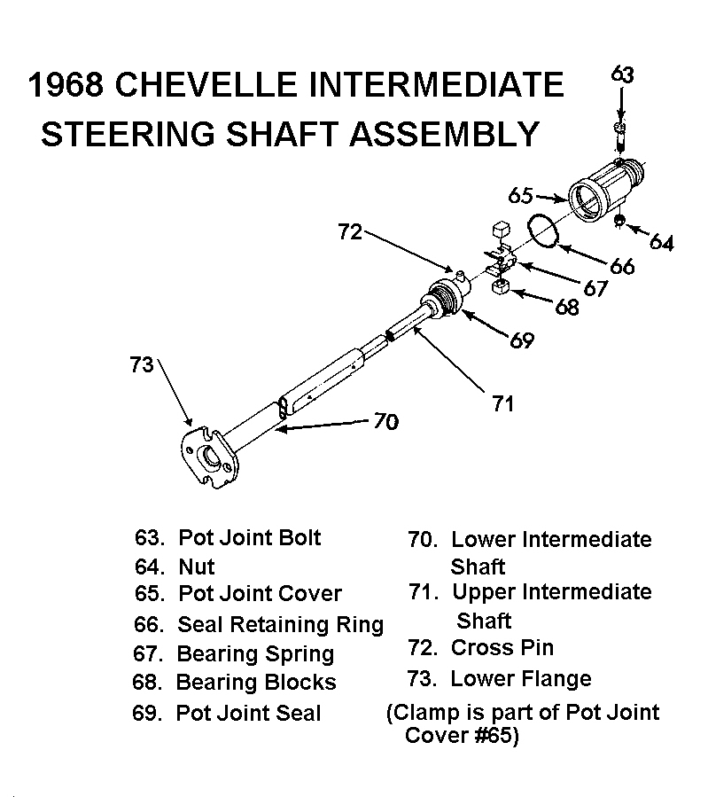
If you have a big block you will find that there is insufficient clearance between the exhaust manifolds and the upper control arm for the flange (#73) on the intermediate shaft to pass through. For this reason, there is a special intermediate steering shaft for big blocks. The small block intermediate shaft has the flange that is permanently staked in place. On big blocks the flange is a separate casting that can be detached from the intermediate shaft. Mark the detachable flange to intermediate steering shaft orientation with chalk or a crayon and remove the flange pinch bolt. Spring the flange open with a large screwdriver and remove it.

A-Car Steering Column Removal Information (Continued)
Another option is to unfasten the intermediate shaft from the steering column by removing the nut (#64) and bolt (#63) at the pot joint connection. Mark the radial position of the pot joint to column and leave the intermediate shaft in place under the hood.

Go back inside the car and disconnect the connectors on the neutral-start/back-up lamp switch. It is a good idea to remove the two screws and the switch itself from the lower end of the column to prevent it being damaged while the column is being removed. Also disconnect the turn signal switch “harmonica” connector from the body harness.

Remove floor pan trim cover screws and remove the plastic cover. Remove the screws (C) securing the two halves of the floor pan cover (A & B); then remove the screws (J, L, Q, & R) securing the halves and seal (D) to the floor pan and remove the cover. Remove the transmission indicator cable from the column, if so equipped.
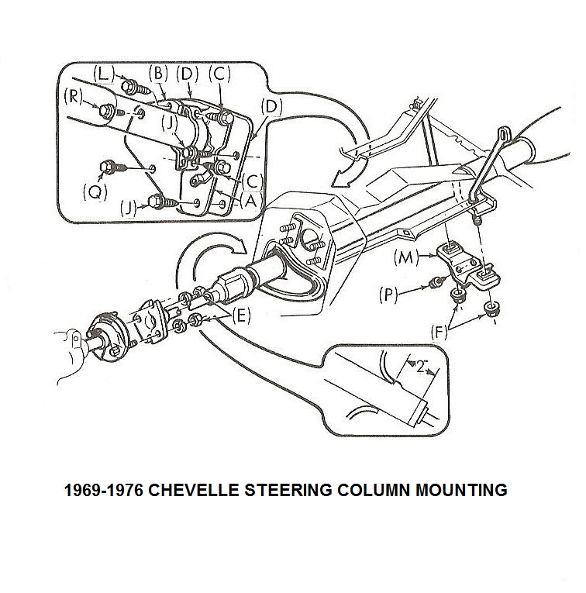
It is most helpful to have an assistant guide the lower end of the column from the engine side while you perform the following procedures. Unfasten the two nuts (F) that hold the column up under the dash. You should now be able to carefully rotate and lower the steering column. Now pull the column straight back, disconnecting the column from the intermediate shaft or the flexible coupling. This will allow the column to drop so that it will rest on your front seat.

A-Car Steering Column Removal Information (Continued)
You can now disconnect the body harness connectors from the column ignition switch. There are three plastic tabs located on the body wiring harness connectors. On tilt columns the tabs will be located on the bottom side of the harness connectors (between the connectors and the steering column). The standard columns will have the tabs on top. You will need to depress them to get them to disengage. The switches and/or the steering column can now be removed from the car.

Special Instructions for Holding a Steering Column in a Vise
Remove the four screws (P) that hold the column support bracket (M) to the column weld nuts. Remove the bracket and disengage the plastic turn signal wiring protector from the weld nuts. You can now clamp the column in a vise by using either two sets of weld nuts that are in line along the length of the steering column. Caution: Do not clamp the column in a vise by using only one weld nut or by clamping on adjacent nuts across from each other. Damage to the column could result.

Removing the Turn Signal Switch – Description #2
Never allow the steering column to “hang” in the car supported only by the floor pan mounting. For this reason, you will find that you really should remove the steering column from the car in order to pull the turn signal switch #8 completely from the steering column. Since the switch wiring routes between the steering column jacket and the column support bracket, you must remove the bracket in order to remove the plastic cover #9 from the switch wiring and thus be able to “fish” the harmonica electrical connector up through the column. Removing the bracket leaves the column unsupported.

Remove the plastic wiring protector cover. It has a slit along its entire length so you can remove it from the wires.

Begin by wrapping the edge of the plastic turn signal switch “harmonica” connector and the wires that lead back into the column with tape to keep them in a line. This will help prevent the connector from cocking and snagging as you pull the turn signal switch wires up through the column. You want the tape to form a very smooth “bullet” nose between the connector and the wiring. However, you do not want the tape to be very thick! Clearances are extremely tight coming up through a tilt column!!

Helpful Hint! Tie a piece of light but strong wire or some twine to the connector to be used as a “tracer” wire to help during reassembly.

Adjustable columns - place the tilt head in the straight position. Caution! Without the steering wheel to counterbalance the tilt spring, the column head can snap quite violently to the full UP position when you release it with the tilt lever.

Place the lower column lever in the full DOWN position. Now, pull the switch straight out, guiding the wiring harness and connector out at the same time. Leave the “tracer” wire or twine in the column so that you can tie it to the new signal switch connector and help direct the wiring back down through the column.
Removing the Turn Signal Switch (Continued)
You might find that fishing the turn signal wires and connector out of the column to be very frustrating. You could try having someone hold The steering column vertical while you pull directly up on the turn signal switch.

Alternate method of feeding switch wires through the column
Some people have been successful using the following procedure; disengage and remove the individual switch wires and metal contacts from the plastic “harmonica” connector. Straighten a heavy paper clip and insert it into the "harmonica" connector from the contact side to disengage each wire and contact. There should be a small molded square channel in the connector that will guide you to a metal tang on the contact that holds it in place. Once you depress the tang and pop the wire and contact out of the connector, you should take a small knife blade and bend the tang back out so that it will engage the old connector correctly

The turn signal switch wiring can now be fed separately through the column much more easily. You must make careful note of the exact order of the wires in the connector so that when you reassemble them, all your lights, horn, and buzzers will work correctly.

“Harmonica” Connector Problem
If all you wanted to do was replace the turn signal switch, the installation procedure follows directly. Here is a helpful hint. Some people have reported that replacement switches have a “harmonica” connector that will not snap into the original vehicle harness. (They look very similar but they just won’t connect.) So take the new turn signal switch down under the dash and try to snap the flat “harmonica” connector into the vehicle harness before you begin installing the switch into the steering column. If the new switch connector easily snaps into place you are good to go. However, if the connector will not assemble, you will want to swap the old “harmonica” connector onto the new switch.

If you are continuing to disassemble the column you will need to remove the ignition switch from the column (following page) and then proceed to (either the Tilt Column or the Standard Column) Disassembly & Repair Paper #3.

Reinstalling the Turn Signal Switch
Adjust the column head so that it is straight and the lower lever all the way down. Pull the wiring down through the housing with the aid of the tracer wire. Again, if the column is out of the car, you will find that feeding the wires and connector is easier if someone holds the column vertical. You will note that the cavity inside the column for the wires to feed extends from about the 4 to 5 o’clock positions. Have the connector at 5 o’clock and the wires at 4 o’clock. Use the tracer wire and push down on the connector with a long, thin screwdriver.

Please return to Tilt Column Disassembly and Repair Paper #1, page #6 or Standard Column Disassembly and Repair Paper #1, page #6 to complete the installation of the turn signal switch into the column as well as reassembling the rest of the steering column.
Ignition Switch - General Information
There are two different ignition switches. The standard (non adjustable) steering column ignition switch works in the opposite direction from the T&T or tilt steering column switch. In other words, the standard column has a rod that pushes down on the standard ignition switch to move it into the START position. The adjustable column pulls up on a rod to move its ignition switch to the START position. Although either switch will connect to your vehicle wiring harness, the switches are unique and not interchangeable. You will find that the adjustment procedures are mirror opposites of each other.

A point of information. There are five positions inside the ignition switch. They are as follows: START, RUN, OFF, OFF-LOCK, and ACCESSORY. There is a slider on the underside of the switch that the rod from the column head attaches. You can operate the slider with a small phillips screwdriver or allen wrench. You will find that there is a spring return at the end of travel when you reach the START position. The other end of travel will be ACCESSORY.

Remove Ignition Switch
The ignition switch #55 should be positioned in the OFF position before removing.
If the lock cylinder has already been removed from the column proceed as follows:

Standard Columns – the connecting rod to the switch should be pulled up toward the steering wheel to a definate stop and then moved down two detents, which is the OFF position.

Tilt Columns – the connecting rod #38 to the switch should be pulled all the way down toward the intermediate shaft and then moved up two detents, which is the OFF position.

Now remove the two attaching screws #54 and the switch. You may need to twist the switch 90 degrees to get it off the actuator rod.

If replacing the ignition switch was all that was required, the installation procedure follows next.

Installing and Adjusting the Ignition Switch –

Std Column Description #5; Adjustable Column Description #7
In order to correctly install the ignition switch it is necessary for the lock cylinder to be installed in the column and placed in the OFF position. On all columns, reach down to the lower column lever and move it down to its lowest position. Now rotate the lock cylinder all the way counterclockwise until it stops. This will be the OFF position.

You should have removed the ignition switch in the OFF position. However, if you are in doubt that it is correct, proceed as follows:

Move the slider inside the ignition switch all the way to the end of travel (that will be the ACCESSORY position) where it should detent and stay in that position. If in doubt, the other extreme will be the START position and you will feel a spring return. Now move the slider two detent positions back from the ACCESSORY position.
Installing and Adjusting the Ignition Switch (Continued)
Fit the actuator rod into the slider hole and assemble it to the column with the two screws. Lightly push the switch down the column (away from the steering wheel), to take out lash in the actuator rod, and tighten the mounting screws. Caution should be exercised to prevent moving the switch out of the OFF detent. Tighten the screws to 35 in-lbs.

Remove/Replace Steering Column Lower Bearing
All GM steering columns 1969 thru 1976 use the same lower end parts. All of the parts (except the spring) are still available through GM dealers. Note the spring is only used on the standard (non-adjustable) steering columns. Zip Products (a Corvette supplier) lists all of the parts (including the spring) at their website.

Column Lower Bearing GM #7805700 Zip SC-442
Column Lower Bearing Adapter (plastic) GM #7805822 Zip SC-452
Column Lower Bearing Shield Wire Clip GM #7804439 Zip SC-453
Column Lower Bearing Shield GM #7804440 Zip SC-454
Column Lower Bearing Spring Zip SC-463

Pry the lower bearing wire clip from the column jacket with a screwdriver. Remove the stamped lower bearing shield (retainer). Pull the lower bearing and plastic lower bearing adapter from the column mast jacket.

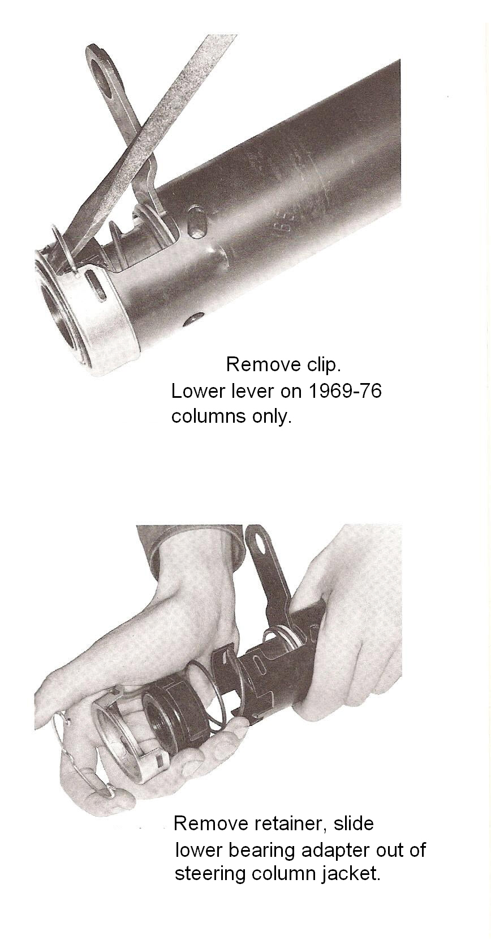

Reassembly – Lower Column Bearing
Assemble the lower bearing to the plastic adapter. Align the tabs on the adapter to the cutout in the column mast jacket. Slide the bearing and adapter assembly up the steering column shaft and into the end of the column mast jacket. Install the lower bearing shield with the cutout in the shield aligned with the mast jacket cutout. Install the retainer clip.
Note: The pictures on the left show a coil spring behind the plastic adapter. Tilt steering columns do not have a spring.

The above procedure is very straight forward and easy AS LONG AS THE PARTS ARE NOT ALL CORRODED TOGETHER. If you find a lot of corrosion on your lower column parts, it is a good idea to soak them in penetrating oil for a day or two before trying to remove them.

Replace Lower Column Bearing (Continued)
The previous description on replacing the lower steering column bearing takes into account new old stock (NOS) bearings, plastic adapters, and corrosion free parts. Now that our cars are in the range of thirty to forty years old, NOS is expensive and difficult to find. Enterprising suppliers have found their own sources for bearings and possibly the plastic adapter has been retooled. Because of this fact, you may find that parts do not easily slide up the steering shaft nor do they easily snap together.

Sometimes the corrosion on the shaft and bearing is so advanced that there is only the bearing race that remains and it is corroded onto the steering shaft. Take a Dremel type tool with an abrasive wheel and cut the bearing off. Polish up the shaft so that it will go together easier. Obtain a new bearing and plastic adapter as you will most likely destroy both when taking them apart.

Make sure that you assemble the new bearing in the correct orientation to the adapter. Apply some grease to the inside diameter of the adapter to aid in the assembly of the bearing to it.

Original bearings and plastic adapters were a light snap fit. You would hope that obtaining your replacement parts from the same source would result in parts that snap together fairly easily. However, today there may be a slight mismatch of parts and you may have to use a vise to force them together. If the press fit is too great, some people have cracked the plastic adapter when forcing them together. One method would be to freeze the bearing and warm up the adapter. This will greatly reduce the interference fit.

The next area of concern is the fit of the inner bearing race to the steering shaft. Clean up the corrosion on the shaft first. Some people have reported that the inside diameter of the bearing inner race has an o-ring. This could cause the bearing to have fairly high press on forces to the steering shaft. Apply some grease to the shaft and o-ring to aid in the assembly.

Other people have reported no o-ring inside the bearing but that it still needs to be hand forced up the shaft.

Still other people have reported a minor press fit to the shaft that requires the bearing and adapter to be lightly tapped to slide it up the shaft. Obtain a pipe with a one inch ID and tap the bearing so that the tapping force is directly on the inner race to get it up the shaft.

Reassembly – Column Support Bracket to Column
Remove the column from the vise. Place the turn signal wiring protector on the two appropriate weld nuts. Install the column support bracket (M) to the column. Make sure that the aluminum capsules on the bracket are toward the steering wheel. Torque the four screws (P) to 15 ft-lbs.

Reinstalling the A-Car Steering Column
As mentioned previously, the following is A-car specific reinstallation information. Please consult the appropriate Chevrolet Chassis Service Manual for the model year of your F-car and the specific reinstallation information.

Loose assemble inner (A) and outer (B) dash covers on the column with two screws (C). dash covers must be able to slide on the column. Glue cover seal (D) to outer cover (B).

Position rolled portion of dash seal (part of column assembly) at column lower reaction tab, two inches from bottom of jacket.

Caution: The rolled portion of the seal must be directed down the column toward front of car and must remain in this position during and after column installation (Page #2).

Move the lower column lever back to the UP position. Carefully slide the column back through the dash hole. Reconnect the body electrical connectors to the ignition, turn signal, neutral start, and the back-up lamp switches.

If you are switching from a standard (non-adjustable) steering column to a tilt column (or vise versa) you will find that the original vehicle wiring harness connectors will adapt to either steering column ignition switches. However, the ignition switch will require that you twist the two wiring harness connectors 180 degrees to get them to snap into the switch.

Some people have reported that when they replaced their turn signal switch they found that the “harmonica” connector from the new switch would not snap correctly into the vehicle wiring connector. The problem can easily be corrected by swapping your original connector onto wires from the new switch. See “Harmonica” Connector Problem on Page #5.

If you removed the detachable flange from the intermediate steering shaft, orient the flange to the chalk marks on the parts and install the flange from the steering shaft. Tighten the flange pinch bolt to 30 ft-lbs. Install the flange onto the flexible coupling and tighten the flexible coupling nuts and lockwashers (E) to 20 ft-lbs. If you unfastened the column at the pot joint connection, reassemble the intermediate shaft to the column and torque the nut (#64) and the bolt (#63) to 30 ft-lbs.

Snug but do not tighten steering column in place with the two nuts (F) up under the dash.

Position outer cover to dash and start screw (Q). Install screw (L), then screw (Q), and finally screw (R) and tighten to 35 in-lbs. Tighten two clamp screws (C) to 35 in-lbs.
Install two inner cover screws (J) and tighten to 35 in-lbs. Replace the plastic cover and tighten floor pan trim cover screws.

Secure the column by tightening the two dash to column nuts (F) to 20 ft-lbs.

Reinstalling the A-Car Steering Column (Continued)
Install the transmission indicator cable on columns with automatics. Reattach the lower dash panels.

With the lower column lever all the way UP, connect the transmission control linkage at the lower column lever.

Please proceed and follow instructions in Tilt Column Disassembly & Repair Paper #1 or the Standard Column Disassembly & Repair Paper #1 for reinstalling the shaft lock, steering wheel and horn parts.

TiltColumnD&R#2Rev15JA2010
StdColumnD&R#2Rev15JA2010
JIML82@aol.com

