Last Revision 08AP2009
1969 THRU 1976 GM A&F-CAR STANDARD (NON-ADJUSTABLE) STEERING COLUMN DISASSEMBLY & REPAIR INSTRUCTIONS

PAPER #3

Disassembly and Repair Instructions Addressed in this Paper

Degree of Difficulty Page

REPLACE RACK AND/OR SECTOR Moderate 2

REPLACE UPPER BEARING Moderate 2

REPLACE LOWER COLUMN BEARING See D&R Paper #2

How the Paper is Setup
There are a limited number of steering column service procedures that are addressed in this paper. This paper starts at the point where the steering wheel, horn parts, shaft lock, ignition lock cylinder, key warning buzzer, turn signal switch, and ignition switch have been removed from a standard steering column. Also for much easier access to the steering column it is assumed that it has been removed from the car. All of these disassembly and removal procedures were described in detail in Std Strg Column 69-76 Disassembly & Repair Papers #1 & #2.

This paper also describes replacing the lower column bearing. I imagine that it is possible to replace the lower bearing with the column still in the car. However, I would think that it will be far easier to remove the bearing with the column out of the car.

This paper refers to several other papers, a blowup drawing, and several line drawings that are entitled GM A-Car. These papers are very generic and you will find them to be most helpful when working on most General Motors standard (non-adjustable) steering columns from this time frame.

This paper makes reference to various line drawing descriptions. They are included on several pages entitled GM A-Car Standard Steering Column Page #1 & #2.

The steering column installation is shown on a drawing entitled GM A-Car Steering Column Parts and Mounting.

Also there is a drawing entitled GM A-Car 1969-76 Standard Steering Column Blowup. Steering column parts are called out in this paper with reference to numbers on that drawing.

The drawings are all available from the author or from the host websight. You will find these pictures and descriptions to be most helpful when working on your steering column.

Types of Steering Columns Addressed in this Paper
This is a generic paper for all standard (non-adjustable) steering columns that were installed in GM vehicles from 1969 through 1976 and particularly A & F-car models.
Column Shift Models
Drive out the upper shift lever pivot pin #13 and remove the shift lever #11.

Remove Turn Signal Housing and Shroud from Column Jacket – Description #4
Remove the four hex head screws #35 securing the turn signal housing to the column jacket #63. Pull the assembly from the jacket (See FIG. 1).

On floor shift models, tip the housing and shroud assembly upside down. Remove three screws and separate the shroud #12 from the housing. On column shift models the shroud snaps into the gearshift lever housing #14.

Remove the thrust cup #23 from the lower side of the housing (See FIG. 2).

FIG 1 REMOVING TURN SIGNAL FIG 2 TURN SIGNAL HOUSING ASSY
HOUSING
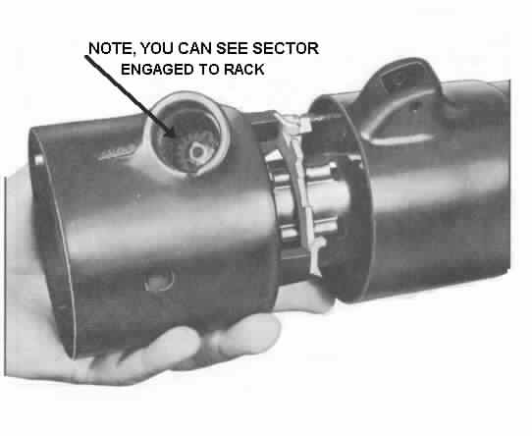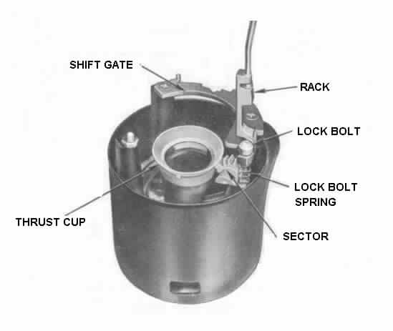

Remove Rack and/or Sector

Lift the ignition switch actuating rod and rack assembly #20 and shaft lock bolt and spring assembly #22 out of the housing (See FIG 3). If required, pull the rack away from the lock bolt to separate. Remove the rack preload spring #24.

Remove the shift lever detent plate #19. Remove the sector #26 through the lock cylinder hole by pushing firmly on the block tooth of the sector with a blunt punch (See FIG. 4).

FIG 3 REMOVING RACK & LOCK BOLT FIG 4 REMOVING SECTOR
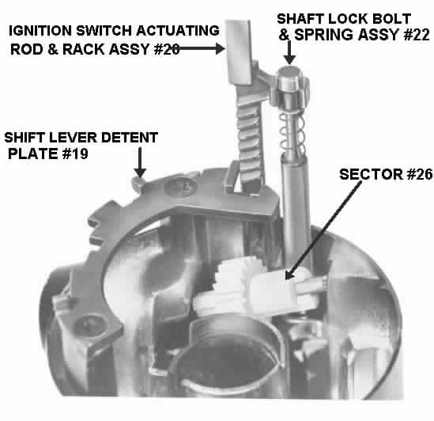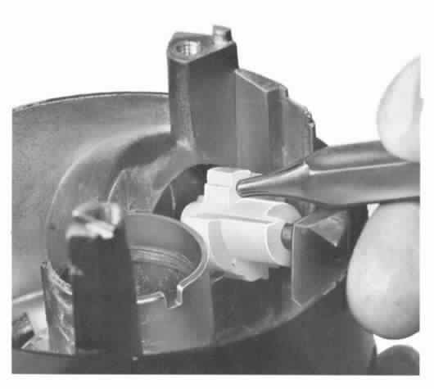
Replace Upper Steering Shaft Bearing
Remove the four screws #35 attaching the bearing housing #30 to the jacket #63. The upper steering shaft bearing is installed into the die cast housing from the driver side and the housing lip is spun over to retain it.
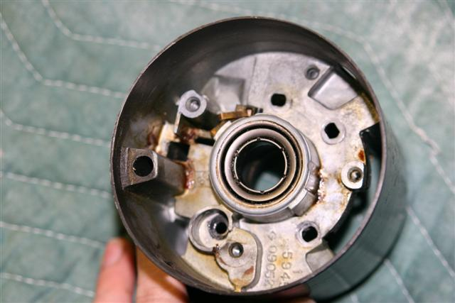

According to the Saginaw service literature, the bearing was not serviceable. However

there was a service bearing available through GM dealers until recently. I believe that the part number was 7800269. If your local dealer does a part search, you may still find a few of them on dealer’s shelves.

As a service procedure, it would seem that you would take the housing and grind the spun lip away, then remove the bearing from the instrument panel side. The new bearing can then be placed in the housing bore. As long as you are careful with the housing and bearing assembly (particularly when reinstalling the steering shaft) there is really no need to glue or epoxy the bearing into the housing. Once the spring, canceling cam, and locking plate are in place, the bearing is preloaded back into the housing and cannot move.

Disassembly of the Lower End - Replace Lower Bearing

Steering Column Lower Bearing Parts
All GM standard steering columns 1969 thru 1976 use the same lower end parts. All of the parts except the spring are still available through GM dealers and various other suppliers. Zip Products (a Corvette supplier) lists all of the parts (including the spring) in their online store at the Corvette Forum websight.

Column Lower Bearing GM #7805700 Zip SC-442
Column Lower Bearing Adapter (plastic) GM #7805822 Zip SC-452
Column Lower Bearing Shield Wire Clip GM #7804439 Zip SC-453
Column Lower Bearing Shield GM #7804440 Zip SC-454
Column Lower Bearing Spring Zip SC-463

Pry the Lower Bearing Clip #52 from the column jacket with a screwdriver (Fig 5). Remove the stamped Lower Bearing Retainer #57. Pull the Lower Bearing #51 and plastic Lower Bearing Adapter #53 from the column Mast Jacket #63. Remove the Lower Bearing Spring #54 (Fig 6). The lower bearing may be removed from the adapter by light pressure on the bearing outer race.
Replace Lower Bearing (Continued)
This service procedure is very straight forward and easy AS LONG AS THE PARTS ARE NOT ALL CORRODED TOGETHER. If you find a lot of corrosion on your lower column parts, it is a good idea to soak them in penetrating oil for a day or two before trying to remove them.
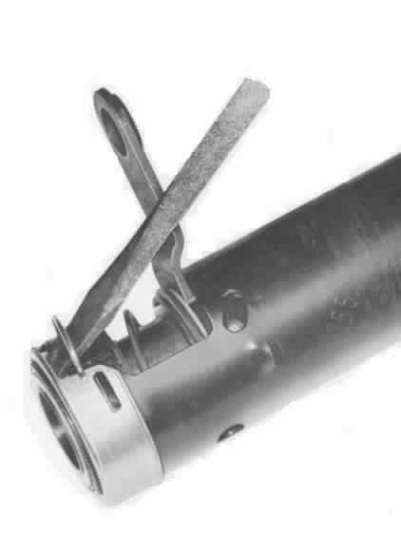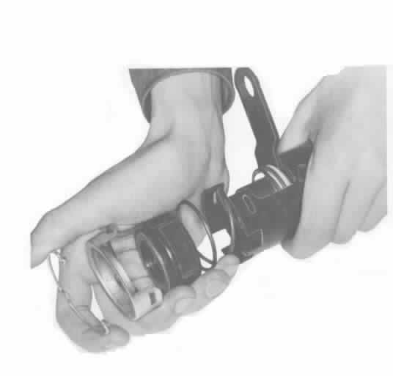
FIG 5 REMOVING RETAINER FIG 6 REMOVING BEARING ADAPTER
CLIP AND SHIFT TUBE SPRING
Remove the two Screws #44 that hold the neutral start switch (or the backup light switch) #43 in place. Remove the switch. You can now slide out the shift tube assembly #58.

The following procedures address replacing parts and reassembling the steering column.

Reassembly of the Lower End
Apply a thin coat of lithium based grease to all friction surfaces.

Press the lower bearing assembly #51into the plastic adapter #53.

Insert the shit tube assembly #56 into the lower end of the jacket and rotate until the upper shift tube key slides into the #14 bowl keyway.

Assemble the thrust washer #55, shift tube thrust spring #54, the bearing and adapter assembly, and lower bearing retainer #57 into the bottom of the jacket. Holding the retainer in place, insert the retainer clip #52 into the jacket and mating retainer slots.

Install the neutral –start/back up switch, making sure to use the proper screws.

Reassembly – Sector, Rack, & Bolt
Insert the new sector through the housing lock cylinder hole and assemble it onto the pin. Orient the sector so that the tang end is toward the outside of the hole. Press the sector over the pin with a blunt tool. The sector should turn freely when installed.

Reassembly – Sector, Rack, & Bolt (Continued)
Insert the rack preload spring #24 from the bottom side. The bow of the spring should be against the rack. Note: On early columns the long end of the spring will hook onto the steering wheel side of the housing. Later springs are symmetrical so there is no up or down.

Assemble the bolt to the rack cross-arm (FIG 3). Insert the rack and lock bolt into the housing from the bottom with the teeth up (toward the steering wheel) and toward the centerline of the column (FIG 3). Assemble the rack to the sector so that the teeth match. Make sure that the large tooth on the sector matches the large tooth cutout on the rack when the rack assembly is pushed all the way in.

Reassembly – Bowl & Shroud, Turn Signal Housing to Jacket
On floorshift models, position the shroud into the bowl #14. Drive three screws tighten to 18 inch-lbs. On column shift models, snap the shroud into the shift bowl. Install the assembly onto the upper end of the column jacket. Rotate the bowl to be sure it is seated in the bearing.

With the bowl in place, install the turn signal and lock cylinder housing onto the jacket. The gearshift housing should be in PARK position and the rack pulled downward. Be sure that the turn signal housing is seated on the jacket and drive the four screws (60 inch-lbs).

Slide the steering shaft assembly into the column. (The upper housing should be in place before the shaft is assembled.)

Continue with Reassembly Instructions Contained in Papers #2 and #1.

Final Words of Caution:
To maintain the energy absorbing function of the steering column, always replace screws, bolts, and nuts as specified.

When a steering column assembly is removed from the car, special care must be taken in handling it. A sharp blow on the end of the steering shaft, leaning on the assembly, or dropping the assembly could shear or loosen the plastic fasteners that maintain column rigidity.

Plastic parts that are 30 years old can be very brittle! Handle your steering column parts with care.

StdColumnD&R#3Rev08AP09
JIML82@aol.com

