Last Revision: 09JA2010
1969 THRU 1979 C3 CORVETTE STANDARD (NON-ADJUSTABLE) STEERING COLUMN DISASSEMBLY & REPAIR INSTRUCTIONS
PAPER #2

Disassembly and Repair Instructions Addressed in this Paper
Degree of Difficulty Page

DROP OR REMOVE STEERING COLUMN FROM VEHICLE Moderate 3
REPLACE TURN SIGNAL SWITCH Moderate4 4 & 5
TURN SIGNAL SWITCH WIRE COLOR AND GAGE Moderate 4
REPLACE/ADJUST DIMMER SWITCH Moderate 5 & 6 REPLACE/ADJUST IGNITION SWITCH Moderate 6

REPLACE LOWER COLUMN BEARING Moderate 7 & 8

How the Paper is Setup
There are a limited number of steering column service procedures that are addressed in this paper. This paper starts at the point where the steering wheel, horn parts, shaft lock, ignition lock cylinder, and the key warning buzzer have been removed from the steering column. The turn signal switch has been detached from the column housing and has been moved up and out of the way (the wiring is still in the column.) All of these operations were described in detail in Disassembly & Repair Paper #1.

There are several reasons why you would want to drop or remove your steering column from your vehicle. First, in order to work on the ignition switch or the dimmer switch you will find that they are totally inaccessible unless you drop the column. Second, for other major work on the column, it is far easier to do it on a bench than in the car.

This paper makes reference to various line drawing descriptions. They are included on several pages entitled C3 Standard Steering Column Page #1 & #2. Also there are schematic drawings entitled Std Column 69-76 Blowup Pic and Std Column 77-79 Blowup Pic. Most steering column and installation parts will be called out with a reference numbers and letters from these drawings. The drawings are all available from the author or from the host websight. You will find these pictures and descriptions to be most helpful when working on your steering column.

Types of C3 Steering Columns Addressed in this Paper
This paper addresses the 1969 through 1979, second generation, energy absorbing, function locking, C3 standard (non-adjustable) steering columns. It does not address the 1968, first generation, energy absorbing, standard steering column.

A word of caution: DISCONNECT THE BATTERY when you work on the steering column. With the steering column partially disassembled it is possible to inadvertently move the ignition switch to the start position.

General Information
There are two different designs of steering column mounted ignition switches. The standard (non adjustable) steering column ignition switch works in the opposite direction from the T&T steering column switch. Although either switch will connect to your vehicle wiring harness, the switches are not interchangeable. So if you are replacing your ignition switch, make sure that you obtain the correct replacement part.

The headlight dimmer switch was mounted on the floor and was foot actuated from 1969 through 1976. The switch was moved to the steering column on all C3 Corvettes in 1977 and was actuated by the turn signal lever. The switch remained on the steering column through 1982.

On 1969 through 1976 Corvette columns there is a lever on the lower end of the steering column (out under the hood, just under the brake booster.) It is connected to a cable that attaches to the transmission. On cars with automatic transmissions, the cable pushes the column lever to the full Up position when the transmission is shifted into Park. With manual transmissions, it pushes the column lever full Up when shifted into Reverse.

All 1977 through 1979 Corvettes with standard steering columns have a small key release lever next to the ignition lock cylinder that the driver has to trip in order to be able to rotate the ignition key to the Off-Lock position. This later design does not require a back drive cable. This key release column requires that you install the ignition switch and lock cylinder differently than the older steering columns.
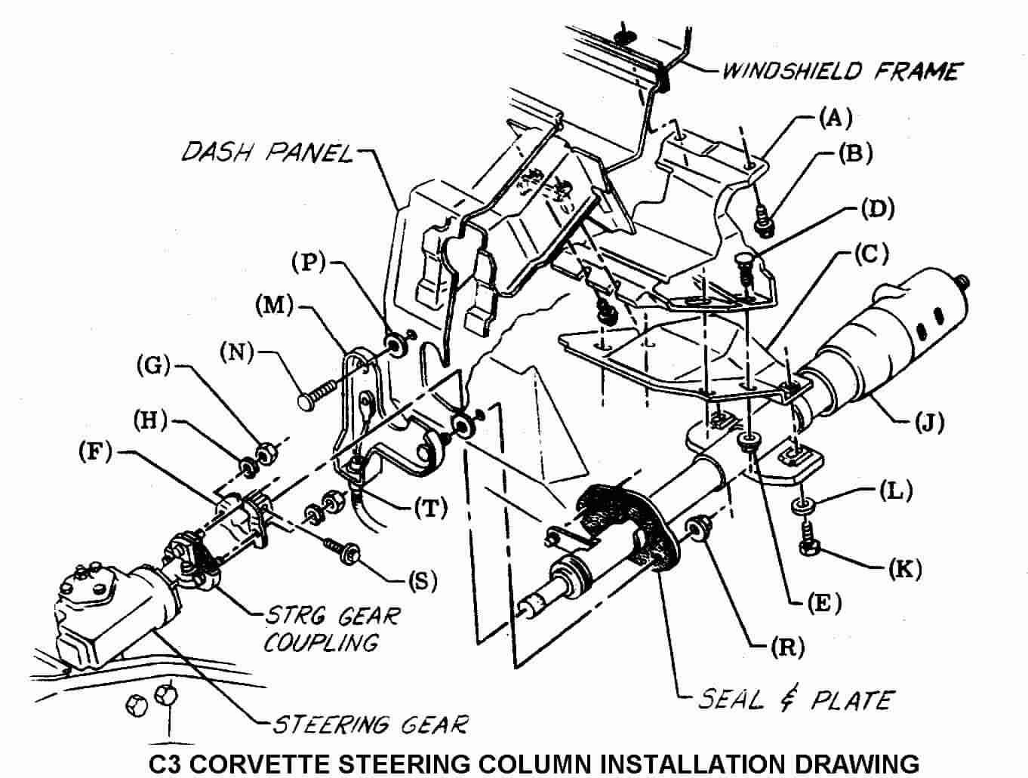

Instructions for Dropping and/or Removing the Steering Column
First of all, NEVER just remove the two vertical screws that hold the steering column up into the dash and let the column “hang” by the attachments at the flexible coupling and the two fasteners coming through the dash panel. Letting the column “hang” in that manner puts very high loads on the steering column lower bearing and can cause it to fail.

Second of all, disconnect the battery before working on the steering column.

If your C3 has a steering column back drive system (all 1969 through 1976 models), you will need to open the hood and look directly under the brake booster. There will be a lever on the lower end of the steering column with a cable attached to it. Remove the cotter pin and washer, disconnect the back drive cable from the pin on the lever. There is also a metal lower column plate (M) attached to the dash panel. The cable sheath is attached to the plate. You can leave the cable attached to the plate. This plate also holds a welded stud and a loose carriage bolt (N) that secures the lower end of the column (J).

If you have a manual transmission, you will find a fairly heavy clutch pedal return spring attached to the plate and to the Z-bar. You should detach one end of the spring at this time. Hint! Detach the clutch pedal push rod from the Z-bar. This will allow the Z-bar to rotate rearward and take some tension off the spring.

Next, remove the two nuts (G) and lockwashers (H) that connect the flexible coupling to the steering column flange (F).

Go back inside the car and remove the plastic closeout panel from under the steering column. Remove the crossover bar and the air conditioning duct that passes under the steering column. Remove the two nuts (R) that attach the steering column to the outside lower column plate. Now go back under the hood and pull the plate away from the dash. You will also find that there are two washers (P) sandwiched between the plate and the dash panel.

Now, go back inside and unfasten the two vertical screws (K) and washers (L) that hold the column up into the dash.

Make sure on 1976 and earlier columns that you have the back drive lever all the way in the Up position and that it is aligned with the cutout in the front of dash. Now pull the column straight back, disconnecting the column flange from the two flexible coupling bolts. (You may need an assistant out under the hood to help disengage the parts.) Pull back and rotate the steering column so that it will drop and rest on your front seat.

You can now disconnect the two body harness electrical connectors from the column ignition switch. There are three plastic tabs that need to be depressed in order to disengage them from the switch. Disconnect the turn signal “harmonica” electrical connector from the vehicle wiring. Disconnect the electrical connector(s) from the dimmer switch and the cruise control wires (if so equipped.) The steering column can now be removed from the car.
Removing the Turn Signal Switch – Description #2
Begin by wrapping the edge of the plastic turn signal switch connector and the wires that lead back into the column with tape to keep them in a line. This will help prevent the connector from cocking and snagging as you pull the turn signal switch wires up through the column. You want the tape to form a very smooth “bullet” nose between the connector and the wiring. However, you do not want the tape to be very thick!

Helpful Hint! Tie a piece of light but strong wire or some twine to the connector to be used as a tracer wire to help during reassembly. Place the lower column back drive lever in the full Down position. Now, pull the switch straight out, guiding the wiring harness and connector out at the same time. Leave the tracer wire or twine in the column so that you can tie it to the new signal switch connector and help direct the wiring back down through the column.

Alternate Method of Feeding Switch Wires Through the Column
Some people have been successful using the following procedure; disengage and remove the individual switch wires and metal contacts from the plastic “harmonica” connector. Straighten a heavy paper clip or use a very thin blade screwdriver. Insert it into the "harmonica" connector from the contact side to disengage each wire and contact. There should be a small molded square channel in the connector that will guide you to a metal tang on the contact that holds it in place. Once you depress the tang and pop the wire and contact out of the connector, you should take a small knife blade and bend the tang back out so that it will engage the connector correctly upon reinstallation. The turn signal switch wiring can now be fed separately through the column.
YEARS | WIRE COLOR AND GAGE | CONNECTOR POSITION
1969-82 | White 18 gage | P
1969-82 | Dark Green 18 gage | N
1969-82 | Yellow 18 gage | M
1969-82 | Purple 18 gage | L
1969-82 | Brown 18 gage | K
1969-82 | Dark Blue 18 gage | J
1969-82 | Light Blue 18 gage | H
1969-82 | Black 18 gage | G
1969-82 | Light Green 20 gage | F
1969-82 | Tan 20 gage | E
1980, 81, & 82 | Black 18 gage | C
1980, 81, & 82 | Orange 18 gage | B
1980, 81, & 82 | Brown 18 gage | A

Make sure that you reinstall your switch wires into the “harmonica” connector in the correct order, so that when you reassemble them, all your lights, horn, and buzzers will work correctly.

If all you wanted to do was replace the turn signal switch, the installation procedure follows directly.

If you are continuing to disassemble the column you will need to remove the ignition and dimmer switches from the column and then proceed to Disassembly & Repair Paper #3.

Reinstalling the Turn Signal Switch

Set the back drive lever all the way Down. Pull the wiring down through the housing with the aid of the tracer wire. Be sure it feeds under the mounting bracket. If the column is out of the car, you might find that feeding the wires and connector is easier if someone holds the column vertical. You will note that the cavity inside the column for the wires to feed extends from about the 4 to 5 o’clock positions. Have the connector at 5 o’clock and the wires at 4 o’clock. Use the tracer wire and push down on the connector with a long, thin screwdriver.

Please return to C3 Standard Column D&R Paper #1, page #6 to complete the installation of the turn signal switch into the column. The reinstallation procedure for the entire steering column into the vehicle follows at the end of this paper.

Replace/Adjust Dimmer and/or Ignition Switches
In order to gain access to the ignition switch and/or the dimmer switch, the steering column must be dropped down from the dash or removed from the car entirely. It is best to first remove the steering wheel since the column will not drop very far because the steering wheel rim hits the car seat. The various types of C3 steering wheels and their removal are discussed quite thoroughly in Paper #1.

General Information
As mentioned previously in this paper, there are two different ignition switches. The standard (non-adjustable) steering column ignition switch works in the opposite direction from the T&T or tilt steering column switch. In other words, the standard column actuates the switch with a rod that pushes down on the switch to move it into the Start position. The adjustable column pulls up on a rod to move its ignition switch to the Start position. Either switch will connect to your vehicle wiring harness. However, you will need to twist the three connectors on your vehicle wiring harness 180 degrees to convert from the switch on a standard (non-adjustable) steering column to the switch on a T&T column.

The headlight dimmer switch was mounted on the floor from 1969 through 1976. It was placed on the steering column in 1977 and continued through 1982.

Removing the Dimmer Switch
The lower dimmer switch attachment (closest to the floor) is with a nut. The nut threads onto a stud. The lower half of the stud holds the ignition switch in place. If you are not going to work on the ignition switch make sure that you only remove the nut and do NOT loosen the stud otherwise you will have to adjust the ignition switch as well.

Now remove the screw on the upper part (steering wheel side) of the switch. You can now disengage the dimmer switch from the actuator rod and remove it.

Installing and Adjusting the Dimmer Switch –

Std Column Description #5
Insert the dimmer rod into the switch. Loosely install the screw in the upper attaching hole and snug the nut on the stud. Depress the switch slightly and insert a 3/32” drill into the switch as shown in Description #5 to remove lash. Tighten the screw and nut to 35 in-lbs. Remove the drill and check the dimmer switch function by actuating the turn signal lever. You should hear a sharp snap.

Removing the Ignition Switch
On cars equipped with column mounted dimmer switches, the dimmer switch will have to be removed first and then the ignition switch. Follow the above procedures to remove the dimmer switch.

Remove the ignition switch from the column by removing two screws (or a stud and a screw). Pull the switch off the column actuator rod. You may need to twist the switch 90 degrees to get it off the actuator rod. If further disassembly of the column is necessary, please download paper #3 and continue your repairs.

Installing and Adjusting the Ignition Switch –

Std Column Description #5
In order to correctly install the ignition switch it is necessary for the lock cylinder to be installed in the column and placed in the Off-Unlock position.
Back Drive Columns (1969 through 1976) reach down to the lower column lever and move it down to its lowest position. Now rotate the lock cylinder all the way counterclockwise until it stops. The lock cylinder is now in the Off-Unlock position.

Key Release Standard Columns (1977, 78, & 79) just rotate the lock cylinder all the way counterclockwise until it stops. DO NOT actuate the key release lever. This will place the lock cylinder in the Off-Unlock position.

You now need to place the ignition switch in Off-Unlock position. You do this by moving the slider all the way to the end of travel to the Accessory position. It should detent and stay in that position. If in doubt, the other extreme will be the Start position and you will feel a spring return. Now move the slider two detent positions back from the Accessory position, this will be the Off-Unlock position.

Fit the actuator rod into the slider hole and assemble it to the column with the two fasteners. Lightly push the switch down the column (away from the steering wheel), to take out lash in the actuator rod, and tighten the mounting screws. Caution should be exercised to prevent moving the switch out of the Off-Unlock detent. Tighten the fasteners to 35 in-lbs.

Reinstall and readjust the dimmer switch if so equipped.

Remove Steering Column Lower Bearing
All T&T steering columns 1969 thru 1982 use the same lower end parts. All of the parts are available through GM dealers, Zip Products, and several other suppliers.

Column Lower Bearing GM #7805700 Zip SC-442
Column Lower Bearing Adapter (plastic) GM #7805822 Zip SC-452
Column Lower Bearing Shield Wire Clip GM #7804439 Zip SC-453
Column Lower Bearing Shield GM #7804440 Zip SC-454

Pry the lower bearing wire clip from the column jacket with a screwdriver. Remove the stamped lower rearing shield (retainer). Pull the lower bearing and plastic lower bearing adapter from the column mast jacket.

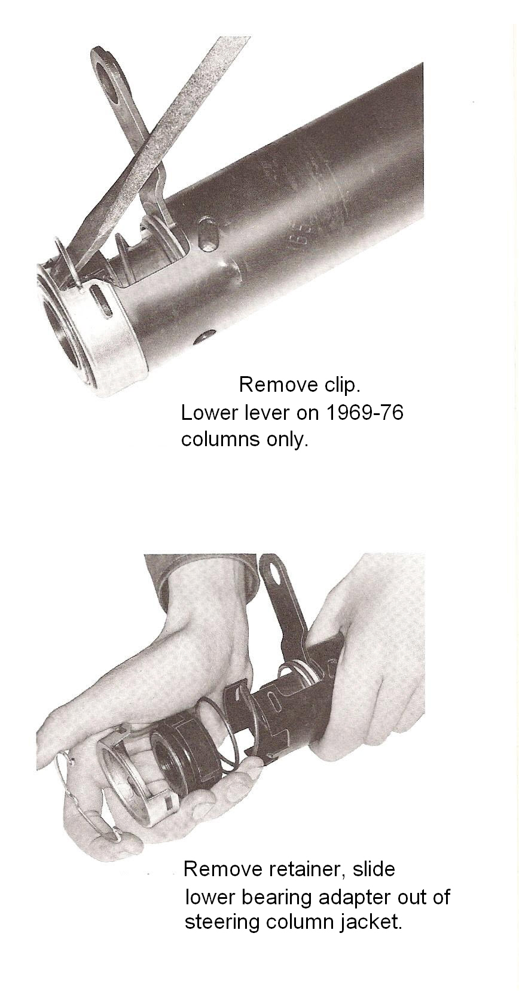

The above procedure is very straight forward and easy AS LONG AS THE PARTS ARE NOT ALL CORRODED TOGETHER. If you find a lot of corrosion on your lower column parts, it is a good idea to soak them in penetrating oil for a day or two before trying to remove them.

Reassembly – Lower Steering Column Bearing
Assemble the lower bearing to the plastic adapter. Align the tabs on the adapter to the cutout in the column mast jacket. Slide the bearing and adapter assembly up the steering column shaft and into the end of the column mast jacket. Install the lower bearing shield with the cutout in the shield aligned with the mast jacket cutout. Install the retainer clip.

Replace Lower Column Bearing (Continued)
The previous description on replacing the lower steering column bearing takes into account new old stock (NOS) bearings, plastic adapters, and corrosion free parts. Now that our cars are in the range of thirty to forty years old, NOS is most likely not available. Enterprising suppliers have found their own sources for bearings and possibly the plastic adapter has been retooled. Because of this fact, you may find that parts do not easily slide up the steering shaft nor do they easily snap together. The following are recent comments posted on the Corvette Forum with respect to assembly of the lower bearing.

Sometimes the corrosion on the shaft and bearing is so advanced that there is only the bearing race that remains and it is corroded onto the steering shaft. Take a Dremel type tool with an abrasive wheel and cut the bearing off. Polish up the shaft so that it will go together easier. Obtain a new bearing and plastic adapter as you will most likely destroy both when taking them apart.

Make sure that you assemble the new bearing in the correct orientation to the adapter. Apply some grease to the inside diameter of the adapter to aid in the assembly of the bearing to it.

Original bearings and plastic adapters were a light snap fit. You would hope that obtaining your replacement parts from the same source would result in parts that snap together fairly easily. However, today there may be a slight mismatch of parts and you may have to use a vise to force them together. If the press fit is too great, some people have cracked the plastic adapter when forcing them together. One method would be to freeze the bearing and warm up the adapter. This will greatly reduce the interference fit.

The next area of concern is the fit of the inner bearing race to the steering shaft. Clean up the corrosion on the shaft first. Some people have reported that the inside diameter of the bearing inner race has an o-ring. This could cause the bearing to have fairly high press on forces to the steering shaft. Apply some grease to the shaft and o-ring to aid in the assembly.

Other people have reported no o-ring inside the bearing but that it still needs to be hand forced up the shaft.

Still other people have reported a minor press fit to the shaft that requires the bearing and adapter to be lightly tapped to slide it up the shaft. Obtain a pipe with a one inch ID and tap the bearing so that the tapping force is directly on the inner race to get it up the shaft.

Reinstalling the Steering Column into the Vehicle
Move the lower column lever back to the up position. Carefully slide the column back through the dash hole. Insert the column flange onto the two flexible coupling bolts (the bolts are different sizes so the flange will only go on one way.) Tighten the nuts and lockwashers to 20 ft-lbs.

Reinstalling the Steering Column (Continued)
Reconnect the electrical connectors to the ignition switch, turn signal switch, dimmer switch, and cruise control (if so equipped).
Some people have reported that when they replaced their turn signal switch they found that the “harmonica” connector from the new switch would not snap correctly onto the vehicle wiring connector. The problem can easily be corrected by swapping your original connector onto wires from the new switch. Instructions were included earlier on page #3 to remove and reinstall the wires.
Snug but do not tighten the column in place with the two vertical screws up under the dash. Go back under the hood and loosely install the lower column plate with its stud and washer onto the dash panel. Also insert the carriage bolt into the plate, assemble the washer to the bolt, and assemble the plate, bolt, and washer to the dash panel. Now check the alignment of the flexible coupling pins in the column flange slots. They should be central. You may need to move the lower column and outside plate around in order to make the pins central. Then go back inside the car and reattach the nuts to the welded stud and carriage bolt and torque to 10 ft-lbs. Rotate the steering wheel 90 degrees and again visually check if the flexible coupling pins are central in the flange slots. Loosen the two plate fastener nuts and readjust the column as necessary. Torque the two vertical column screws to 15 ft-lbs.

Reattach the AC duct, the crossover bar, and plastic closeout panel under the steering column.

(If so equipped), place the lower column lever in the full UP position, reattach the transmission backdrive cable (manual transmission in Reverse, automatic in Park). Fasten the cable to the pin on the lower lever with the washer and cotter pin.

Refer to Disassembly & Repair Paper #1 for reinstalling the shaft lock, steering wheel and horn parts.

StdC3ColumnD&R2Rev09JA2010.doc
JIML82@aol.com

