Last Revision: 16JA2009

1967 (Late) - 1968 CORVETTE TELESCOPING STEERING COLUMN DISASSEMBLY & REPAIR INSTRUCTIONS
PAPER #2

Disassembly and Repair Instructions Addressed in this Paper
Degree of Difficulty Page

DROP OR REMOVE STEERING COLUMN FROM VEHICLE Moderate 2 & 3

REPLACE LOWER COLUMN BEARING Moderate 4 & 5

REMOVE UPPER TELE SHAFT FROM LOWER STRG SHAFT Moderate REMOVE UPPER TUBE & FLANGE FROM MAST JACKET Moderate

How the Paper is Setup
There are a limited number of telescoping steering column service procedures that are addressed in this paper. This paper starts at the point where the steering wheel and horn parts are already removed from the steering column. These operations were described in detail in 1967-68 Corvette Telescoping Steering Column Disassembly & Repair (D&R) Paper #1.

This paper includes drawings of the steering column installations for the two specific years. It also contains a corrected steering column blowup drawing.

Types of Steering Columns Addressed in this Paper
The 1967 Corvette telescoping steering column is included in this paper because it is so close in design to the 1968 C3 model. However, they will not interchange because they have different mounting patterns under the dash. So we are really looking at unique, one year only steering columns. Therefore, parts are very rare (and expensive.)

Please note that I believe that the instructions in the 1967 and/or 1968 Chevrolet Chassis Service Manuals are confusing at best. The 1967 manual does not reflect the revised lower bearing design that was introduced early during 1967 production. The 1968 manual confuses 1967 lower column attaching procedures with the new 1968 design.

The 1967-68 Corvette steering columns (and 1967, 68, 69 Corvair) were quite unique from the rest of the General Motors columns in that the steering column jackets were smaller in diameter than any other Saginaw steering columns (for just those years.) They are also unique in that they use virtually no parts from earlier years nor do they use any parts from the second generation, function locking steering columns that followed in 1969.

Specifically this paper covers the 1967 (Late) and 1968 Corvette standard steering columns that are quite similar to each other and use several common parts.

All part numbers in parenthasis ( ) refer to Strg Column Mounting Pics on page 3.
All part numbers beginning with # refer to the Steering Column Blowup on page 4.
The 1967 model year saw the introduction of the General Motors first generation, energy absorbing, collapsible steering columns. At the very start of production there was a recall where a very great number of the steering shafts and lower bearings were replaced. This is why we identify the steering shaft and lower bearing parts for the 1967 Corvette in this paper as being (Late) since all early parts should have been recalled and replaced.
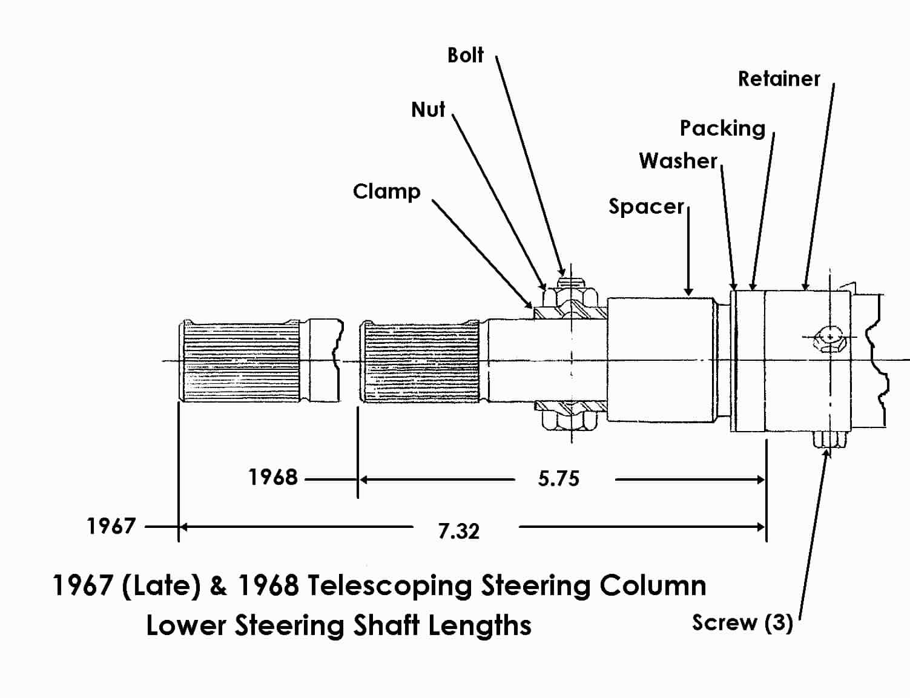
Instructions for Dropping and/or Removing the Steering Column
In order to replace the lower steering column bearing the steering column first must be removed from the car.

DISCONNECT THE BATTERY whenever you work on the steering column.

Helpful Hint: It will be most helpful to have an assistant out under the hood to help disengage parts.

Upper End
1967 – The steering column has two separate plastic covers and a collar called an escutcheon. The covers attach together with screws. Remove the covers and detach the escutcheon from the instrument cluster. (Picture included in Telescoping Strg Column D&R Paper #1, Page 3.)

1968 - Remove the fasteners and the four plastic covers that enclose the upper end of the steering column. Remove the four fasteners and the closeout panel that is underneath the column. (Picture included in Telescoping Strg Column D&R Paper #1, Page 4.)

1967-68 All
Detach air ducts, crossover bars, and any other dash components that prevent the steering column from dropping straight down from the instrument panel structure. Disconnect the steering column curved turn signal switch connector from the body harness.
Dropping and/or Removing the Steering Column (Continued)
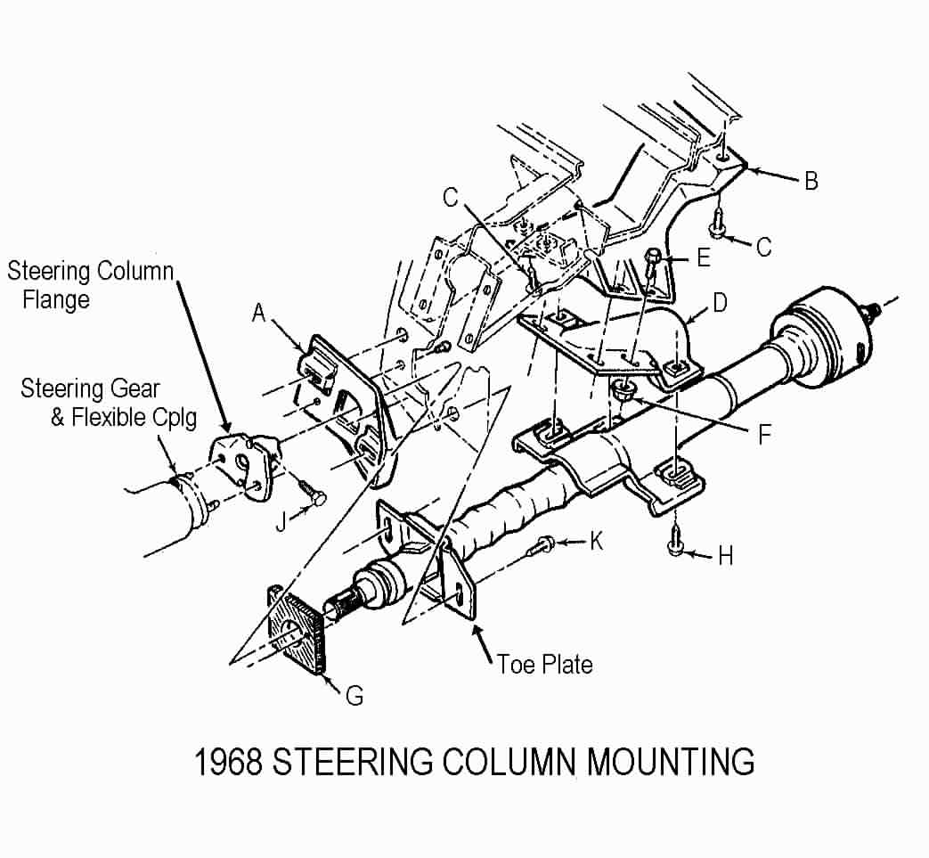
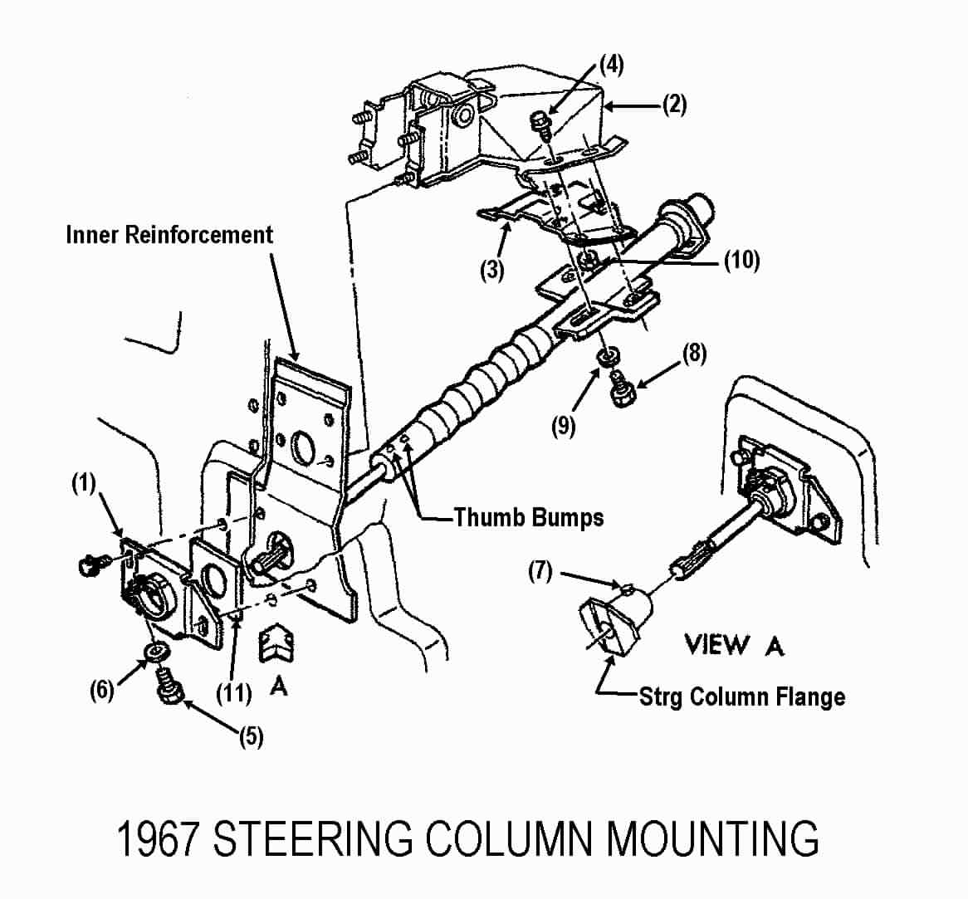
Lower End Mounting – 1967
Remove the clamp bolt (5) and washer (6) from the support assembly (1) on the engine compartment side of the lower dash panel. You should be able to pry the clamp open sufficiently to be able to clear the thumb bumps on the lower end of the steering column.

Use a crayon or piece of chalk to mark the orientation of the steering column shaft to the steering column flange.

Remove pinch bolt (7) from the steering column flange and spring the flange open with a large screwdriver.

Lower End Mounting – 1968
If you have a manual transmission, you may find a fairly heavy clutch pedal spring attached to support (A) and to the Z-bar. You should detach one end of the spring at this time. Hint! Detach the clutch pedal rod from the Z-bar. This will allow the Z-bar to rotate rearward and take some tension off the spring.

Use a crayon or piece of chalk to mark the orientation of the steering column shaft to the steering column flange. Remove pinch bolt (J) from the steering column flange. Spring the flange open with a large screwdriver. Go back inside the car and remove two screws (K).

Column Removal Procedures 1967-68
Note: The steering column flange is shown loose from the flexible coupling in both of the above mounting pictures. However, in order to remove the steering column from the car I do not think that it needs to be detached from the flexible coupling. For one thing I am quite sure that the steering column flange is too large to fit through the holes in support plates 1967 (1) or 1968 (A). Therefore my removal procedure detaches the steering column shaft directly from that flange (leaving the flange attached to the flexible coupling assembly.)

Unfasten the three vertical bolts & washers 1967 (8 & 9) or bolts 1968 (H) that hold the column up into the dash. NEVER just remove the three vertical main mounting bolts and let the column “hang” by the attachments at the flexible coupling and the plates and fasteners on the lower dash panel. Letting the column “hang” in that manner puts very high loads on the steering column jacket and the lower bearing.

Now pull the column straight back, disconnecting the column shaft from the steering column flange.
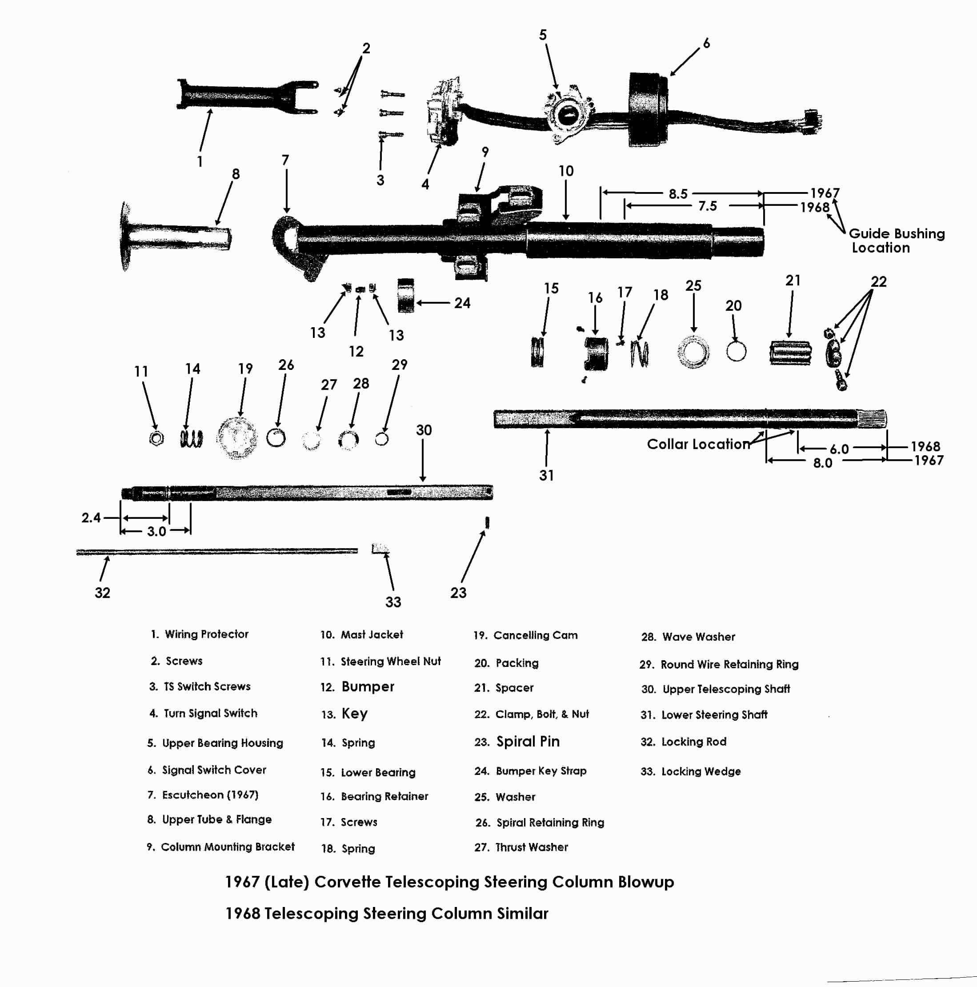

Remove Lower Bearing
Now that the steering column is out of the car, place it on a suitable workbench. Do not use a bench vise to clamp around the steering column jacket. It is actually quite fragile. Clamp on the heavy column mounting bracket. Do not clamp on the aluminum capsules. They are designed to “break away” from the mounting bracket in a severe frontal collision and allow the steering column to collapse.

The following bearing replacement procedure should be straight forward AS LONG AS THE PARTS ARE NOT ALL CORRODED TOGETHER. If you find a lot of corrosion on your lower column parts, it is a good idea to soak them in penetrating oil for a day or two before trying to remove them.

Unfasten and remove the bolt, nut, and clamp #19 from the steering shaft #20. Remove the spacer #21, packing seal #20, spring #18, and washer #25.

Remove Lower Bearing (Continued)
Remove three screws #17 and bearing retainer #16. Remove the bearing assembly #15. You will find that it is a light press fit into the mast jacket #10.

Referenced on the blowup picture is a plastic bushing that is further up inside the mast jacket. It should be a light press fit and located about 8.5 inches (1967) or 7.5 inches (1968) up into the mesh section from the lower end. It should have generous clearance to the steering shaft.

Alternative Method of Removing the Lower Bearing
Depending upon the condition of the lower bearing and the amount of corrosion on the lower end of the steering column you may consider this alternative method of replacing the lower bearing. Completely remove the steering shaft through the upper (steering wheel) end and then reach in behind the bearing and pull it out from the mast jacket.

In order to pass the steering shaft through the upper end, you must remove the signal switch cover, upper bearing housing, and turn signal switch. (Refer to D&R Paper #1, Page 4).

Unfasten and remove the bolt, nut, and clamp #19 from the steering shaft #20. Remove the spacer #21, packing seal #20, spring #18, and washer #25. Remove any rust or dirt deposits on the lower end of the steering shaft so it will more easily pass through the lower bearing. Pass the steering shaft up and through the upper end of the steering column jacket.

Remove three screws #17 and bearing retainer #16. Remove the bearing assembly #15. You will find that it is a light press fit into the mast jacket #10.

Referenced on the blowup picture is a plastic bushing that is further up inside the mast jacket. It should be a light press fit and located about 8.5/7.5 inches up into the mesh section from the lower end. It should have generous clearance to the steering shaft.

Replacing the Lower Bearing
The 1967 (late) and 1968 Corvette standard & telescoping steering columns use a lower bearing that is unique to just those two years. (Possibly the energy absorbing Corvair steering column (1967, 68, & 69) may use the same lower bearing as well.)

I have found the lower bearing at these two locations. Although you may want to consider the kit over the bearing alone (depending upon the condition of your parts.)

Corvette Steering Service www.corvettesteering.com (864)-287-9990
67 2nd design, all 68s Lower Bearing Kit includes 2 springs, flat washer, split washer/wedge. No part number provided on websight.

Doc Rebuild www.docrebuild.com 1-800-866-9362
67Late-68 Lower Shaft Bearing #6521138

Steering Shaft Check
The steering shaft assembly consists of two telescoping shafts. A solid upper shaft where the steering wheel hub attaches and a tubular lower shaft where the steering column flange attaches. They are locked together by tightening the “star” screw #4 shown in the steering wheel drawing on Page 2 of Telescoping D&R Paper #1. The end of the star screw pushes on locking rod #32 which cocks the small locking wedge #33 and securely locks the two steering shafts together.

With respect to pulling the steering shafts apart, you will probably find that they only extend so far but then abruptly will not pull apart any further. You will note that there are a pair of small holes in the lower tubular shaft about ¾ of the way up the shaft from the lower end. These holes provide access to a small spiral pin #23 that is a press fit in the upper shaft. Use a small punch from one side to drive the pin out through the hole in the opposite side.
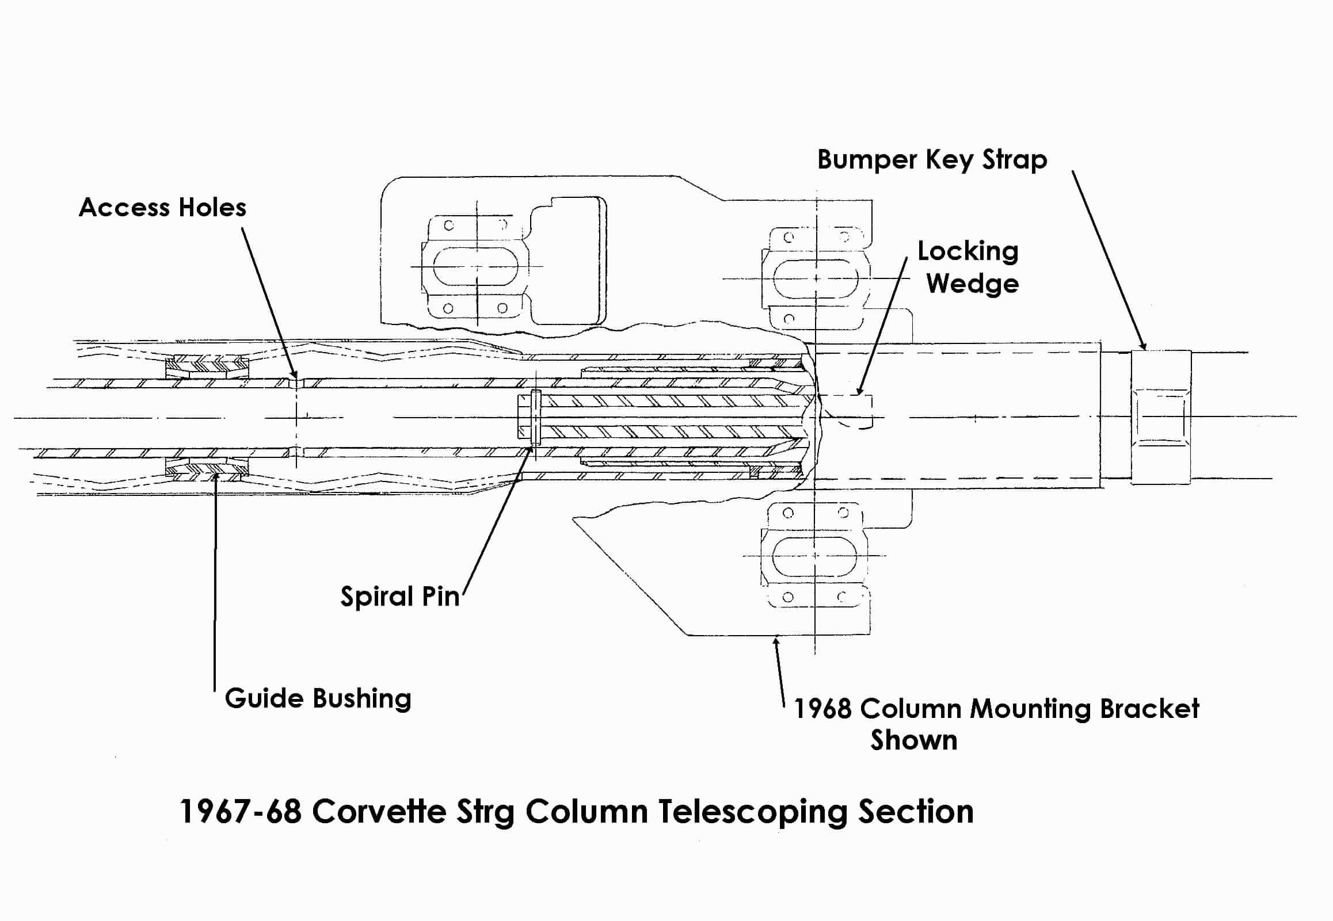
Now is a good time to check that the index (or chisel) mark on the very end of the upper shaft is aligned with the notch that is machined across the splines on the lower shaft.
This will insure that the steering wheel ends up oriented correctly and not upside down.
The upper tube and flange #8 is a matched fit to the mast jacket assembly #10. So the two parts are not serviceable. If you want to disassemble them in order to add grease to the sliding area, here are the instructions.

The key bumper strap #24 retains a rubber bumper #12 and two metal keys #13 in a slot in the mast jacket. You must pry open the bent over portion of the strap as shown in the accompanying pictures. The bumper and keys can then be removed and the upper tube flange assembly will then slide out of the mast jacket.
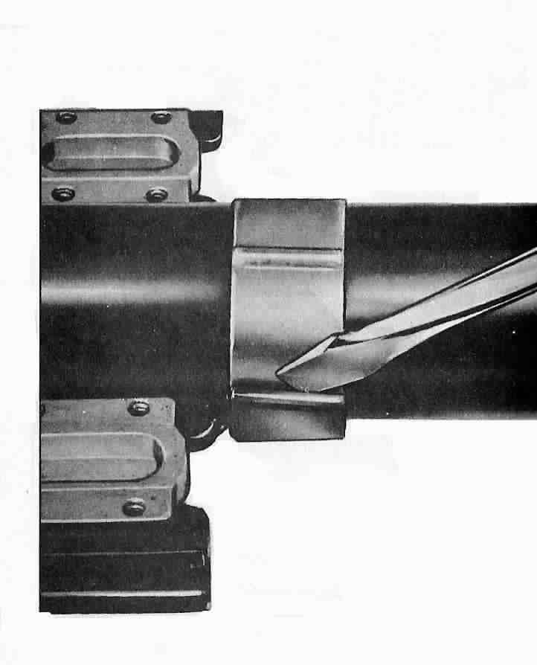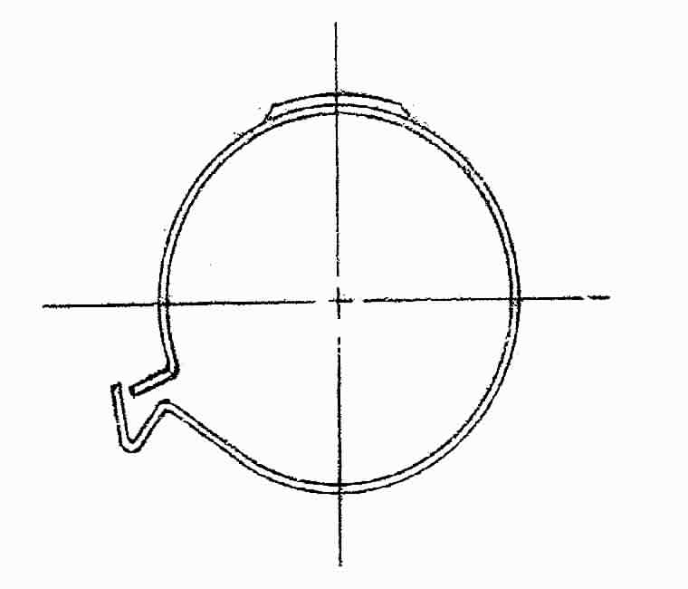

Reassembly – Lower Steering Column Bearing & Steering Shaft
Apply a thin coating of a good lithium based chassis grease to all friction surfaces as you reassemble the column parts.

Lightly tap the bearing assembly into the lower end of the jacket. It is a press fit. Assemble retainer #16 and secure it with three screws #17 torque to 25 inch-lbs.

Carefully slide the steering shaft assembly back into the jacket from the steering wheel end and through the lower bearing.

Assemble the washer spring #18, washer #25, packing #20, spacer #21, and clamp, bolt, & nut #22 on the end of the steering shaft. Loosely tighten the nut to hold the parts in place.

Reassembly - Steering Column Upper End
1967 only - Feed the turn signal switch wires through the escutcheon #7.

1967 & 68 - Place the upper bearing housing, turn signal switch, and cover onto the steering column jacket. Attach them to upper tube & flange #8 with three screws #3. Torque to 35 inch-lbs.

Slide the wave washer #28, thrust washer #27, and the spiral retaining ring #26 loosely onto the steering shaft. Install the retaining ring making sure that it is fully seated in the groove in the steering shaft.

Secure the turn signal lever with its screw. Screw the hazard warning knob in place. Install the canceling cam #19 and the upper bearing preload spring #14 on the steering shaft.

Pull the turn signal wires flat against the bottom of the steering column. Snap the metal wiring protector #1 in place over the wires and secure with two screws #2. Torque to 23 inch-lbs.

Steering Column Installation
This paper assumes that the steering column was correctly installed and positioned into the car previous to it being removed for repair. Therefore the 1967 support plate (3) and 1968 bracket (B) and support plate (D) do not have to be repositioned to correctly locate the steering column. Steering column to instrument cluster gapping procedures can be found in the AIM or other chassis service manuals if needed.

It is best to have someone positioned out under the hood to assist in aligning and installing the steering column shaft into the flexible coupling on the gear.

Steering Column Installation – 1967
If previously remove, loosely secure the seal (11) and support plate (1) to the engine side of the dash panel with two screws. Otherwise loosen the two screws that hold the support plate to the dash.

Feed the lower end of the steering column through the dash. Make sure that the clamp part of the support assembly is between the two thumb bumps on the lower end of the steering column jacket. Insert the steering shaft into the flange on the flexible coupling assembly. Make sure that you align the paint or chalk marks on the flange and steering column shaft for correct orientation of the parts. Loosely install the pinch bolt (7) into the flange.

Allow the dash panel attachment to float as you secure the steering column into the dash with the vertical three bolts (8) and washers (9) (20 ft-lbs).

Connect the curved turn signal switch connector to vehicle body harness.

Secure the seal and support assembly to the dash panel on the engine compartment side by tightening the two screws (13 ft-lbs).

Tighten the bolt and washer to clamp the lower end of the steering column to the support assembly (13 ft-lbs).

Tighten the pinch bolt (30 ft-lbs) on the steering column flange that is part of the flexible coupling assembly.

Steering Column Installation – 1967 (Continued)
Now check that the flexible coupling stop pins are central in the column flange slots. Turn the steering wheel one quarter turn and recheck the pin to flange centrality. If the pins are not central, you must loosen the support assembly to dash panel and the three vertical column bolts to allow the column to seek a position that is not binding. Recheck stop pin to flange slot centrality at both steering wheel positions.

Reattach the AC duct and the crossover bar under the steering column.

Slide the escutcheon into position on the instrument cluster and secure with screws.

Steering Column Installation - 1968
Install gasket (G) into toe plate on the steering column.

Hold support assembly (A) to dash panel on the engine side of the dash panel. Carefully insert the steering column through the hole in the dash panel and the support assembly.

Insert the steering shaft into the flange on the flexible coupling assembly. Make sure that you align the paint or chalk marks on the flange and steering column shaft for correct orientation of the parts. Loosely install the pinch bolt (J) into the column flange.

Loosely install bolts (K) through the steering column toe plate and thread them into the floating nuts that are part of the support assembly.

Reconnect the electrical connector to the turn signal switch.

Allow the support assembly to float as you secure the steering column into the dash with the vertical three bolts (H) (20 ft-lbs). Secure the support assembly to the dash panel by tightening the two screws (K) (13 ft-lbs) inside the car.

Tighten the pinch bolt (J) on the flexible coupling flange (30 ft-lbs).

Now check that the flexible coupling stop pins are central in the column flange slots. Turn the steering wheel one quarter turn and recheck the pin to flange centrality. If the pins are not central, you must loosen the support assembly to dash panel and the three vertical column bolts to allow the column to seek a position that is not binding. Recheck stop pin to flange slot centrality at both steering wheel positions.

Reattach the AC duct, the crossover bar, and plastic closeout panel under the steering column.

1967-68 All
Refer to Disassembly & Repair Paper #1 for reinstalling the turn signal switch, bearing housing, and cover unit as well as steering column covers, steering wheel, and horn parts.

67-68CorvetteStdColumnD&R#2Rev16JA2009
JIML82@aol.com

