Last Revision: 27DE2008

1967 and 1968 CORVETTE STANDARD (NON-ADJUSTABLE) STEERING COLUMN DISASSEMBLY & REPAIR INSTRUCTIONS

PAPER #1
Disassembly and Repair Instructions Addressed in this Paper

Difficulty Page
REMOVE STRG WHEEL AND HORN PARTS Easy 2
REMOVE TURN SIGNAL LEVER Easy 2
REPLACE THE TURN SIGNAL SWITCH Moderate 3 & 4
REPLACE OR REPAIR UPPER COLUMN BEARING Moderate 5

How the Paper is Setup
This is the first of two papers that address various replacement and repair procedures that can be performed on 1967-1968 Corvette first generation, energy absorbing, standard (non-adjustable) steering columns. All of the service procedures outlined in this paper should be fairly easy and accomplished without removing the steering column from the car. Disassembly & Repair (D&R) Paper #2 addresses removing the steering column from the car, replacing the lower bearing, and checking the steering shaft length.

There are errors in the 1967 and 1968 Chevrolet Chassis Repair Manuals where they show a steering column blowup drawing. There is a round wire retaining ring that is not called out. It is installed in a groove on the Corvette standard steering shaft and is located 3.4 inches from the steering wheel end of the shaft. That ring is GM #5694191 and is available through GM dealers, numerous Corvette suppliers, or at salvage yards. I have added the ring to the drawing. Also the lower bearing package for the 67 (Late) and 68 columns has an additional spring, spring seat, and washer that are not shown in the Repair Manual drawings. I have added notation for them as well.

1967 and 1968 Steering Columns
Even though the 1968 Corvette had an all new exterior and interior, the chassis remained the same as the 1967 model. For these reasons the 1967 Corvette standard steering column is similar but not identical to the 1968 Corvette column. The large mounting bracket (with the three aluminum mounting capsules) is welded in place and is quite different between the two years. Therefore, the columns will not interchange.

It is not necessary to remove the steering column from the vehicle in order to work on the components in the upper end. Such things as the steering wheel, horn parts, turn signal switch, and the die cast housing that retains the upper steering shaft bearing can all be removed and serviced in-car and are covered in this D&R Paper #1.

A Word of Caution Before Beginning Work On Your Steering Column
DISCONNECT THE BATTERY.

Remove the Steering Wheel and Hub

Carefully reach under the horn button cap assembly #1 with a small screwdriver and pry the cap from the horn contact #14. Most 1967-68 cap assemblies consist of three pieces that are all staked together. At this time, you might want to check the underside of the cap assembly to make sure that the three stakes are secure. You may even want to add some JB Weld to the stakes for insurance.

Remove the six screws #3 from the steering wheel #4 and remove the wheel from the hub assembly #7. Remove the three screws #2 and the horn contact #14.

Remove the steering wheel nut #5 and the hub washer #6. Now you should be able to see a small indentation on the steering wheel hub assembly and a similar indentation on the very end of the steering column shaft. The two marks should be aligned. These marks will allow the hub to be properly indexed to the spines on the column shaft when you reassemble them. If you can’t find the markings, use a crayon or chalk to make your own marks on the steering wheel hub and the end of the steering column shaft.

Next, using a steering wheel puller, remove the hub. Make sure that your puller and bolts are square to the hub as you turn the large bolt and apply force. Never hammer on the end of the steering shaft.

You can now remove the large spring #8 and the canceling cam #12. There should be a spring loaded plunger (called eyelet #10) that protrudes from the tower on the canceling cam. You should be able to freely depress the eyelet against the small spring #11 inside the tower. Insulator #9 holds them in place. It can now be removed to access the eyelet and spring if these parts are to be inspected or replaced.
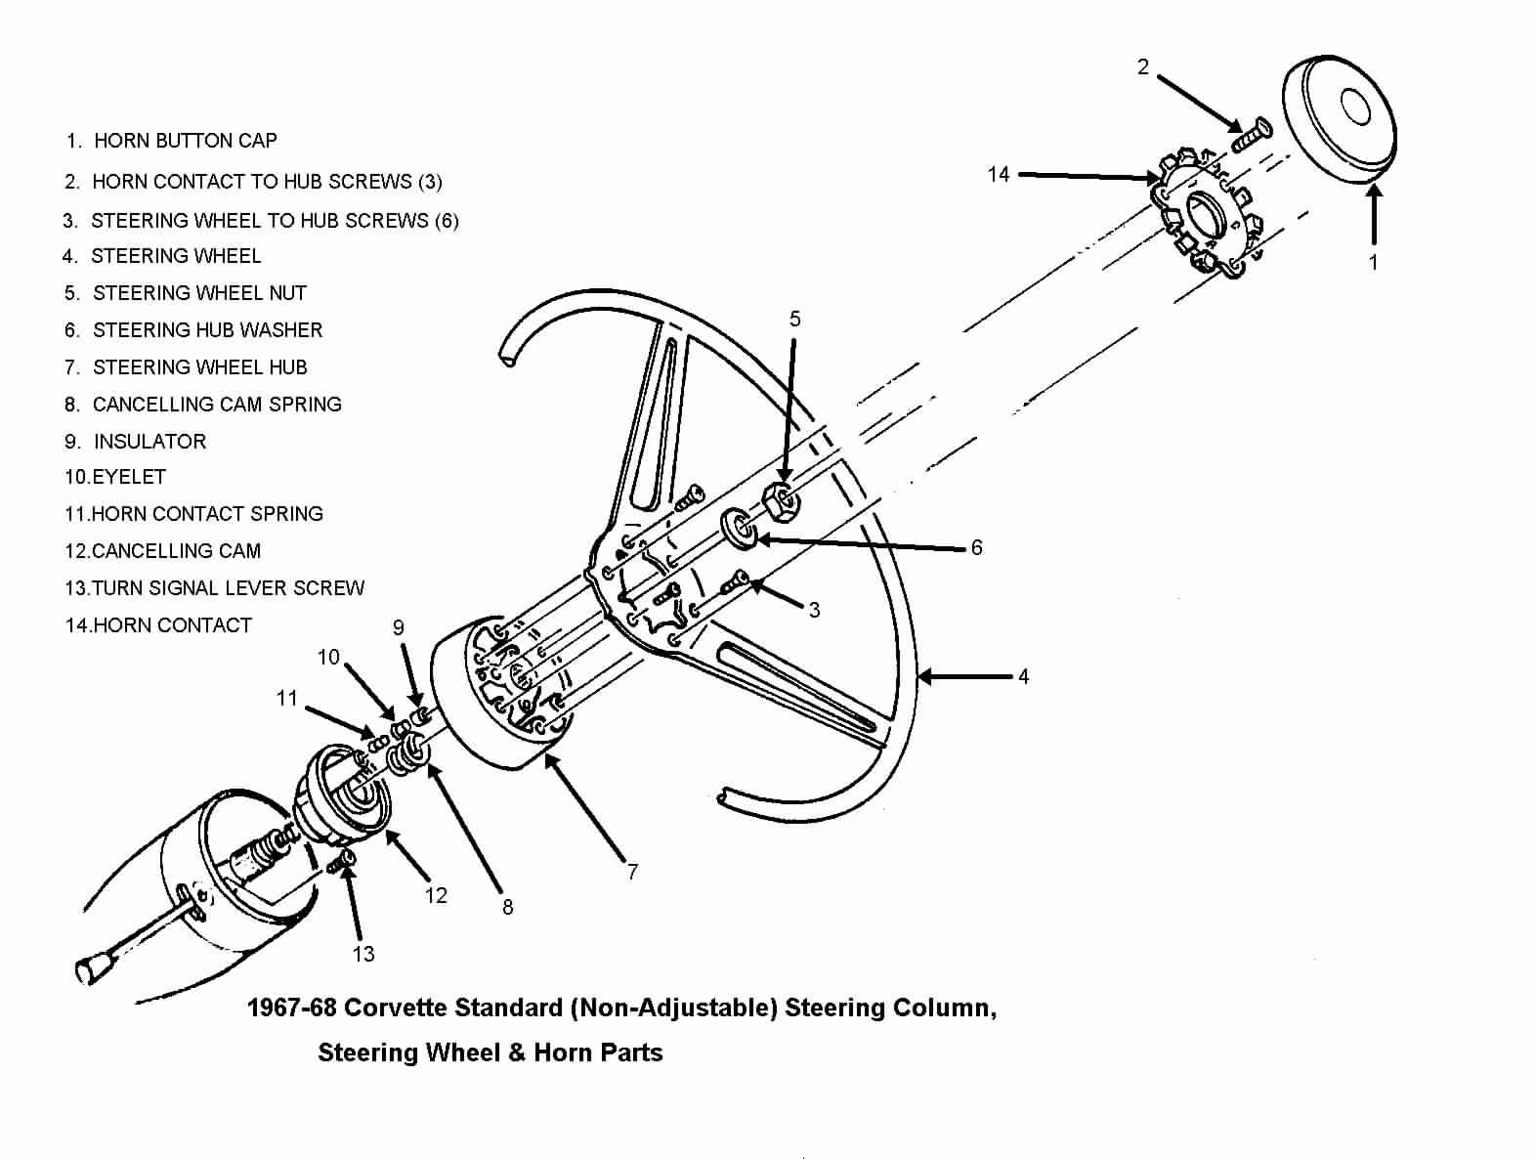
Removing Turn Signal Lever
You can now access the screw #13 that retains the turn signal lever to the turn signal switch. You now have full access to the turn signal switch.

Note: All part numbers on this and subsequent pages refer to parts shown on the 1967 (Late) Steering Column Blowup at end of this paper.

1967 Only - Gaining Access to Remove the Turn Signal Switch & Wires
Go down under the dash and disconnect the curved turn signal switch connector from the vehicle body harness. The 1967 steering column has a part called an escutcheon installed on the steering column jacket. It serves to close the gap between the instrument cluster and the steering column.

Detach the two plastic covers from the column head by removing two screws. Remove the two screws that attach the escutcheon to the dash panel.

If your goal is to remove the steering column from the car, it is suggested that you skip to D&R paper #2 before removing further parts.

Pull the escutcheon up toward the steering wheel. You will now have access to remove the metal wiring trough #4 by prying it loose with a screwdriver.

The turn signal switch wires pass through a narrow gap between the escutcheon and the column jacket. However, you will find that the curved plastic connector on the end of the wires is too large to pass through the gap.
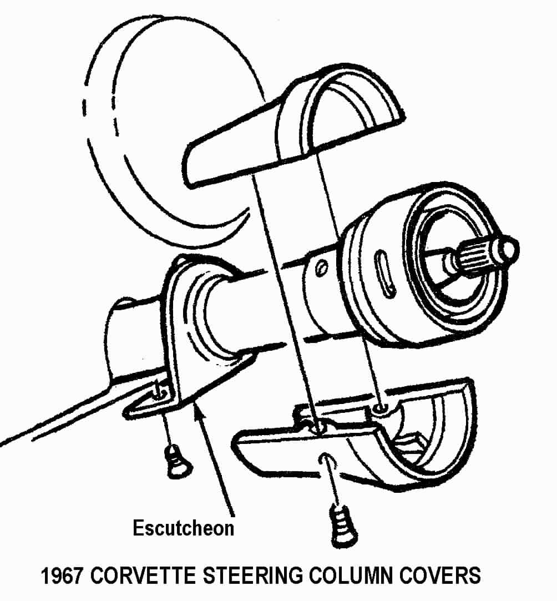

So if you need to remove or replace the turn signal switch, you have two alternatives.
You can remove the entire column head (along with the wires and escutcheon). Another alternative is to remove the connector from the wires and just pull the wires through the escutcheon. Make sure that you make note of the wire positions before you remove them.

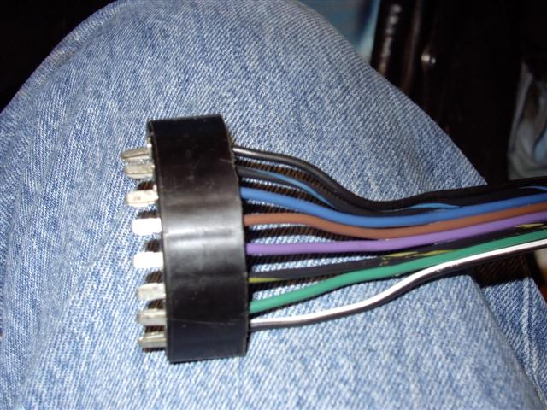
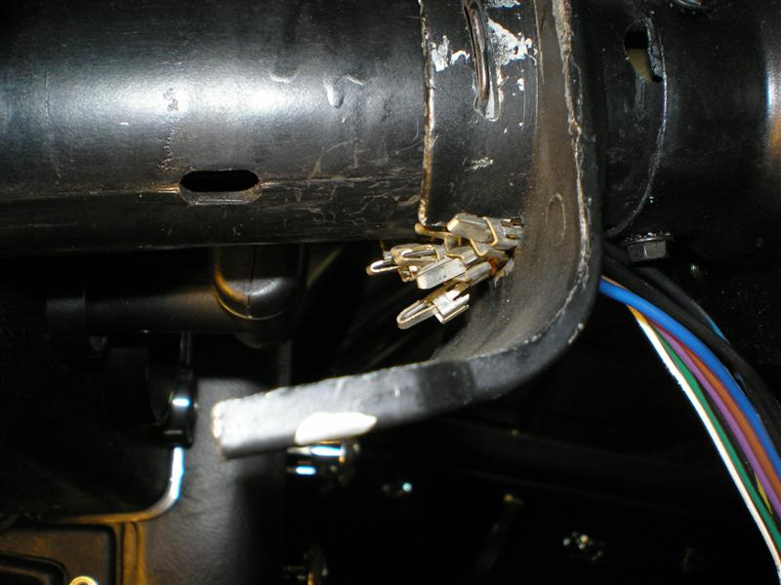

Straighten a heavy paper clip or use a very thin blade screwdriver. Insert it into the connector from the contact side to disengage each wire and contact. Once you pop the wire and contact out of the connector, you should take a small knife blade and bend the tang back out so that it will engage the connector correctly upon reinstallation.

Feed the individual wires through the escutcheon a few at a time.

1968 Only - Gaining Access Remove Turn Signal Switch & Wires
Go down under the dash and disconnect the curved turn signal switch connector from the body harness. In order to gain access to metal trough #4 that protects the wiring you will

need to remove the covers and closeout panel that surrounds the steering column. Remove the fasteners and the four plastic covers that enclose the upper end of the steering column. Remove the four fasteners and the closeout panel that is underneath the column.

If your goal is to remove the steering column from the car and/or replace the lower bearing, it is suggested that you skip to D&R paper #2 before removing further parts.

Use a screwdriver to unsnap the metal turn signal wiring protector #4 from the steering column jacket. The wires are now free to easily pass up and through upper flange #1 and the signal switch cover #9.
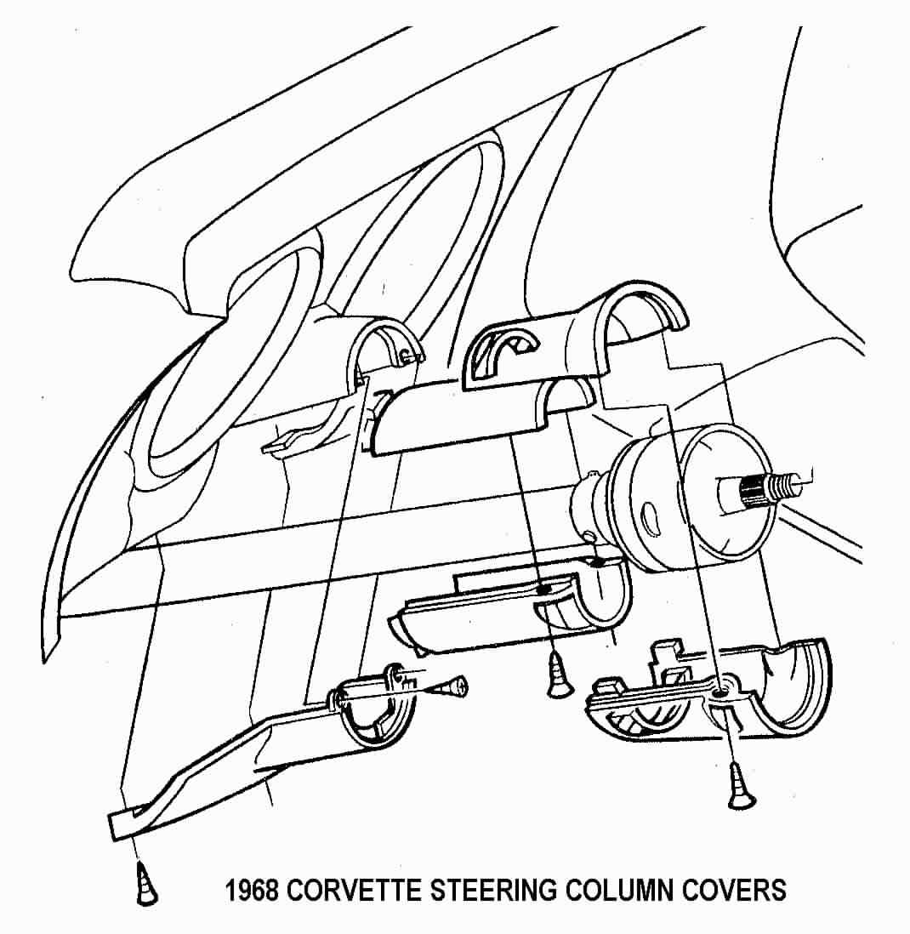

ALL - Removing the Turn Signal Switch Only
Push in the hazard warning knob and remove the knob and screw. Remove three turn signal switch screws #6. You may need to place the turn signal switch in a “right or left turn” position to have better access to the screws. Pull the switch and wires straight out of the switch cover #9.

ALL - Remove Turn Signal Switch, Bearing Housing, and Switch Cover as a Unit
Push in the hazard warning knob and remove the knob and screw.

Remove the retaining ring #13, the thrust washer #14, and the wave washer #15 from the steering shaft.

Remove the three upper flange mounting bolts #2. You can now slide the entire upper end assembly (consisting of the upper flange #1, signal switch cover #9, upper bearing housing #8, and turn signal switch #7) off of the steering column. On the 1967 column the escutcheon will come off of the steering column mast jacket along with the upper end assembly and its turn signal switch wires. (You will not need to remove the wires from the plastic connector.)

Remove the three turn signal switch screws #6. You may need to place the turn signal switch in a “right or left turn” position to have better access to the screws.

Replace or Repair Upper Column Bearing
The bearing that is part of housing #8 was not designed to be serviced. It was a press fit into the housing and there was a thin lip on the housing bore that was staked or spun over to retain the bearing. The bearing has been known to come loose. If this is the problem that you are correcting, you can try to epoxy glue the bearing case into the housing bore. You can also attempt to carefully peen limited areas of the case over on the bearing.

You can also purchase a bearing or bearing housing assembly from suppliers such as:

Corvette Steering Service
www.corvettesteering.com
(864)-287-9990
The bearing and bearing housing are shown as being available but no part numbers are provided on the websight.

Doc Rebuild
www.docrebuild.com
1-800-866-9362
67-68 Upper Bearing Only 6521108
67-68 Upper Bearing Housing (Used) 6521145

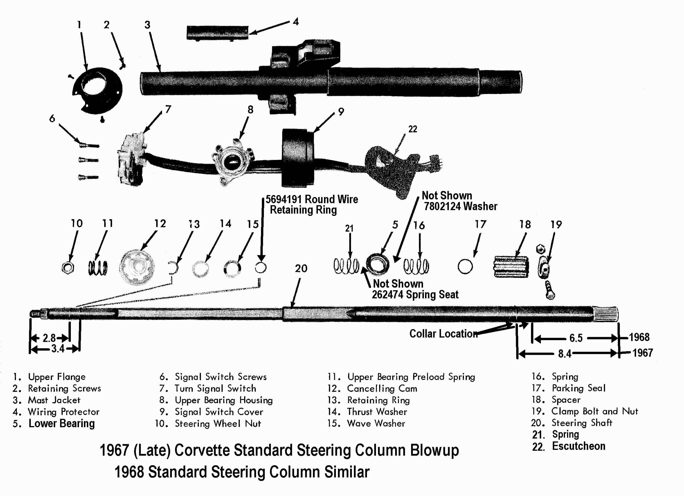

Turn Signal Switch, & Bearing Housing Reassembly
Assemble the upper bearing housing #8 and turn signal switch #7 into the cover #9 and attach to flange #1. Secure parts together with three screws #6 tighten to 30 inch-lbs.

1967 Only – Assemble escutcheon #22 to turn signal switch wires. Assemble escutcheon to mast jacket #3.

Assemble cover and flange assembly over steering shaft #20 and onto mast jacket #3. Attach flange to the mast jacket with three screws #2 tighten to 24 inch-lbs.

Slide wave washer #15, thrust washer #14, and retaining ring #13 onto steering shaft. Press parts together and seat retaining ring into groove in steering shaft. Make sure that the retaining ring is fully seated.

Place the turn signal lever into the slot in the turn signal switch. Assemble with screw and tighten to 20 inch-lbs. Screw hazard warning knob in place, torque to 4 inch-lbs.

Pull signal switch wires flat to mast jacket and assemble metal wiring protector trough to jacket. Connect the curved turn signal switch connector to vehicle body harness.

Reassemble Covers, Canceling Cam, Hub, Steering Wheel, and Horn Cap
Assemble plastic covers and escutcheon (1967) or covers and closeout panel (1968).

Assemble the canceling cam #12, the large spring #11, and the hub #7 on the steering shaft. The horn tower on the canceling cam (with the eyelet, spring, and retainer) fits through the hole in the hub. Align the mark on the hub to the mark on the end of the steering shaft. Assemble washer #6 and steering hub nut #5. Torque nut to 35 ft-lbs.

Attach the steering wheel to the hub with six screws #3. Torque to 20 inch-lbs. The 6 o’clock spoke on the steering wheel should be opposite the mark on the end of the steering shaft.

Attach the horn contact #14 to the hub with three screws #2. Torque to 19 inch-lbs. Make sure that the eyelet plunger #10 sticking up through the hub touches the horn contact.

Snap the horn button cap #1 into horn contact.

Connect the car battery.

JIML82@aol.com
67-68StdColumnD&R#1Rev27DE2008

