Last Revision: 06DE2008

1967 and 1968 CORVETTE STANDARD (NON-ADJUSTABLE) STEERING COLUMN DISASSEMBLY & REPAIR INSTRUCTIONS

PAPER #1
Disassembly and Repair Instructions Addressed in this Paper

Difficulty Page
REMOVE STRG WHEEL AND HORN PARTS Easy 2
REMOVE TURN SIGNAL LEVER Easy 2
REPLACE THE TURN SIGNAL SWITCH Moderate 3 & 4
REPLACE OR REPAIR UPPER COLUMN BEARING Moderate 5 & 6

How the Paper is Setup
This is the first of two papers that address various replacement and repair procedures that can be performed on the 1967-1968 Corvette first generation, energy absorbing, standard (non-adjustable) steering column. The first pages of each paper concern the disassembly and replacement procedures. All of the service procedures outlined in this paper should be fairly easy. The second Disassembly & Repair (D&R) paper addresses removing the steering column from the car and somewhat more difficult service procedures.

There is a steering wheel & horn parts drawing and a steering column blowup picture included with this paper. There are errors in the Chevrolet Chassis Repair Manual steering column blowup drawing. There is a round wire ring installed in a groove on the steering shaft that is located 3.4 inches from the steering wheel end of the shaft. That ring is GM #5694191 and is available through GM dealers, numerous Corvette suppliers, or at salvage yards. I have added the ring to the drawing. Also the lower bearing package for the 67 (Late) and 68 columns has an additional spring, spring seat, and washer that were not shown in the Repair Manual drawing. I have added them.

1967 and 1968 Steering Columns
Even though the 1968 Corvette had an all new exterior and interior, the chassis remained the same as the 1967 model. For these reasons the 1967 Corvette standard steering column is similar but not identical to the 1968 Corvette column. The large mounting bracket (with the three aluminum mounting capsules) is welded in place and is quite different between the two years. Therefore, the columns will not interchange.

It is not necessary to remove the steering column from the vehicle in order to work on the components in the upper end. Such things as the steering wheel, horn parts, turn signal switch, and the die cast housing that retains the upper steering shaft bearing can all be removed and serviced in-car.

A Word of Caution Before Beginning Work On Your Steering Column
DISCONNECT THE BATTERY.

Remove the Steering Wheel and Hub
Note: All part numbers referenced on this page relate to the steering wheel drawing on this page.

Carefully reach under the horn button cap assembly #1 with a small screwdriver and pry the cap from the horn contact. Most 1967-68 cap assemblies consist of three pieces that are all staked together. At this time, you might want to check that the three stakes are secure. You may even want to add some JB Weld to the stakes for insurance.

Remove the six screws #3 from the steering wheel #4 and remove the wheel from the hub assembly #7. Remove the three screws #2 and the horn contact #14.

Remove the steering wheel nut #5 and the hub washer #6. Now you should be able to see a small indentation on the steering wheel hub assembly and a similar indentation on the very end of the steering column shaft. The two marks should be aligned. These marks will allow the hub to be indexed properly when you reassemble it to the column shaft. If you can’t find the markings, use a crayon or chalk to make your own marks on the steering wheel hub and the end of the steering column shaft.

Next, using a steering wheel puller, remove the hub. Make sure that your puller and bolts are square to the hub as you turn the large bolt and apply force.

You can now remove the large spring #8 and the canceling cam #12. There should be a spring loaded plunger (called an eyelet) that protrudes from the tower on the canceling cam. You should be able to freely depress the eyelet against the small spring inside the tower. The spring #11, eyelet #10, and insulator #9 can now be removed if these parts are to be inspected or replaced.
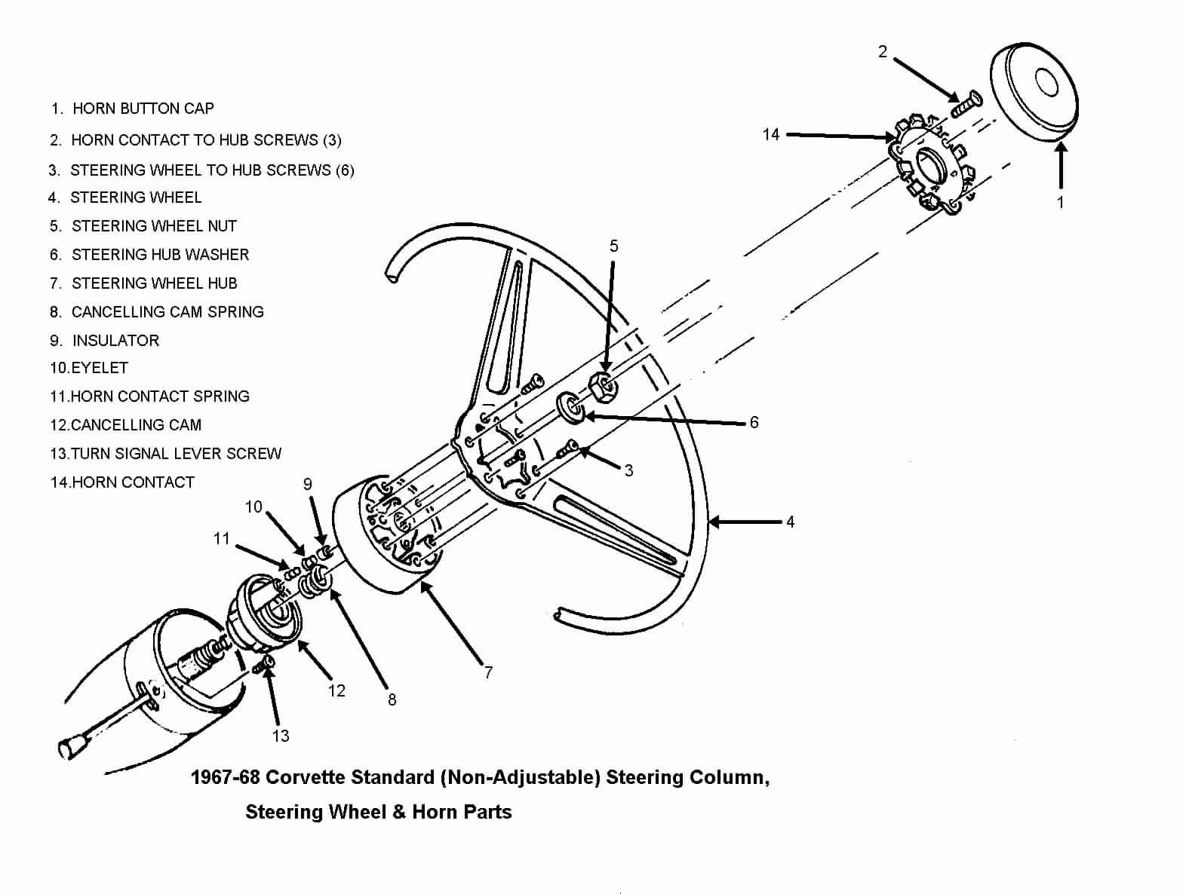
Removing Turn Signal Lever
You can now access the screw #13 that retains the turn signal lever to the turn signal switch. You now have full access to the turn signal switch.

Note: All part numbers on this and subsequent pages refer to parts shown on the 1967 (Late) Steering Column Blowup at end of this paper.

Gaining Access to Remove the Turn Signal Switch & Wires - 1967
The 1967 steering column was shipped to the St. Louis Assembly Plant with a part called an escutcheon already installed on the steering column. It served to close the gap between the instrument cluster and the steering column jacket.

Detach the two plastic covers from the column head by removing two screws. Remove the two screws that attach the escutcheon to the dash panel. Pull the escutcheon up toward the steering wheel. You will now have access to remove the metal wiring trough #4 by prying it loose with a screwdriver.

The turn signal switch wires pass through a narrow gap between the escutcheon and the column jacket. However, you will find that the curved plastic connector on the end of the wires is too large to pass through the gap.
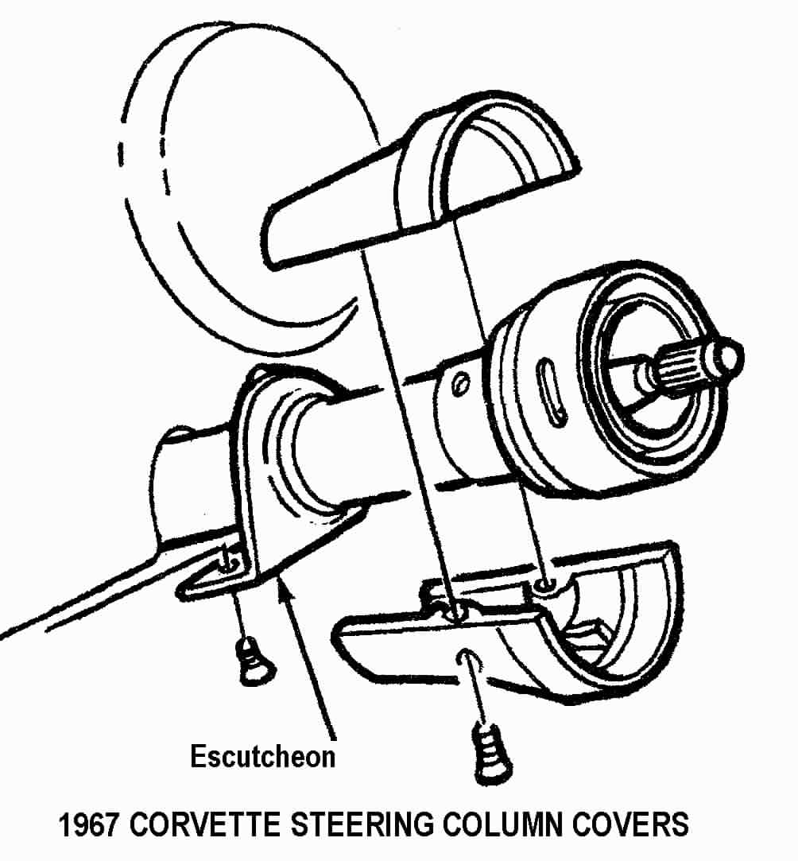

So if you need to remove or replace the turn signal switch, you have two alternatives.
You can remove the entire column head (along with the wires and escutcheon). Another alternative is to remove the connector from the wires and just pull the wires through the escutcheon. Make sure that you make note of the wire positions before you remove them so that when they are reassembled, all your lights, horn, and buzzers will work correctly.

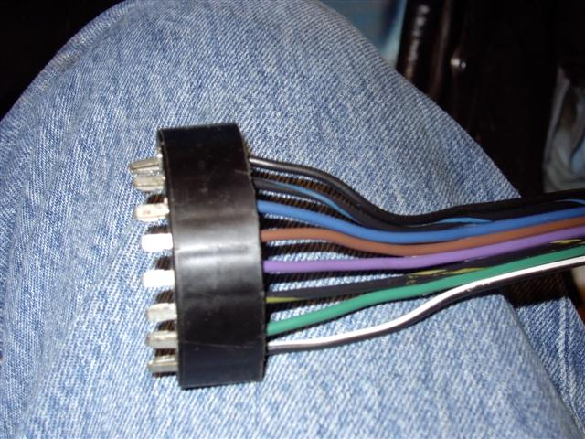
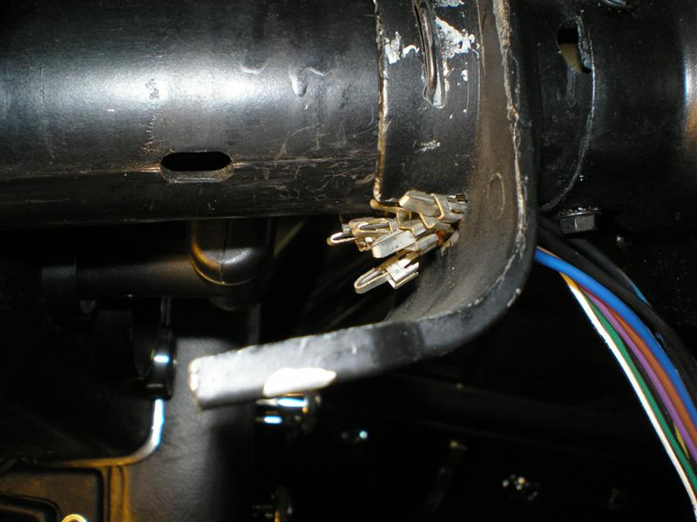

Straighten a heavy paper clip or use a very thin blade screwdriver. Insert it into the connector from the contact side to disengage each wire and contact. Once you pop the wire and contact out of the connector, you should take a small knife blade and bend the tang back out so that it will engage the connector correctly upon reinstallation.

You will now be able to feed the individual wires through the escutcheon a few at a time as you pull the turn signal switch.

Gaining Access Remove Turn Signal Switch & Wires - 1968
Go down under the dash and disconnect the curved turn signal switch connector from the body harness.

In order to gain access to the connector and to the metal trough that protects the wiring you will have to remove the covers and closeout panel that surrounds the steering column. Remove the fasteners and the four plastic covers that enclose the upper end of the steering column. Remove the four fasteners and the closeout panel that is underneath the column. Use a screwdriver to unsnap the metal turn signal wiring protector #4 from the steering column jacket. The wires should now easily pass up and through upper flange #1 and the signal switch cover #9.

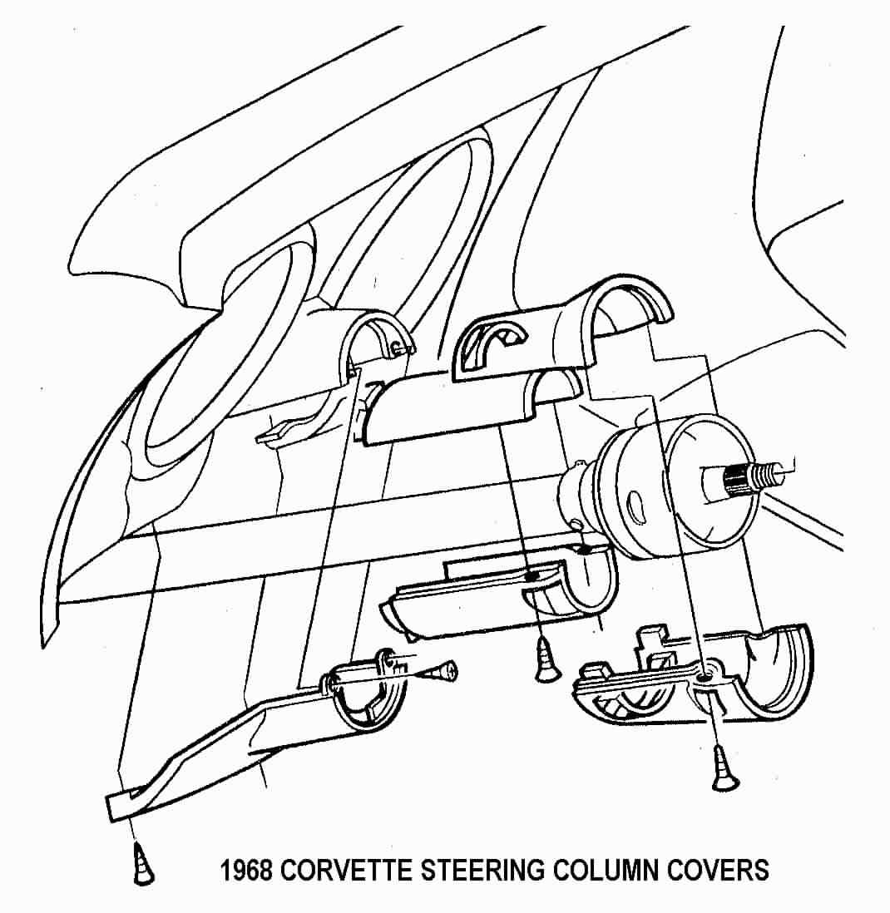

Removing the Turn Signal Switch Only
Push in the hazard warning knob and remove the knob and screw. Remove three turn signal switch screws #6. You may need to place the turn signal switch in a “right or left turn” position to have better access to the screws. Pull the switch and wires straight out of the switch cover #9 using the techniques described above.

Remove Turn Signal Switch, Bearing Housing, and Switch Cover as a Unit
Push in the hazard warning knob and remove the knob and screw. Remove the retaining ring #13, the thrust washer #14, and the wave washer #15. Remove the three upper flange mounting bolts #2. You can now slide the entire upper end assembly consisting of the upper flange #1, signal switch cover #9, upper bearing housing #8, and turn signal switch #7 off of the steering column. Note, on the 1968 column the escutcheon will come off of the steering column jacket along with the turn signal switch wires.

Remove the three turn signal switch screws #6. You may need to place the turn signal switch in a “right or left turn” position to have better access to the screws.

Replace or Repair Upper Column Bearing
The bearing that is part of housing #8 was not designed to be serviced. It was a press fit into the housing and there was a thin lip on the housing bore that was spun over to retain the bearing. The bearing has been known to come loose. If this is the problem that you are correcting, you can try to epoxy glue the bearing case into the housing bore. Just make sure that you don’t get the glue in the bearing parts. You can also attempt to carefully peen the case over on the bearing.

Replace or Repair Upper Column Bearing (Continued)
Otherwise you can purchase a bearing or bearing housing assembly from suppliers such as:
Corvette Steering Service www.corvettesteering.com Part is shown as being available but no part numbers provided on websight.

Doc Rebuild www.docrebuild.com
67-68 Upper Bearing Only 6521108
67-68 Upper Bearing Housing Used 6521145

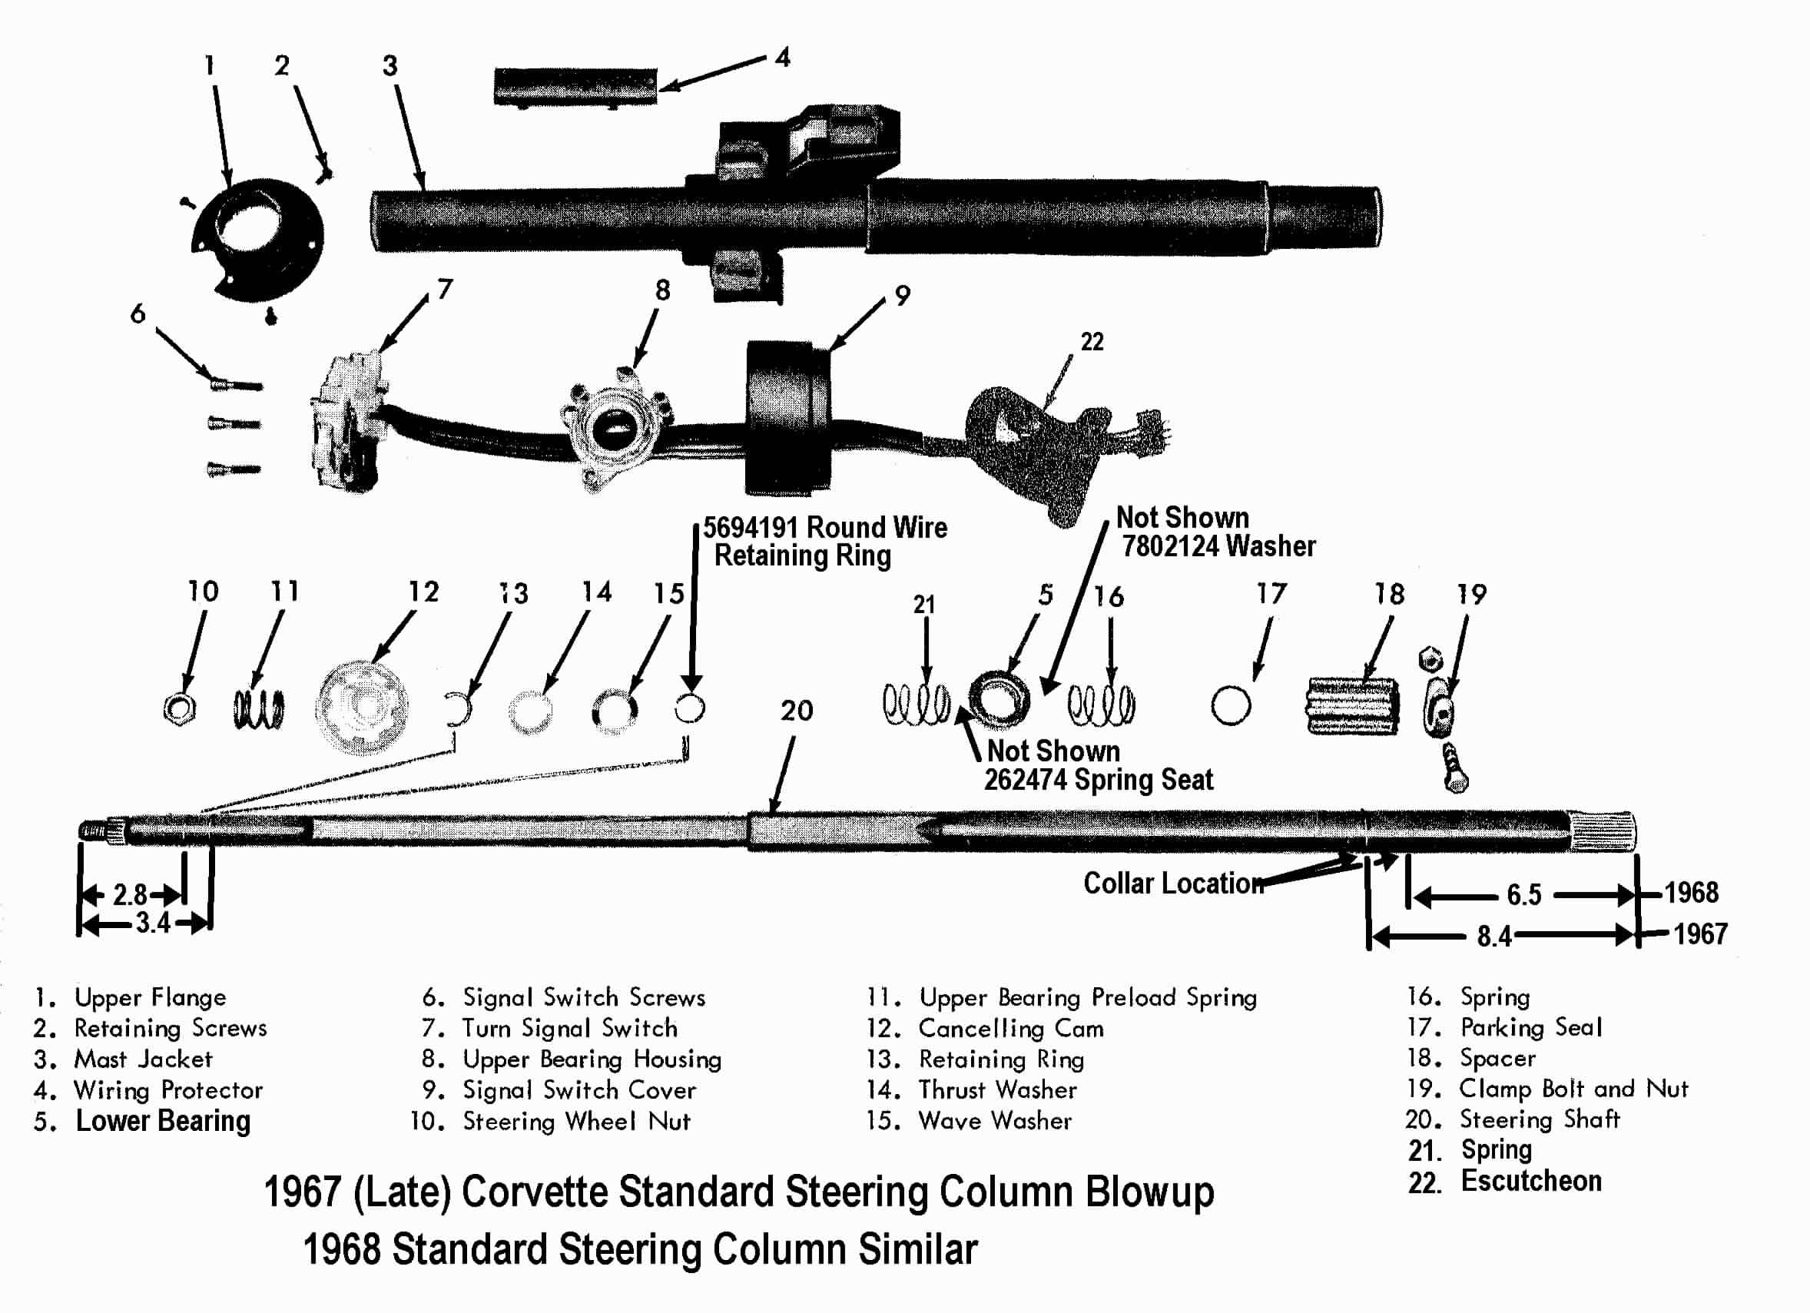
JIML82@aol.com
67-68StdColumnD&RRev06DE2008

