1968 Turn Signal Switch Wire Descriptions

On the earlier switches it was sometimes the striping on the wires rather than the entire wire color that indicated the function.
From the picture.
Label the wires from left to right: A, B, C, D, E, F, & G
A should be Stop Lights – black
B should be Left Front Turn Lamp – light blue stripe
C should be Right Front Turn Lamp – dark blue
D should be Hazard Feed - brown
E should be Turn Flasher - purple
F should be Left Rear Turn Lamp – yellow stripe
G should be Right Rear Turn Lamp – dark green
H should be Horn Ground - black
Move the switch to Right Turn
C, E, & G should be connected. A & F should be connected
Place the switch in neutral
A, F, & G should be connected
Move the switch to Left Turn
B, E, & F should be connected. A & G should be connected
Hazard On
A, B, C, D, F, & G should be connected.
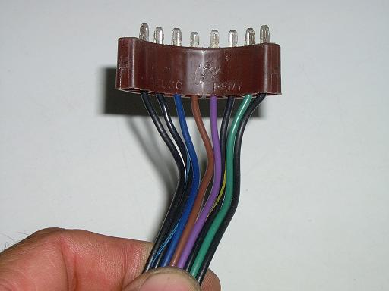

TurnSignalSwitch68WireDescription.doc
JIML82@aol.com

