Created: 04JL2007

LATE 1967 THROUGH 1978 A-CAR, GEN 2 & 3 F-CAR INTERMEDIATE STEERING SHAFT POT COUPLING SEAL REPLACE

Removal
1. Remove the intermediate shaft flange to flexible coupling nuts and lockwashers.
2. Remove the pot joint clamp bolt #3 and nut #4.
3. Remove the steering gear to frame bolts and drop the steering gear. (You will need to drop the steering gear in order to gain clearance to disassemble the intermediate shaft flange from the flexible coupling bolts. You will not need to disassemble the pitman arm from the gear or from the linkage.)
4. Push the intermediate steering shaft rearward until it bottoms in the pot joint and will clear the flexible coupling stop pins. Remove the intermediate shaft and pot joint as an assembly.

Disassembly
1. Mark the pot coupling cover #5 with respect to the lower steering shaft #2.
2. Pry off the snap ring #6 and slide the pot coupling cover #5 from the shaft.
3. Remove the bearings #7 and tension spring #8 from the pivot pin.
4. Clean the grease from the pin and end of shaft. Scribe a location mark on the pin on the same side as the chamfer on the shaft. (Where the pin presses into the shaft, one side of the shaft hole will be chamfered, the other side will not have a chamfer. You always press the pin into the shaft from the chamfered side.)
5. Supporting the shaft securely, with the chamfer up, press the pin out of the shaft using an arbor press. NOTE: Do not drive the pin out with a hammer. This will cause the bearings to stick and bind when reassembled.

6. Remove the seal clamp and then slide the seal #9 off of the shaft.
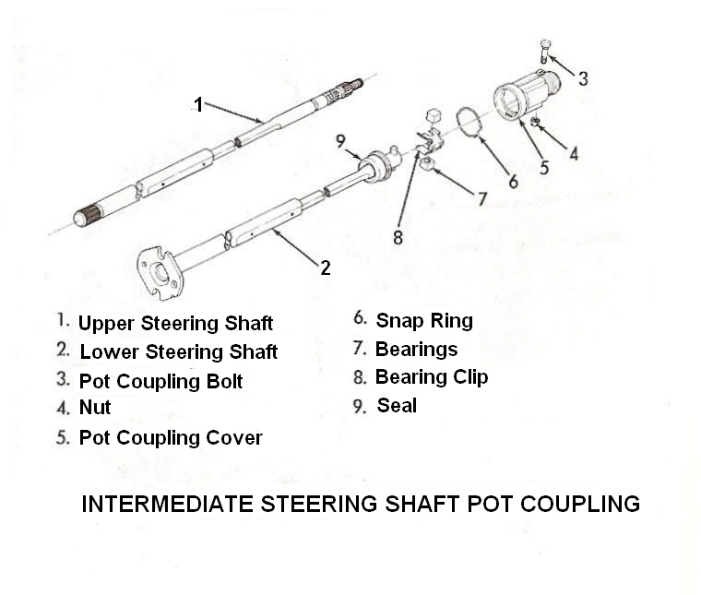
Reassembly
1. Be sure that all of the parts are free of dirt. Slide the new seal onto the steering shaft with the lip of the seal onto the steering shaft with the lip of the seal against the shoulder of the shaft. Install the seal clamp.
2. Press the pin into the shaft from the chamfered side. Locate the pin in the shaft using the scribe marks as a reference. NOTE: The pin just be centered in the shaft within 0.012 inch or binding in the pot coupling will result.

3. Procedure to check centering of the pin.
a. Place just enough 3/8 inch flat washers on the pin to prevent the bearing from bottoming on the pin.
b. Measure the distance from the end of the pin to the top of the bearing with a micrometer.
c. Remove the bearing and washers and place the same bearing and washers on the other side.
d. Measure the distance from the end of the pin to the top of the bearing.
e. If the micrometer readings differ by more than 0.012 inch repress the pin to correct.
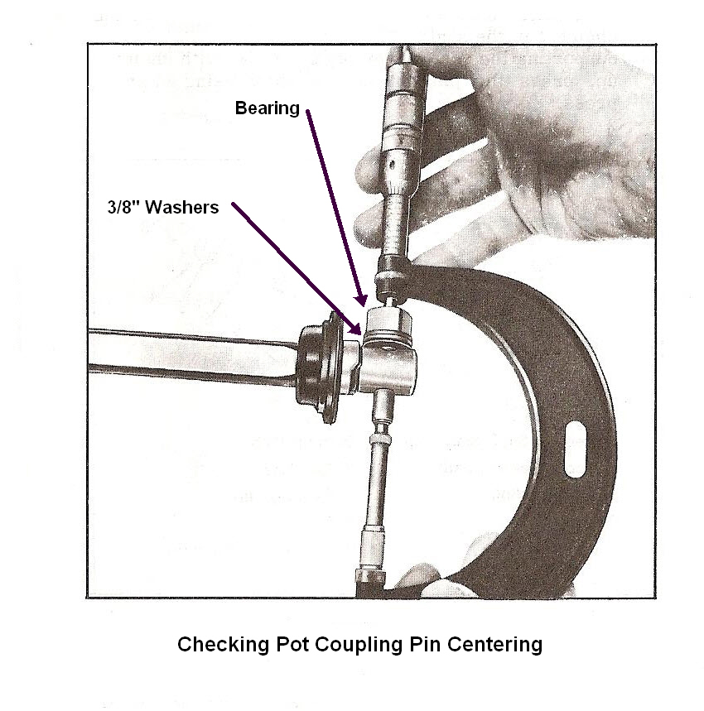
4. Apply a liberal amount of wheel bearing grease to the inside and outside of the bearings and cover.
5. Position the tension spring and bearings on the pin.
6. Align the mark on the pot coupling cover with the mark on the shaft. Slide the cover over the bearings. (If you assemble the pot cover incorrectly, your steering wheel will be upside down.)
7. Install the seal into the end of the pot cover and secure with the snap ring retainer.

Installation
1. Align the flat in the end of the pot cover with the flat on the end of the steering column shaft.
2. Install the pot joint clamp and bolt and tighten to 50 ft-lbs.
3. Assemble the intermediate shaft onto the flexible coupling on the gear and loosely install the coupling nuts and lockwashers on the flexible coupling bolts.
4. Position the steering gear back onto the frame and install the steering gear to frame bolts and torque to 70 ft-lbs.
5. Tighten the flange to coupling nuts and lockwashers to 20 ft-lbs.

PotCouplingSealReplace04JL07.doc
JIML82@aol.com

