Last Revised: 01MR2007

CORVETTE TIE ROD ADJUSTMENT SPECS EXPLAINED

This paper describes the proper orientation and assembly of the C3 Corvette tie rod assemblies to the relay rod and the correct installation of the linkage assembly into the Corvette chassis. The Corvette AIM manual includes a drawing of the linkage and tie rod clamps. It can be found as Figure #2 at the end of this paper. Although this Chevrolet engineering drawing is very complete, it is not that easy to understand.

As part of a steering system centering procedure, the enthusiast must adjust the tie rod lengths in order to bring the steering wheel central when the gear and road wheels are pointed straight ahead. The steering gear centering procedure is described in detail in my paper: Manual Gear Adjustment - (in vehicle). This paper is also available from the author or you should be able to find it at the same host websight where you downloaded this paper.

Description
A tie rod assembly consists of inner and outer tie rod ends with an adjuster tube and clamps in between. Please refer to Figure #1 and Figure #2 at the end of this paper. The C2/C3Corvette has two identical tie rod assemblies that connect the left and right steering arms to the steering relay rod.

Tie rod assemblies operate on the principle of the common turnbuckle. Similar to a turnbuckle, there are right hand (RH) and left hand (LH) threaded connections at each end of the tie rod adjuster tube. Loosening the clamps at each end of the adjuster tube allows the tube to be rotated and the overall length of the tie rod assembly can be lengthened or shortened depending on the direction of rotation. Refer to Figure #1.

The two adjuster tubes are the same. One end has a female RH thread and the other end has a female LH thread. Production adjuster tubes also have a small groove machined on the end of the tube with the LH thread to identify it. If your adjuster tube ends are not identified, place a crayon or ink mark on the LH threaded ends.

The four Corvette inner and outer tie rod ends are identical to each other except that two of them have RH male threads and two of them have LH male threads where they thread into the adjuster tube. By convention, when the tie rod assemblies are assembled to the relay rod, the inner tie rod ends should have the RH threads, outer tie rod ends should have LH threads. So the end of the tie rod assembly with the groove in the adjuster tube should attach to the vehicle steering arm. The stud on the other end attaches to the relay rod.

Assembly of Tie Rods to Relay Rod
Assemble the clamps to the adjuster tubes and take the tie rod ends and screw them into each end of the tubes. Make sure that you refer to the Figure #2 so that the clamps and bolts are assembled in the correct orientation (outer tie rod clamps have the nuts forward, inner tie rod clamps have the nuts to the rear.) Now orient the tie rod assemblies so that each has its adjuster tube with the groove on the outboard end.

Assemble the inner tie rod ends to the relay rod. Tighten the castle nuts to the inner tie rod studs and torque them to 35 ft-lbs plus additional tightening torque so that the nut castillations will align with the tie rod stud cotter pin holes (not to exceed 50 ft-lbs). Install the cotter pins and bend the ends to secure.

Assembly of Steering Linkage to Vehicle and Orientation of Tie Rod Clamps
The steering linkage must be assembled to the pitman arm, idler arm, and to the steering arms using the correct fasteners and assembly torques. Refer to the Chevrolet Shop Manual or other authorized manuals for the correct assembly and torque information.

The C3 AIM sheet for tie rod clamping indicates that when you tighten the adjuster tube clamps in place, both inner and outer clamps and bolts must be rotated and located properly. The center of the clamps have to be located ½ inch from the ends of the adjuster tube. Also the orientation of the clamp relative to the slot in the adjuster tube is very important for secure clamping. Please refer to Fig #2.

Now rotate both inner and outer tie rod ends rearward to the limit of ball stud travel. This note is a bit confusing in that the inner tie rod is on the front side of the relay rod. There really isn’t any forward or rearward position. However, the outer tie rod end is located under the steering arm. You can definitely rotate it rearward in the car. So looking down the tie rod from the steering arm end, the inner tie rod will rotate down at the same time that the outer tie rod is rotated rearward to the limit of socket travel.

Now you should note from Figure #2 with the tie rod sockets rearward at the end of travel. the nominal position for the inner tie rod clamps should be so that their pinch bolts are on the bottom and horizontal. The nut should be to the rear. The nominal position for the outer tie rod clamps should be such that the pinch bolts are on the back side and vertical with the nut down.

Next, the slit in the adjuster sleeve must not be in the slot of any of the adjuster clamps. If necessary, rotate the clamp(s) +/- 45 degrees to either side of nominal so that the slit in the adjuster in no longer in the clamp slot. Now tighten the tie rod adjuster clamp nuts to 22 ft-lbs.

With the inner and outer tie rod sockets positioned rearward, all clamp bolt centerlines must be within the angles shown in View A and View B of Figure #2.

In a nutshell, here is a six step summary on how to position production clamps and tie rod ends according to the AIM. (You must use shop manual or AIM torque specs and cotter pins as specified for all fasteners.)

1). Production adjuster tubes have a groove on one end. Assemble the tie rod assemblies to the relay rod so that the groove is located outboard on each side. (Left hand threads outboard on each side.)
2). Tip the outer tie rod ends rearward. Tip the inner tie rod ends down.
3). The inner tie rod clamp bolts should be positioned under the tube, horizontal, with the nut rearward.
4). The outer tie rod clamp bolts should be positioned to the rear of the tube, vertical, with the nut down.
5). Locate the center of the clamps 1/2 inch from the adjuster tube ends.
6). If necessary rotate a clamp a maximum of 45 degrees either direction so that the slit in the adjuster tube is not in line with the slot in the clamp.
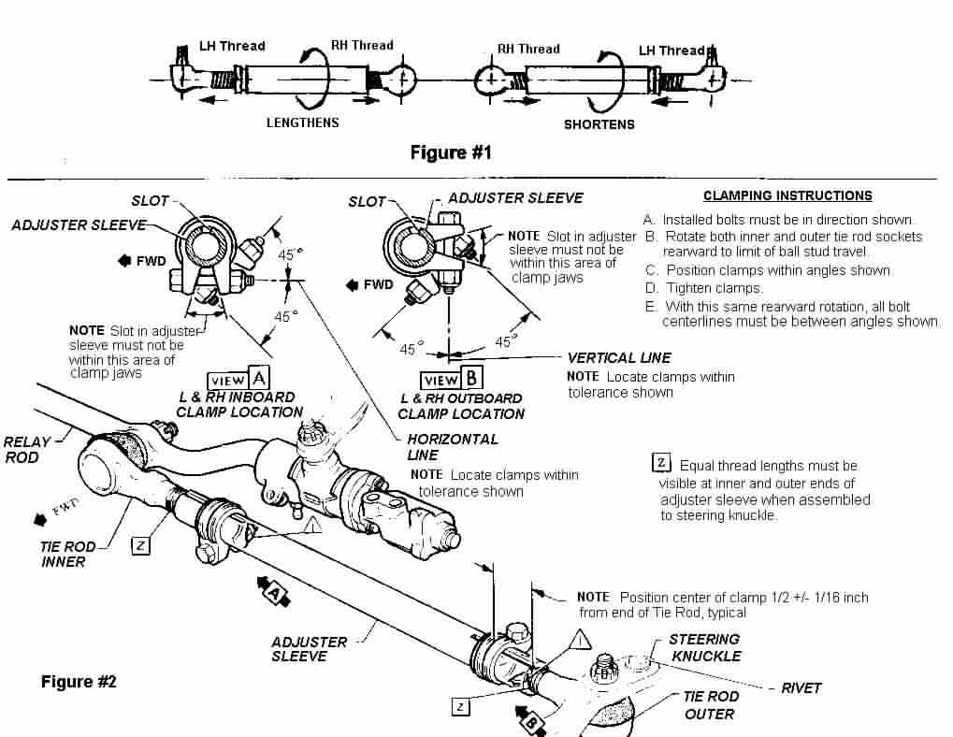
SteeringLinkageTieRodSpecs01MR07.doc
JIML82@aol.com

