Last Revised: 24JA2007

ALL YOUR EVER WANTED TO KNOW ABOUT FIRST GEN CAMARO FLEXIBLE STEERING SHAFT COUPLINGS – AND PROBABLY MORE

This paper discusses the flexible steering shaft coupling assembly that was used in the first generation F-Car (1967-69 Camaro/Firebird) as well as the X-Car (1968-74 Nova, Skylark, Ventura, Apollo) and other GM vehicles. Specifically, vehicles where the steering column connects directly to a rear mounted steering gear by means of the flexible coupling.

Background and Repair Instructions Contained in this Paper
TOPIC PAGE
FLEXIBLE COUPLING COMPONENTS AND DESIGN BACKGROUND 1,2,3,& 4
STEERING SYSTEM INSPECTION AND PROBLEM DIAGNOSIS 5 & 6
REMOVING THE FLEXIBLE COUPLING 6 & 7
ORIENTING THE FLEXIBLE COUPLING TO THE GEAR INPUT SHAFT 7 & 8
ATTACHING THE FLEXIBLE COUPLING TO THE GEAR 8
STEERING COLUMN NO LONGER REACHES THE FLEXIBLE COUPLING 9
WHAT IF MY STRG WHEEL IS NOW UPSIDE DOWN? 9
STEERING COLUMN TO GEAR ALIGNMENT AIDS 9 & 10
ALIGNING THE STEERING COLUMN 10
A WORD ABOUT REBUILD KITS 11

All flexible steering shaft coupling assemblies for GM passenger cars and light trucks were manufactured by Saginaw Steering Gear Division. Some people call it a “rag joint”, but I prefer the engineering term “flexible coupling assembly” or just the contraction “flex cplg” which will be used throughout this paper to save me time and typing.

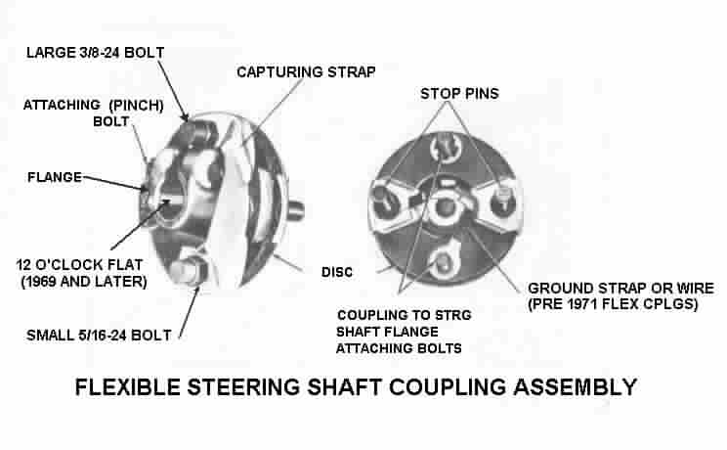
Figure A

FLEX CPLG COMPONENTS
A flex cplg assembly consists of the following major components: A flange that attaches to the steering gear input shaft; two stop pins that are hot riveted to the flange; a laminated rubber disc held securely to the flange by the two stop pins; two shoulder bolts that extend through the coupling disc with their threaded ends facing toward the steering column; a capturing strap (after 1969) to limit the amount of tension experienced by the assembly; and a method of providing an electrical ground from one side to the coupling assembly to the other (ground wire or a strap before 1971, then fine wire mesh molded into the rubber disc.)

STEERING GEAR TO STEERING COLUMN ATTACHING PARTS
Please refer to Figure B below. You will find that the GM AIM manuals from this time frame do not call out the flex cplg as a separate part from the steering gear. This is because Saginaw Division shipped the steering gear to the vehicle assembly plant with the flex cplg already attached. The AIM manual only describes car assembly plant operations. One thing to keep in mind, the flex cplg always is installed all the way onto the gear input shaft until it stops. It is then secured with pinch bolt (#7). There is no adjustability at this connection.

The steering gear and the flex cplg (#1) are attached to the steering column by means of a steering column flange (#2). This flange came in two designs. For tilt columns it was a separate part that was first loosely attached to the steering column steering shaft at the vehicle assembly plant. The standard (non-adjustable column) had a flange that was permanently staked to the steering column shaft. In either case the flange on the column was then assembled onto the two shoulder bolts extending rearward from the flex cplg. They were secured with appropriate nuts and lockwashers (#3, #4, #5, & #6)]. The tilt steering column flange was then secured in place with pinch bolt (#7). This pinch bolt is the same as the one that attaches the flex cplg to the steering gear.
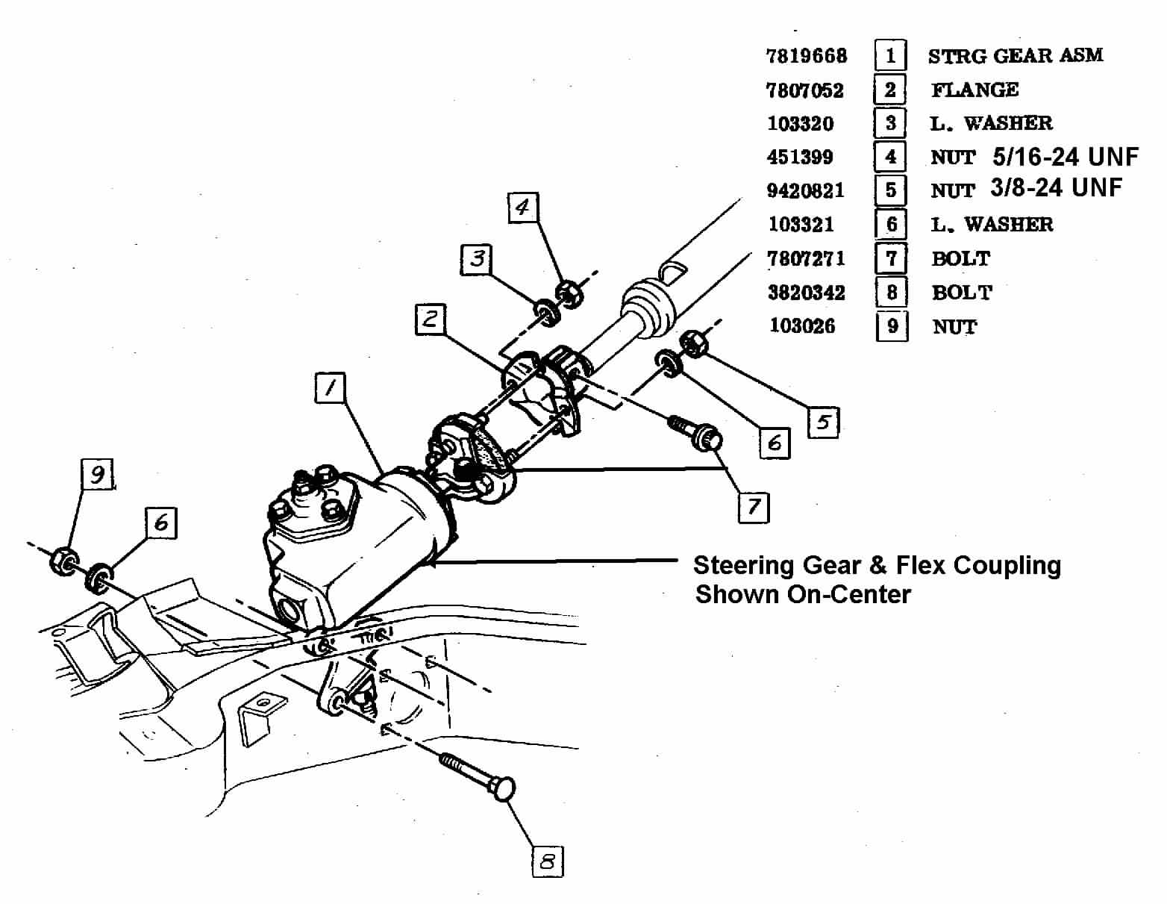
Figure B – TYPICAL REAR MOUNTED STEERING GEAR TO STEERING COLUMN ATTACHMENTS
DESIGN STANDARDIZATION
Before 1967, the Car Divisions (Chevrolet, Buick, Oldsmobile, Cadillac, and Chevrolet) designed their own steering columns. Saginaw Steering Gear Division manufactured adjustable steering columns (tilt, tilt & telescoping, and telescoping only) but for the most part, these columns had to directly interchange with the Car Division standard (non-adjustable) columns. Saginaw had major control over the design of the steering gear but again the flex cplg had to attach to various steering columns whose design was controlled by the Car Divisions. This led to several different designs of flex cplgs and column flanges.

In 1967 General Motors introduced the energy absorbing steering column on all of its lines of passenger cars. Saginaw was awarded the contract to design and manufacture 100% of them. These columns now included the standard as well as the tilt, tilt & telescoping, and telescoping only models. This provided an opportunity to finally standardize the steering columns as well as the steering column connections. This resulted in cost savings for General Motors because of the standardization of the parts at high volumes.

One other design fact had to be taken into account with the energy absorbing steering columns. The steering column steering shaft was manufactured in two pieces. The parts were designed to telescope over each other in the event of a severe frontal collision. Full vehicle crash testing indicated that dynamic motion of the steering shaft could result in the flex cplg being extended and in some cases actually pulled apart. For this reason, Saginaw designed and incorporated a capturing strap (Fig A) on all of its flex cplgs. By the 1969 model year, Saginaw had pretty much completed the standardization process.

I have researched the various GM Shop Manuals from the 1968 time frame. There is very little specific information on the different flex cplg designs that were in use at that time. For the most part, I have concentrated on flex cplg designs from 1969 through the late 1970s. I have also found that in many cases, later design flex cplgs and steering column flanges can be adapted to older vehicles.

Before 1969 there were flex cplgs with different size stop pins, in some cases the two shoulder bolts were the same size. This allowed the gear to connect to the steering column in two possible orientations. (One resulting in the steering wheel being oriented correctly, the other with the steering wheel upside down.) By 1969, Saginaw had standardized on two different size flex cplg shoulder bolts that would only connect to the column flange one way.

Before 1969 many of the flanges could be attached to the steering gear on any one of the 30 or 36 serrations (splines) that were machined on the input shaft. Around 1969 Saginaw incorporated a flat on the power and manual gear input shafts. A corresponding flat was incorporated into the flex cplg flanges. This insured that the orientation of the flex cplg to the steering gear was always correct because they would only assemble one way.

DESIGN BACKGROUND
The flex cplg serves several purposes:
First, it isolates and greatly reduces steering system and engine compartment noise from entering the driver compartment.
Second, the rubber disc provides vibration isolation from harsh tire and road feedback.
Third, the flex cplg is used to accommodate the design angle between the steering column and the steering gear input shaft (5 degrees maximum).
Fourth, the flex cplg takes up minor movement of the vehicle body relative to the frame.
Fifth, the flex cplg provides an electrical ground path for the horn.

I have seen flex cplgs that performed extremely well for over 100,000 miles as long as they were kept within their design limits and guidelines.

However, the flex cplg was not designed to take up misalignment between the gear and the column. Here is the difference. The angle between the gear and the column is the angle in which the theoretical column centerline and the steering gear input shaft centerline intersect. The intersection point of the column and the gear should be right in the middle of the flex cplg and should not exceed 5 degrees. Therefore, the laminated rubber disc flexes at the intersect angle.

A real problem arises if the column centerline and the gear input shaft centerline do not intersect. In other words the column doesn’t point directly at the gear. Now the flex cplg has to stretch up, down, or to the side (as well as being placed at the design angle) just to attach the column to the gear. It is this stretching of the laminated rubber disc that quickly ends its useful life. Furthermore this misalignment causes the steering column flange to continually contact and wear through the stop pins. Misalignment also puts a very high stress on the steering column lower bearing.

For this reason, Chevrolet specified a mandatory assembly sequence in their AIM sheets and in their Chassis Service Manuals for all vehicles where the steering column connected directly to a rear mounted steering gear by means of a flex cplg. Please follow these complete procedures so that you will have proper alignment between your steering column and steering gear.

In a nutshell, the gear is hard mounted to the frame so it is not adjustable. The upper part of the steering column has a minor amount of adjustment to allow it to pass through the instrument cluster. The attaching plates on the lower end of the steering column were designed so that they could be adjusted so that the lower end of the steering column could be pointed right at the steering gear.

Misalignment of a large number of first generation energy absorbing steering columns caused a massive recall throughout General Motors in 1967. This fact was one of the main reasons that most GM steering systems were redesigned so that they incorporated forward mounted steering gears and separate intermediate steering shafts (I-shafts.) The typical I-shaft had a “pot coupling” universal joint at the steering column and a flex cplg at the steering gear. This two joint I-shaft system effectively eliminated any possibility of misalignment between the steering column and the steering gear. The separate I-shaft design was incorporated into the 2nd and 3rd generation Camaros starting in 1970.
SYSTEM INSPECTION AND DIAGNOSIS
Open the hood and look down under your brake master cylinder. You should see the flex cplg in your car. If you closely inspect the stop pins you might see a minor amount of polish where the pins have contacted the window openings in the steering column flange (this would be considered normal). Even if your Camaro has manual steering, the pins should still show only light polish from such rare conditions as turning the steering wheel with the car completely stopped.

If you see deep gouges in the sides of the stop pins, your flex cplg needs to be replaced. And more importantly, the stop pin wear has been caused by the steering column not being correctly aligned to the steering gear.
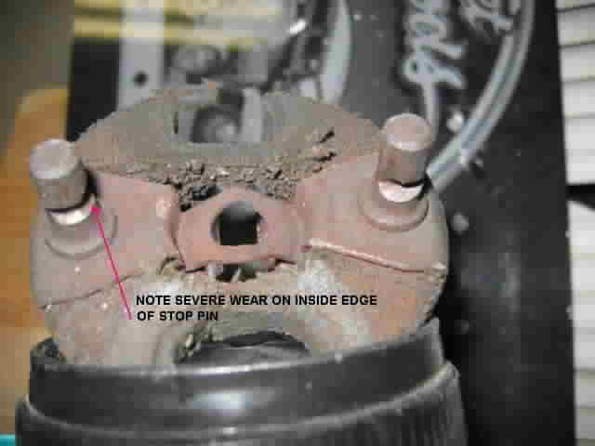
Figure C SEVERELY WORN FLEX CPLG

If you find your flex cplg in poor condition, it is important to try to understand the cause of the problem. The F-car subframe is mounted to the body and radiator support in six places. It is possible that through the years the body mounts could have settled. There could have been a collision affecting the front end. Possibly the assembly plant didn’t properly align the column in the first place. Maybe “Bubba” had his hands on your steering components before you got there. In any case, something could have caused the column to be out of alignment with the gear.

The important thing is that if your column and gear are badly out of alignment, you probably will see severe wear on the sides and inside edges of the stop pins. You may note that the rubber disc is torn. Both conditions can be seen in the above photograph, Figure C.

If your column was not aligned to the gear in the first place, just replacing the flex cplg will result in the new part quickly wearing out as well.
SYSTEM INSPECTION AND DIAGNOSIS (Continued)
Now maybe things are in alignment but the reason you need to replace the flex cplg is simply that the laminated neoprene rubber and cotton disc just gave up because of old age. Engine oil, brake fluid, heat, salt, road grime, etc. can cause the rubber to deteriorate over the years. Or maybe you just wanted to replace or refurbish parts with minor surface rust. If everything is in alignment, then installing the flex cplg and reinstalling the column and/or the gear the way you found them should result in the coupling being aligned properly with a long projected future life.

REMOVING THE ORIGINAL FLEX CPLG
The reason that the flex cplg flange connection to the gear (and also your detachable steering column flange connection to the steering column shaft) is so difficult to remove is that the flange was designed to “wrap” around its respective shaft when the special attaching “pinch” bolt (GM #7807271) was tightened. There is a slot through the flange right through the middle where the special pinch bolt attaches. This is called the "pinch bolt slot". When the special pinch bolt is tightened it actually forces the slot nearly closed causing the flange to wrap around the shaft. Add some 30 years of rust to the connections and you have parts that just do not want to come apart.

I would suggest that you soak a rusty flange and the shaft serrations with penetrating oil. Then completely remove the pinch bolt. Now take a screwdriver or fine chisel and slide it into the pinched (partially closed) slot in the flange. You want a tool that is small enough to fit into the slot and then twist it. This way you won't be pounding on the steering column or steering gear bearing that is right next to the flange. All you need to do is spring the flange open just a small amount, it will be enough to allow the flange to slide right off.

There is still another reason that makes the flex cplg and flange connections so difficult to service. It is the difficulty in gaining distance to actually remove the steering flanges from the shafts. Saginaw engineers tried to make these very critical steering connections just as safe as they possibly could. They wanted to make sure that the assembly plant people, the mechanics, the enthusiasts, (and even Bubba) had steering component connections that were as fool-proof as possible. Unfortunately, this meant that some of the connections are more difficult to assemble/disassemble than you would normally expect.

The flex cplg and steering column flange connections overlap. In other words, you have to either disconnect and move the steering column rearward into the driver compartment or you have to loosen and tip the steering gear in order to gain sufficient distance to actually get the steering coupling and the column flange to disengage. The way the components are designed, the steering components cannot disengage if just one critical fastener is missing. So if something is not tightened or connected correctly, the operator of the vehicle should have plenty of noticeable steering looseness as well as audible rattles as a warning that something is not right.

REMOVING THE ORIGINAL FLEX CPLG (Continued)
The assembly manual describes two methods of gaining clearance to remove the flex cplg. Begin by disconnecting the battery.

It is helpful to start the disassembly of the flex cplg from the gear by making sure the steering wheel is rotated so that you have good access to the pinch bolt and the two nuts and lockwashers that attach the flex cplg assembly to the column flange. Now remove the two nuts and lockwashers from the flex cplg shoulder bolts. Then remove the special pinch bolt from the gear flange. You will need a 7/16 inch 12 point socket.

The first method is to tip the gear for clearance: Remove two of the steering gear to frame attaching bolts and loosen the third. Now rotate the gear around the third bolt until you gain clearance to remove the flex cplg.

The alternate method is to pull the steering column back into the driver compartment to gain axial clearance: Remove the steering column attaching nuts and screws. You do this by first remove the panels under the steering column. Then disconnect the turn signal switch wiring harness at the connector. Also disconnect the neutral safety switch and back-up lamp switch connectors if so equipped. Disconnect the clip and wire to the instrument panel transmission shift indicator if so equipped.

Now go back under the hood and disconnect the linkage from the steering column lower lever if so equipped. Then go back inside and fold the toe pan grommet back on the column. Remove the screws securing the lower cover to the upper cover. Remove the screws that secure the upper cover, lower cover, and the seal to the dash panel. Remove the covers. Then unfasten the three nuts that hold the column up into the dash.

Let the steering column drop far enough so that you can pull the column rearward and disengage the column flange from the flex cplg.

WARNING! Never let the steering column just hang under the dash with the vertical fasteners removed but with it still securely connected at the flex cplg and at the floor pan. This will cause considerable loading on the steering column lower bearing and could cause it to fail.

ORIENTING THE FLEX CPLG TO THE GEAR
(GEARS WITHOUT A FLAT ON THE INPUT SHAFT)
The manual gear input shafts on 1967 thru early 1969 Camaros were ¾ inch diameter with serrations (or splines) all the way around (known as the “full round” type of input shaft). The OEM flex cplg had a full compliment of serrations to mate with that input shaft. The flex coupling is still available from GM as #7806391.

The power steering gear had a 13/16 diameter input shaft. I do not know if there was a flat on this input shaft or not. Flex cplgs with flanges that will attach to a 13/16 shaft are no longer available from GM.

(GEARS WITHOUT A FLAT ON THE INPUT SHAFT - Continued)
If you are going to remove the flex cplg from the gear and reattach it later, it is a good idea to mark the coupling flange and the gear input shaft with chalk or a grease pencil so that you can easily reinstall the flange on the correct spline.

If you have a new flex cplg or you forgot to mark the flange and shaft as described above, here is another method of installing the flex cplg correctly. Place the steering gear exactly on center. You do this by counting the full and partial revolutions of the input shaft full lock to lock (X). Divide that number in half (X/2). Now place the gear at full lock and come back exactly X/2 revolutions. Your gear is now exactly on center.

Now install the flex cplg on the input shaft such that the stop pins are at 6 and 12 o’clock (as viewed from the driver seat.) Make sure that the pinch bolt is vertical and passing through the 9 o’clock position. The pinch bolt head should be pointing straight up.

(GEARS WITH A FLAT ON THE INPUT SHAFT)
Sometime during the 1969 model year, a milled flat was added to the manual gear input shaft and carried forward from then on. The design of the flex cplg was changed at that time to also include a flange with a flat so that it would mate correctly with the new input shaft in only one position. This second design flex cplg for a manual gear is still available from GM dealers as #7818568 and also from other suppliers.

Note that this flex cplg flange with a flat will NOT assemble to a gear shaft that does not have a flat. Therefore, it is a good idea to check the input shaft on your gear to determine if it is full round or does it have a flat.

Turn the gear input shaft so that the gear is exactly on center (machined flat on the input shaft exactly at 12 o’clock as you look at the input shaft from the driver position.) If the flange on your flex cplg has a matching flat, it will only install on the gear input shaft in one position. If your flex cplg does not have a flat, align it as follows: Again, with the steering gear exactly on center, orient the flex cplg so that the stop pins are at 6 and 12 o’clock and the attaching pinch bolt passes through the 9 o’clock position with the head pointing straight up.

ATTACHING THE FLEX CPLG TO THE GEAR
Orient the flex cplg flange and slide it on the gear input shaft until it bottoms out. You should now be able to easily pass the special pinch bolt (GM #7807271) through one side of the flange, through the clearance notch on the gear input shaft, and begin screwing it into the threaded side of the flange. The pinch bolt has a torque prevailing nylon patch on its 3/8-24 threads. You will only be able to screw the pinch bolt into the flange by a couple threads by hand. You will then need a wrench with a 12 point 7/16 socket to tighten it to 25–30 ft-lbs. Remember, the flex cplg goes all the way on the gear input shaft until it stops. Then install and tighten the pinch bolt. There is no axial adjustment available as you make this connection.

WHAT IF THE COLUMN FLANGE DOES NOT REACH THE FLEX CPLG?
A do-it-yourself magazine article recommended prying on the end of the steering column shaft in order to gain clearance to remove the flex cplg from the gear. I strongly DO NOT recommend this approach. Prying on the steering column shaft will most likely collapse the shaft back into the column. This will result in the steering column flange not reaching the flex cplg shoulder bolts when you try to reassemble the components.

All energy absorbing steering columns (from 1967 onward) were designed to collapse and absorb energy in a severe frontal collision. The steering shafts were designed in two pieces so that they would telescope over each other. It is possible that the steering shaft can actually be pushed back into the steering column. Then you will find that the lower shaft can be quite difficult to pull back out. I do not recommend pounding on the lower shaft and flange since damage can occur to the upper and lower column bearings that hold the steering shaft in position. With the column out of the car, a constant steady force should be applied to return it to its original length.

WITH THE GEAR ON CENTER, WHAT IF THE FLEX CPLG PINCH BOLT ATTACHES WITH THE BOLT HEAD POINTING UNDER THE CAR?
I am aware of some service flexible couplings where the flange that attaches to the gear has been machined incorrectly. The flat inside the flange that matches the flat on the gear in on the wrong side! This will cause your steering wheel to end up upside down and your turn signal switch will not cancel correctly. You can try to swap the two different size attaching bolts (this will rotate the column flange by 180 degrees and bring your steering wheel back into alignment.) A better course would be to send it back to the supplier and scream like hell about the quality!

STEERING COLUMN TO GEAR ALIGNMENT AIDS
The 1968 Chevrolet Chassis Service Manual makes a vague reference to “rubber protectors” on the flex cplg stop pins. They may have been the first alignment spacers. I am not sure. Later flex cplgs had plastic spacers.

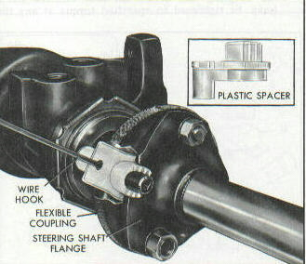

Figure D - FLEX CPLG ALIGNMENT SPACERS

STEERING COLUMN TO GEAR ALIGNMENT AIDS (Continued)
In order to assist the assembly plant in assembling and aligning the column to the steering gear, Saginaw installed special plastic spacers on the flex cplg stop pins. These spacers were designed to take up all the clearance between the stop pins and the window opening slots in the column flange, thus forcing the column to be in alignment with the gear. The plastic spacers were removed and thrown away after the assembly sequence (Figure D). If you purchase a OEM flex cplg, you should receive those special plastic alignment spacers already on the pins.

If you purchase a rebuild kit in the aftermarket, you most likely won’t get those plastic spacer assembly aids. If you are lacking the spacers, I came up with a substitute method of alignment.

I suggest that you use a roll of ½ inch wide masking tape and wrap each of the pins until you have about a 9/16 inch diameter roll of tape (about 1/8 inch thick on a side). Now when you bolt the column flange to the flex cplg assembly, the pins will be held rigidly central in the window slots in the column flange. You can dig the masking tape off the pins when your installation is complete

ALIGNING THE STEERING COLUMN TO THE FLEX CPLG
The vehicle must be on its wheels when reinstalling the steering column.
These vehicles with steering columns and rear mounted gears that directly connect together have very specific instructions as to positioning the steering column so that it is aligned to the steering gear. Please consult your AIM sheets or the appropriate shop manual for the correct procedure.

CHECKING STEERING COLUMN TO FLEX CPLG ALIGNMENT
After the column is installed conduct an inspection. It may be of assistance to use a small mirror to aid with the inspection. Look at the coupling disc. It should remain relatively flat. Look at the stop pins in the steering column flange windows, they should be central and not be compressing the masking tape or the plastic spacers.

Remove the masking tape from the stop pins or pull the plastic spacers. Inspect both stop pins again and insure that remain central in the flange slots. Turn the steering wheel 90 degrees. Inspect both pins again, insuring that they are central. If they are not central, you will need to go back and readjust the lower end of the steering column.

Reattach panels under the steering column. Reattach battery cable. You are ready to go!

ELECTRICAL CONTINUITY THROUGH THE FLEX COUPLING
All first generation Camaros had a electrical ground wire or a ground strap in the center of the flex coupling (Fig A). Later, flex cplgs had discs that incorporated a fine wire screen that was laminated onto the face of the coupling disc. The screen provided a electrical grounding path in place of the ground wire. On the outside diameter of the later coupling disc, you may feel the sharp edges of the small wires sticking out.

A WORD ABOUT REBUILD KITS
I am not in favor of the “do it yourself” flex cplg rebuild kits. The OEM flex cplg was manufactured with extremely secure hot riveted stop pins and special design shoulder bolts to attach the flex cplg to the steering shaft flange. Don’t forget, this is a critical safety part. It is the connection from the steering wheel to your road wheels!

If you look carefully at your original equipment flex cplg, you will note that the attaching bolts have shoulders. They are designed to bottom against the steering column flange.
This results in a connection that tightens metal-to-metal. It sandwiches the rubber disc in place with a controlled squeeze but the disc is not involved in the actual connection.

There is a problem in that some of the parts in the kits are not designed correctly. You should NEVER make a bolted connection by squeezing rubber. A bolted connection depends on bolt stretch generated by tightening the nut. This causes compression in the joint and friction against the nut prevents it from loosening. When you bolt metal parts properly together, the metal parts are unyielding and tension in the bolt keeps the joint secure for life.
However, this is what happens when you try and make a bolted joint through rubber. First of all, you never build adequate nut torque nor do you achieve any amount of tension in the bolt. Over time the rubber relaxes even more and all tension in the bolt is lost, and the nut can then back off. Even if you use double nuts, lockwashers, torque prevailing nuts, or Loctite® the nuts to the bolts, you still will never have adequate tension in the bolt. Also the rubber will relax allowing for even more loosening of the joint. A loose bolt will eventually begin to rock and come apart even though the nut hasn’t moved on the bolt threads.
I have seen pictures of kits that provided just straight common bolts. If you must use one of those kits, please use the shoulder bolts from your original flex cplg regardless as to how rusty they might be.
I purchased a kit a while back in order to look at the parts. This kit actually bolted together correctly. It had stop pins with shoulders and it had separate metal bushings that were inserted into the two rubber disc holes for the coupling bolts. So even though the kit did not contain shoulder bolts, the bushings provided a proper metal to metal joint.
One other thing that is overlooked in the kits that I have reviewed, the OEM flex cplgs and the authorized service flex cplgs should have a method of conducting electrical grounding current from one side to the other so that you can operate your horn. None of the kits that I have reviewed provide any means for electrical continuity from one side of the flex coupling assembly to the other.

A Word About the Author
I am a retired steering system engineer from Delphi Saginaw Steering Systems, (formerly Saginaw Steering Gear Division, GMC). Back in the early 1970s I was responsible for the flex cplg assembly and the power steering hoses for all GM passenger cars and light trucks. So I have very first hand knowledge about these products. I also worked closely with other Saginaw engineers that had responsibility for the power and manual steering gears, power steering pumps, as well as the T&T, tilt, and standard (non-adjustable) steering columns. I still keep in contact with Saginaw engineers (both active and retired) who help me with my steering papers on Terry Rudy’s www.corvettefaq.com websight, (both in the Corvette Steering Paper Section and the A & F-Car Steering Paper Section.)

FlexibleCplgFirstGenEverything24JA07.doc
JIML82@aol.com

