Last Revision: 31MY2006

HORN OPERATION DIAGNOSIS

1969-76 GM A & F-Cars

There are three basic areas that can cause your horns to not operate: 1) the horns themselves;
2) the horn relay/key buzzer; 3) the horn circuit in the steering column and steering wheel parts.

- Horns - There are two horns on most Chevelles. There is a black 14 gage wire connected to them from the horn relay. Disconnect this wire from the horns and connect a 12v source to the horns; they should operate. If they don’t, the horns need to be repaired or replaced.
- Horn Relay/Key Buzzer – Remove the relay from its mounting and identify the #2 and #3 terminals. Connect a jumper from the terminal marked #2 to ground. Slide a probe into the wiring harness connector to make contact if the terminals are the slip-on type. If the horns operate, check the #2 terminal wire and horn switch for defects. If the horns do not operate, leave the #2 terminal connected to ground, and connect a voltmeter from the #3 terminal to ground. If a reading is obtained, check the horn wiring and horns for defects. If no reading is obtained, replace the horn relay/buzzer.
- Steering Column Wiring - The steering column has a flat (harmonica) wiring connecter that connects it to the vehicle instrument panel electrical harness. The last wire in the steering column connector is a black one. Next to it is a pink wire. The next wire (the third one) is another black wire. There should be continuity from that third black wire up to the spring loaded eyelet plunger sticking up at the horn button upper contact on the steering wheel. If not, the problem is within the steering column itself.

When you press the horn button there should be continuity from the third wire all the way to the lower end of the steering column steering shaft. If not, the problem is somewhere within the steering column or steering wheel horn parts themselves.

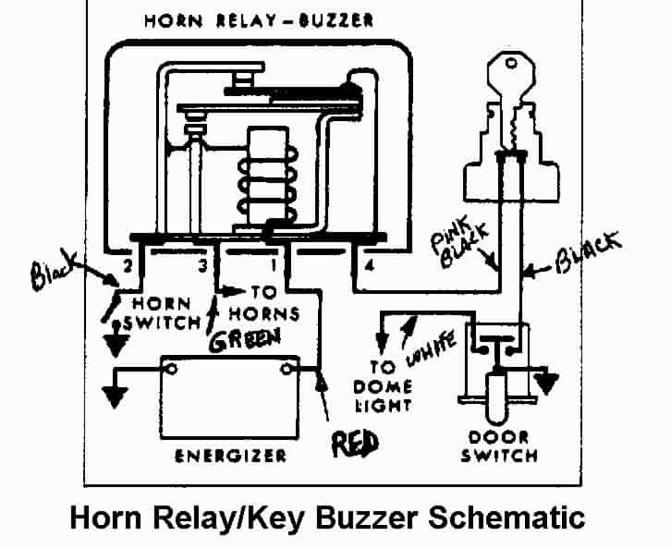

Common Problem – Horn Continues to Blow

Both the standard column and the tilt column from 1969 through 1976 have their turn signal levers attached to the steering column switch by a single screw. This screw can loosen, back out, and ground the horn circuit. You will need to remove the steering wheel and hub. Rotate the steering column so that a hole in the locking plate aligns with the turn signal lever screw. Retighten it.

Tilt Steering Column

Horn Ground Components
The following description is valid for all Chevelle tilt steering columns from 1969 through 1976. It is most helpful if you would download the following pictures from the host websight assist with the description. Download:

Tilt Column 69-72 Blowup Pic
Tilt Column 77-82 Steering Wheel and Horn Parts (the 1969 through 76 steering wheels are similar - this is the best picture showing all the parts!)

As described on the previous page, to operate the horn you need to create continuity from the black wire entering the steering column to the end of the steering shaft.

Please refer to the Tilt Column Blowup Pic. The third black wire comes up the steering column wiring harness to the Turn Signal Switch #8. The wire is connected to the spring loaded plunger that is part of the Turn Signal Switch. The plunger is stationary and rests against a rotating contact strip that is part of the Cancelling Cam #5. The Cancelling Cam fits against the Lock Plate #4 and has a tower that extends up through the Lock Plate.

Now refer to the 69-72 Steering Column Parts and Mounting Pic. The tower incorporates a Spring, an Eyelet, and is retained inside the tower by the Horn Lower Insulator. The eyelet extends up through the steering wheel hub and rests against a contact inside the steering wheel.

Now when the Horn Pad or Cap is depressed, the contact is closed and there is now a ground path that extends down through the hub, into the steering column steering shaft, down through the flexible coupling, into the steering gear, through the steering gear mounting bolts, into the frame and back to the battery through the vehicle ground straps.

If you press the horn cap and there is a lack of continuity from the third wire all the way to the lower end of the steering column steering shaft, you need to look for missing or broken parts (Bubba strikes again!). Also, remember that your steering column is 30 years old, there could be corrosion at some of your steering column component interfaces which could be interrupting the ground path.

Standard (Non-Adjustable) Steering Column

Horn Ground Components
The following description is valid for Chevelle standard steering columns from 1969 through 1976. It is most helpful if you would download the following pictures from the host websight to assist with the description. Download:

Std Strg Column 69-72 Blowup Pic
Std Strg Column 69-72 Column Parts and Mounting Pics

As described on the first page, to operate the horn you need to create continuity from the black wire entering the steering column to the end of the steering shaft.

Please refer to the Std Column Blowup Pic. The third black wire comes up the steering column wiring harness to the Turn Signal Switch Assy #2. The wire is connected to the spring loaded plunger that is part of the Turn Signal Switch Assy. The plunger is stationary and rests against a rotating contact strip that is part of the Turn Signal Cancelling Cam Assy #5. The Cam Assy fits against the Strg Shaft Lock #4 and it has a tower that extends up through a cutout in the Strg Shaft Lock.

Now refer to the 69-72 Steering Column Parts and Mounting Pic. The tower incorporates a Spring, an Eyelet, and is retained inside the tower by the Horn Lower Insulator. The eyelet extends up through the steering wheel hub and rests against a contact inside the steering wheel.

Now when the Horn Pad or Cap is depressed, the contact is closed and there is now a ground path that extends down through the hub, into the steering column steering shaft, down through the flexible coupling, into the steering gear, through the steering gear mounting bolts, into the frame and back to the battery through the vehicle ground straps.

If you press the horn cap and there is a lack of continuity from the third wire all the way to the lower end of the steering column steering shaft, you need to look for missing or broken parts (Bubba strikes again!). Also, remember that your steering column is 30 years old, there could be corrosion at some of your steering column component interfaces which could be interrupting the ground path.

HornOperationDiagnosisACar31MY06.doc
JIML82@aol.com

