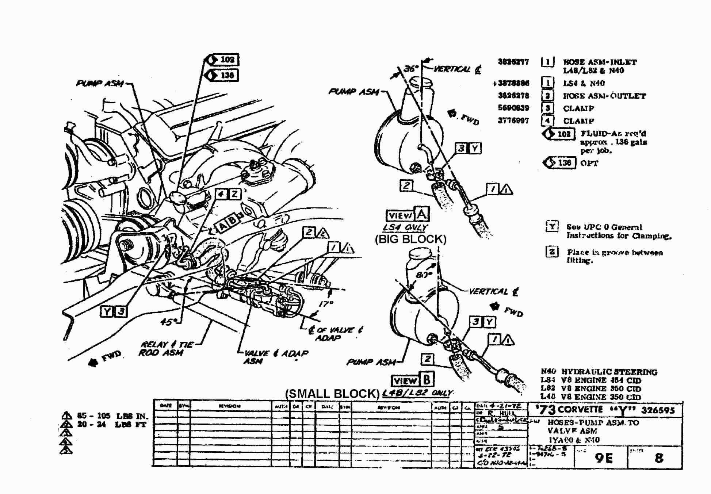

FIG #1 – STEERING HOSES – PUMP TO CONTROL VALVE

PRESSURE HOSE GM PART # AVAILABLE FROM
(HOSE ASM – VALVE INLET)

1968-79 SMALL BLOCK 3826277 GM PARTS, ZIP SC-581

1980-82 SMALL BLOCK 7834409 GM PARTS, ZIP SC-582

1968-74 BIG BLOCK 3878886 ZIP SC-583

LOW PRESSURE HOSE
(HOSE ASM – VALVE OUTLET) 3826278 GM PARTS, ZIP SC-580

These hose assemblies are available from numerous suppliers. Zip Products is listed as a typical supplier.

StrgHosePumpToValvePic.doc

