Revision Date: 03MR2006

CONTROL VALVE REBUILD TIPS
I have always been concerned about the number of people that report that they used a kit to rebuild their control valve only to find that it leaked shortly after the rebuild. I think that the leaks are primarily caused by faulty or incomplete information when people try to rebuild their control valves. This paper describes several tips that hopefully will increase the success rate.

Here is the first tip. Refer to Figure 1 below. If your valve is leaking power steering fluid (make sure it is not grease) from the ball stud area, the fluid leak is located at the Annulus Seal. If there is power steering fluid inside the valve housing dust cap, the leak is at the Vee Block Seal.
Most valve leaks are most likely caused by people installing the Annulus Seal and/or the Vee Block Seal incorrectly or possibly caused by not replacing the valve parts in the correct order. The following diagram has freehand sketches of the Vee Block Seal and the Annulus Seal that present a more detailed picture as to how they are to be assembled.

Figure 1 Control Valve Assembly
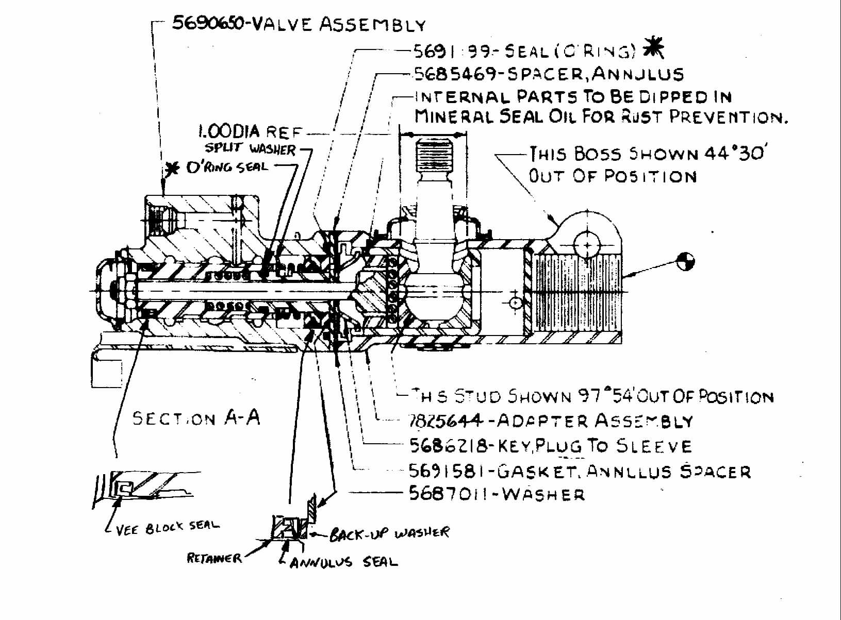
This control valve assembly drawing can also be found at: http://jimshea.corvettefaq.com/wp-content/uploads/2006/03/ControlValveCutaway.doc
Remember that the seal lips need to be pointing at the fluid pressure in order to seal correctly < fluid pressure >.
New seals can quickly wear and leak if they have to operate on a scratched or corroded surface. Before reassembling the control valve, the housing bore should be inspected at both ends to make sure that it is not corroded, gouged, or excessively worn. If it shows any of these types of problems, most likely the housing will need to be discarded. You can consider honing the cylinder bore if the scratches are not too deep. Finally, check the entrance of the valve housing bores to make sure that there are no burrs or sharp edges that could cut the seals during assembly.

The Vee Block Seal and the Annulus Seal must be handled with care. You must be very careful that the sealing lips on these seals are not nicked or cut as you assemble the seals into their respective bores. Assemble the seals using power steering fluid or petroleum jelly (Vasoline®) as a lubricant.

Seals can also leak if contaminants get on sealing lips or sealing surfaces. Be sure that you assemble the valve in a clean work area
The GM shop manual makes mention that after installing and balancing the control valve on the car, a small amount of grease should be placed in the valve housing bore before installing the dust cap the final time.

These are the GM part numbers of the service parts that I have been able to find for the control valve assembly. They are active and can be purchased at local GM dealers as of the date that this paper is written.

7825636 Valve and Adapter Assembly
7816810 Dust Cover Kit, with lock nut
5691581 Annulus Spacer Gasket

JIML82@aol.com
ControlValveRebuildingTips03MR06.doc

