Revised: 24AU2005

ADAPTING A 1969-75 T&T STEERING WHEEL TO A 1976 T&T COLUMN

The 1976 steering column is identical to the 1969-75 steering columns (both the standard [non-adjustable] and the T&T versions). Therefore, you can easily install the 1969 -75 steering wheel in place of the “Vega” steering wheel that came on the 1976 column. However, you will have to locate some of the attaching hardware for the steering wheel and telescope feature since the 1976 hardware was unique for that one model year and will not adapt.

The following link will direct you to my paper on the subject if you are interested.
http://www.corvettefaq.com/redir.asp?site=210

For the most part, if you can purchase the steering wheel along with the hub, extension, screws, spacer, horn cap, upper contact, and telescoping lever, that is the best way to do it.
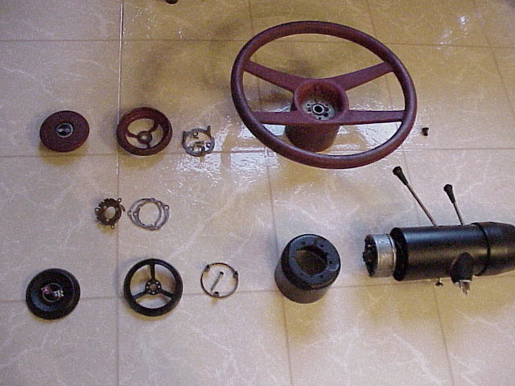

This picture is helpful in understanding the difference the differences even though not all of the parts are shown.

The lower parts are the 1969-75 telescope lock and horn parts. The steering wheel is not shown. Note the aluminum colored hub on the steering column shaft.

The following AIM sheets for the 1969-75 models versus the 1976 will help in understanding what parts that you will have to locate to adapt the early wheel to the 1976 T&T steering column.

http://www.corvettefaq.com/redir.asp?site=608
http://www.corvettefaq.com/redir.asp?site=609

The pictures are a little unclear as to a couple parts. From my analysis, I am quite sure that you can use the original 1976 lower contact assembly, spring, eyelet, and insulator. You will also be able to use the steering wheel nut, the nut retaining clip, shim, the star screw, and the two screws that secure the star screw.

Here is a list of parts along with the GM and the Zip Products part numbers that are needed. Parts are most likely available from other Vette suppliers as well:
Hub Asm 3949110 Zip SC-413
Extension 3949109 Zip SC-680
Steering Wheel Zip SC-592
Steering Wheel Screws (6) 9428089 Zip ZSC-351
Spacer 3952781 Zip SC-624
Telescope Lever 3949108 Zip SC-336
Upper Horn Contact 3949103 Zip SC-45
Contact Screws (3) 3949107 Zip SC-644
Horn Cap 3952780 Zip SC-338

T&T69-75StrgWheelTo76ColumnRev24FE04
JIML82@aol.com

