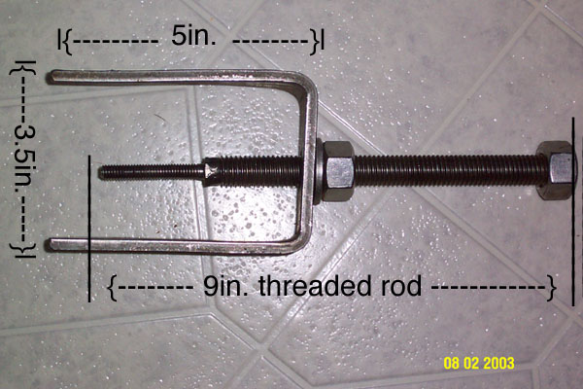

Materials: 1 1/2” X 1/4” steel flat bar, 9” - 5/16” threaded rod, 2 - 5/16” nuts, 1 - 5/16” flat washer.

Construction:

1. Bend a piece of steel flat bar into a squared off “U” that is 5” tall and 3 1/2” wide.
2. Drill a hole large enough to get a 5/16” threaded rod to slip through in the center of the 3
1/2” side of the flat bar “U”.
3. Thread a nut on the end of the threaded rod and weld it in place. (or double nut it if you don’t weld, the idea is to make a 9” long bolt)
4. Thread the other nut on the threaded rod and slip the washer on.
5. Slide the threaded rod through the hole in the flat bar “U”.

That is all you need to do to build a steering column lockplate compressor. The compressor in the photo above is what you will end up with, the exception being the threaded rod. I didn’t have a 5/16” threaded rod, so I used a larger piece then welded a 5/16” bolt on the end. A 9” piece of 5/16” threaded rod will do the same thing and be easier to build. I have seen these priced at $40. You can build your own for around $5. Good luck.

