Last Revised 21AU2005

PROCEDURE FOR REMOVING BROKEN TURN SIGNAL LEVER STUB FROM 1977 THRU 1982 CORVETTE STEERING COLUMN DIMMER PIVOT

Replacing a turn signal lever on the original Corvette C3 steering columns (1968 through 1976) was relatively straightforward. The standard columns (non-adjustable) required that you remove the steering wheel and hub. Then you could reach through an access hole in the steering column locking plate to remove or tighten the screw the held the lever. On T&T steering columns, it was even easier. There was a metal post that was part of the turn signal switch. The post had a threaded hole that you could access through the side of the steering column. The turn signal lever merely screwed into that hole.

Starting the 1977 model year, the turn signal lever also became the headlight dimmer actuator. The lever attachment to the steering column was changed to a plug-in design on both standard (non-adjustable) columns as well as the optional tilt and telescoping types. The turn signal lever end was a round rod with a groove and a bullet nose. When the lever was inserted into the column dimmer pivot, a spring loaded pin engaged the groove on the lever and held it securely in place.

This new design had several advantages. It was great for the car assembly plant. All they had to do was shove the turn signal lever into a hole in the dimmer pivot – no more loose screws or even having to screw the lever into place. This design was good from a service standpoint if you just wanted to replace the entire lever.

However, the early dimmer columns had an annoying tendency for the turn signal lever to break off right where it entered the dimmer pivot. With the lever broken off, there was nothing to get hold of to pull the broken nub out past the detent pin.

The early service procedures required the following: Remove the steering wheel and hub; remove the lock plate, turn signal switch, and lock cylinder; then remove the steering column cover; punch out a pivot pin; remove the pivot assembly; and finally push the broken stub past the detent pin from the back side of the pivot.

So if you are faced with a broken turn signal lever stub inside your 1977 through 1982 Corvette steering column, the following suggestions may be a big help and save you a lot of time in removing the broken stub.

Drill and Tap the Stub
This suggestion involves carefully drilling a small hole and screwing a self tapping screw into the stub. Use a 1/16 inch diameter drill bit, carefully drill a hole about 3/8 inch deep right in the center of the end of the broken stub. Use a sheet rock screw or any type of self tapping screw and drive it into the hole until it is tight. Grab the screw head and pull the stub straight out.

This procedure should work on any broken stub from the 1977 through 1982 model year steering columns.

Press the Stub Out from the Dimmer Pivot from the Back Side (1978-1982)
You will note that I skipped the 1977 model year with this procedure. This method will not work on the 1977 lever because it incorporates the windshield wash/wipe switch. This one year only switch prevents you from reaching around the backside of the dimmer pivot.

For all the other model years, our engineering and skilled trade friends at Delphi Saginaw devised two simple tools that could be used to remove the broken nub from 1978 through 1982 steering column dimmer pivots without tearing the column apart.

The tools can be constructed from simple household items in a very short time.

The reason there are two tools is that the broken nub can either be sticking out through the back side of the pivot or if the stub is short, it could be buried somewhat inside the pivot unit. The end of the turn signal lever is angled and has a bullet nose so that it installs easily into the dimmer pivot. Therefore, if the nub is sticking through the pivot, a flat bladed “L” shaped tool will be used to press it back through the pivot so that you can grab it with a needle nose pliers.

This “L” shaped tool can be constructed from typical household utensils. For instance the end of a butter knife could be bent over to form the 5/8 inch end of the “L”. The knife is stainless steel so the material thickness would not have to be as thick as the drawing indicates. Or possibly you could obtain a spatula or soup ladle with a rectangular metal handle from the Dollar Store. The metal handle may not be quite ½ inch wide but it should be sufficient. Cut the utensil end off and bend the metal handle into the “L” shape.

However, if the stub end is inside the dimmer pivot, you will need a short “J” shaped wire so that you can probe and reach behind into the hole and push the nub toward you. You can then push the stub far enough out so that you can grab it with the pliers.

This second “J” shaped tool can be fabricated from wire, such as heavy coat hanger wire, (hopefully it is strong enough.) Form the end around a 3/8 inch diameter dowel and file or grind the end square so that it will push evenly against the bullet nose on the turn signal lever stub.

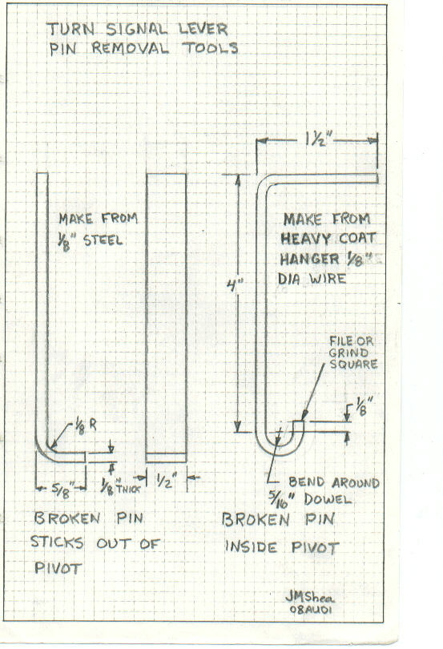

JIML82@aol.com
TurnLeverStubRemoval21AU05.doc

