Last Revised: 17JA2004

GM Steering Column to Transmission Interlock Systems

General Motors introduced the second generation, energy absorbing, function locking steering column in all of their passenger cars starting in the 1969 model year. One of the features of this system was the ability to lock the steering wheel and the transmission shift lever when the ignition key was rotated to OFF-LOCK. There was a great concern that a vehicle operator might inadvertently lock the steering system while the vehicle was moving forward on the road. To prevent this from happening, GM and Saginaw Steering Gear Division came up with a blocking system inside the steering column that interacted with the transmission control position. This system prevented the ignition key from being turned all the way to OFF LOCK unless the automatic transmission was placed in PARK or a manual transmission was shifted into REVERSE. The following are descriptions of the three systems that were developed to provide this interlock function.

Steering Column Shift and Automatic Transmission
GM passenger cars with automatic transmissions and the shift lever on the steering column require that the operator place the shift lever into PARK in order to be able to lock the steering column. Moving the shift lever into PARK opens a gate inside the steering column allowing the ignition key to rotate all the way to OFF-LOCK. When placing the column shift lever in PARK, there is also a lever on the lower end of the steering column that is rotated to the full “UP” position. This lever pulls on a rod or cable that is connected to another small lever on the transmission, placing it in PARK. Also please note that the steering column has a neutral start/backup light switch mounted on top of the steering column down under the dash by your feet. This switch is also actuated by the motion of the shift lever on the steering column and performs the following functions (PARK & NEUTRAL – enable engine start; REVERSE – backup lights.

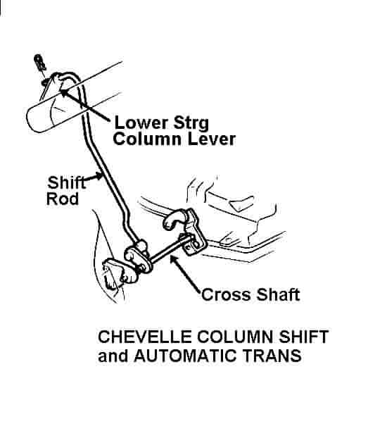

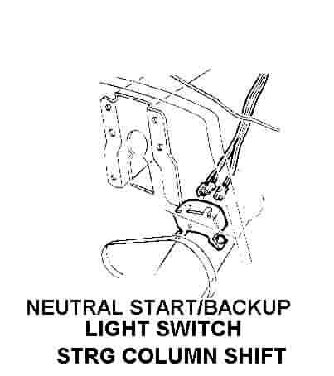

Console Shift and Automatic Transmission
GM passenger cars with automatic transmissions and the shift lever on the console were also designed so that the operator had to place the shift lever in PARK in order to lock the steering column. With a console shift, the system works opposite from the steering column shift previously described. When the console shift is placed in PARK, this motion pushes on a cable or rod that is connected to a lever on the lower end of the steering column. This backdrive system moves the lever to the full "UP" position and thus opens the internal steering column gate.

Also please note that with a console shift automatic, there can be two possible mounting locations for the neutral start/backup light switch. The first and most straightforward location is for the switch to be mounted directly on the shifter mechanism in the console. Many GM vehicles have it mounted there. However, the switch can also be mounted directly on the steering column (the same as column shift modes). So when the shifter is moved, the lower lever on the column moves to various positions and the neutral start/backup light switch is positioned accordingly.
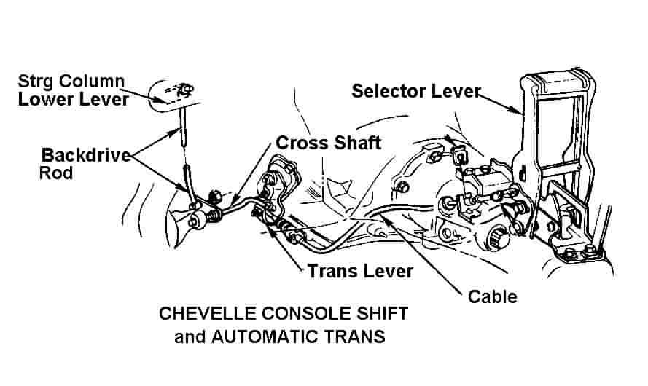
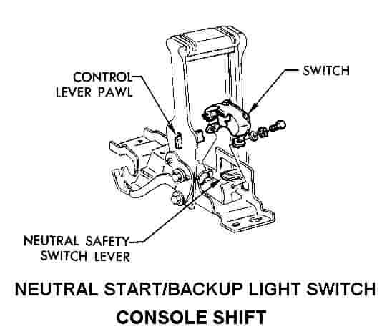

Floor Shift and Manual Transmission
The system that is used with a manual transmission and floor shifter is similar to the automatic transmission system. It was decided that the manual transmission must be shifted into REVERSE before the ignition key could be rotated to the OFF LOCK. This required a rod or a cable to be attached between the reverse gear lever on the transmission and the lower steering column lever. The movement of that transmission lever to the REVERSE gear position also moved the column lever to the full UP position unblocking the ignition key.

Manual transmission vehicles do not require a neutral start switch since GM incorporates a clutch pedal/start switch that requires that the clutch pedal be depressed in order to start the car. Also another, separate switch is usually attached directly to the manual transmission to actuate the backup lights when the transmission is placed in REVERSE.
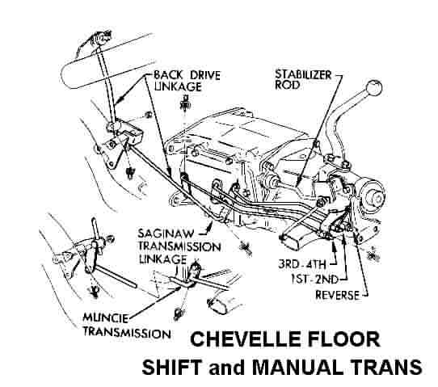

Disconnecting the Backdrive System
For various reasons, some people with console or floor shifters disconnect the rod or cable from the column lower lever. They then wire the lever permanently in the UP position. This defeats the interlock system and results in the following:

1). This allows the ignition key to be rotated to OFF LOCK at any time.

2). If the vehicle is a type of console shift automatic with the neutral start switch inside the car on the steering column, then the backup lights will not operate and the car can be started with the transmission in any gear.

Both of the above conditions can result in unsafe operation of your vehicle.

JIML82@aol.com
StrgColumnTransInterlockSystems.doc

