Last Revised: 04SE2001

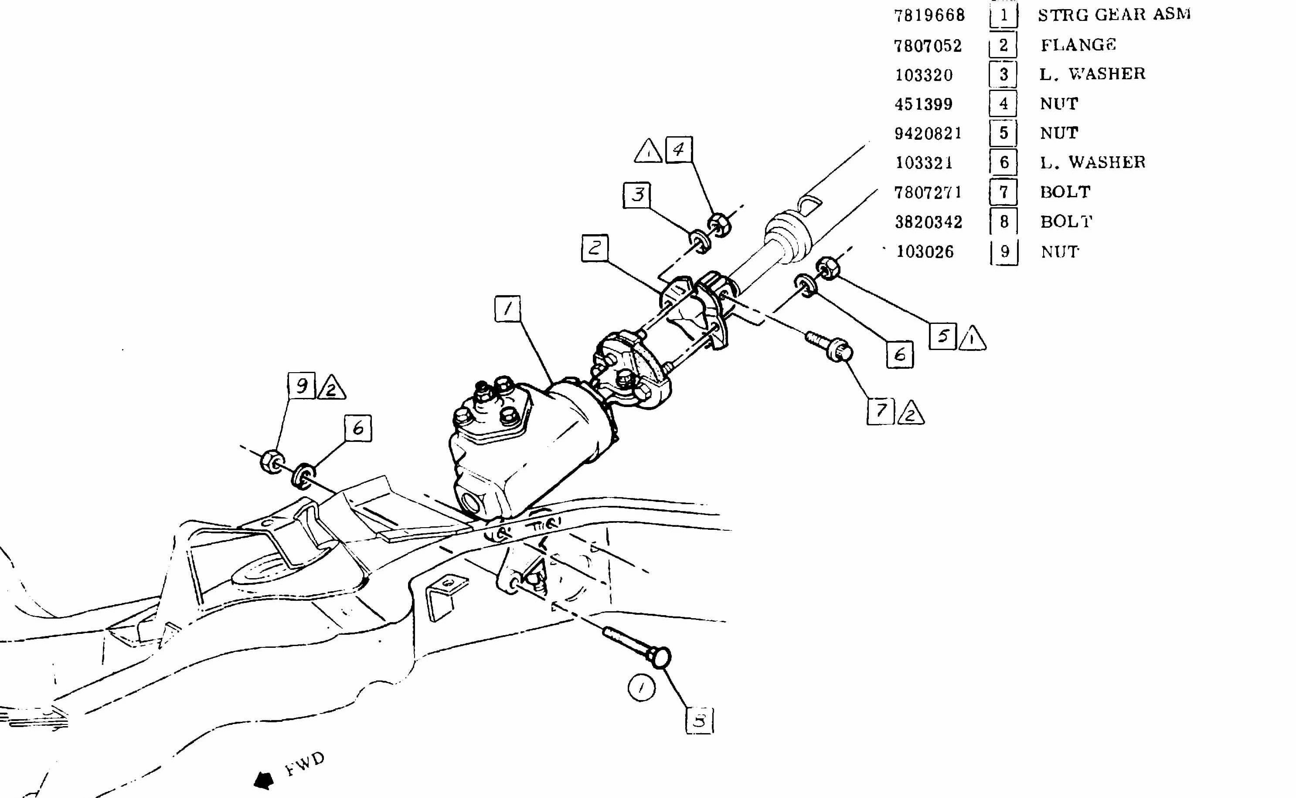
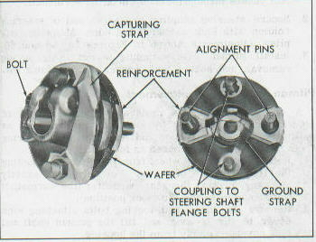
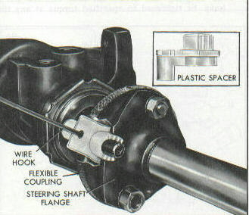
FIG #1 TYPICAL C3 CORVETTE STEERING GEAR & FLEXIBLE COUPLING INSTALLATION
FIG #2 TYPICAL FLANGE AND COUPLING ASSEMBLY
1969 THRU 1982 CORVETTE FLEXIBLE COUPLING INFORMATION
FIG #3 REMOVING THE ALIGNMENT SPACER

