Last Revised: 02JA2006

FLEXIBLE COUPLING INSTALLATION IN A

FIRST GENERATION F-CAR (1967-69) AND 1967 A-CAR

Background and Repair Instructions Contained in this Paper

TOPIC PAGE
FLEXIBLE COUPLING COMPONENTS AND DESIGN BACKGROUND 1, 2, & 3
STEERING SYSTEM INSPECTION AND PROBLEM DIAGNOSIS 3 & 4
REMOVING THE FLEXIBLE COUPLING 4 & 5
FLEXIBLE COUPLING NO LONGER REACHES THE COLUMN FLANGE! 6
REINSTALLING THE FLEXIBLE COUPLING 7
STEERING COLUMN TO GEAR ALIGNMENT AIDS 7
ALIGNING THE STEERING COLUMN 7 & 8
FLEXIBLE COUPLING DESIGNS & SERVICE PARTS 8
A WORD ABOUT REBUILD KITS 8 & 9

Flexible steering shaft coupling assemblies for all GM passenger cars and light trucks were manufactured by Saginaw Steering Gear Division. Some people call it a “rag joint”, but I prefer the more appropriate term “flexible coupling” which is used throughout this paper. Figure A, below, shows a typical 1969 design, flexible coupling assembly.
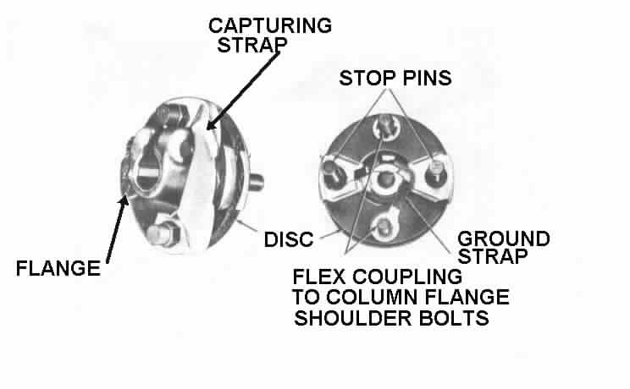
Figure A – 1969 VINTAGE FLEXIBLE COUPLING ASSEMBLY

FLEXIBLE COUPLING COMPONENTS
The flexible coupling (refer to Figure A) consists of a flange that attaches to the steering gear input shaft. It has two stop pins that are hot riveted to the flange. They permanently attach a rubber disc to the flange. The stop pins have shoulders and extend through the disc and point rearward in the car. There are also two shoulder bolts extending through the coupling disc with their threaded ends facing rearward as well. The bolt threads are two different sizes so they will only assemble to the flange on the steering column one way. The flexible coupling also incorporates some method of providing an electrical ground from one side to the other.
STEERING GEAR TO STEERING COLUMN ATTACHING PARTS
You will find that some of the shop manual photos and figures do not call out flexible coupling components with the same engineering nomenclature that is used in this paper. Chevrolet service engineers (thirty some years ago) for some reason used different names and terms when they wrote their shop manuals. Also the AIM manual does not call out the flexible coupling as a separate part from the steering gear. This is because Saginaw Division shipped the steering gear to the vehicle assembly plant with the flexible coupling already attached. The AIM manual only describes and specifies operations that are performed at the car assembly plant.

Please refer to Figure B below. The steering column attaches to the steering gear by means of a flexible coupling and a steering column flange [Fig B (2)]. The flexible coupling is installed all the way onto the gear input shaft and the pinch bolt [Fig B (7)] tightened. The steering column flange assembles onto the two shoulder bolts that extend rearward from the flexible coupling and it is secured with appropriate nuts and lockwashers [Fig B (3,4,5, & 6)]. The flange on the steering column is detachable on all adjustable (tilt) columns. The detachable flange is adjustable in that it can be located along the half inch slot on the steering column shaft and secured in place with a pinch bolt [Fig B (7)]. This pinch bolt is the same as the one that attaches the flexible coupling to the steering gear. Standard (non-adjustable) steering columns have a flange that is permanently attached to the steering shaft.

The column flange also has two window openings through which the stop pins extend. After the column is installed in the car the stop pins must be central in the window openings with about 1/8 inch clearance on all sides.
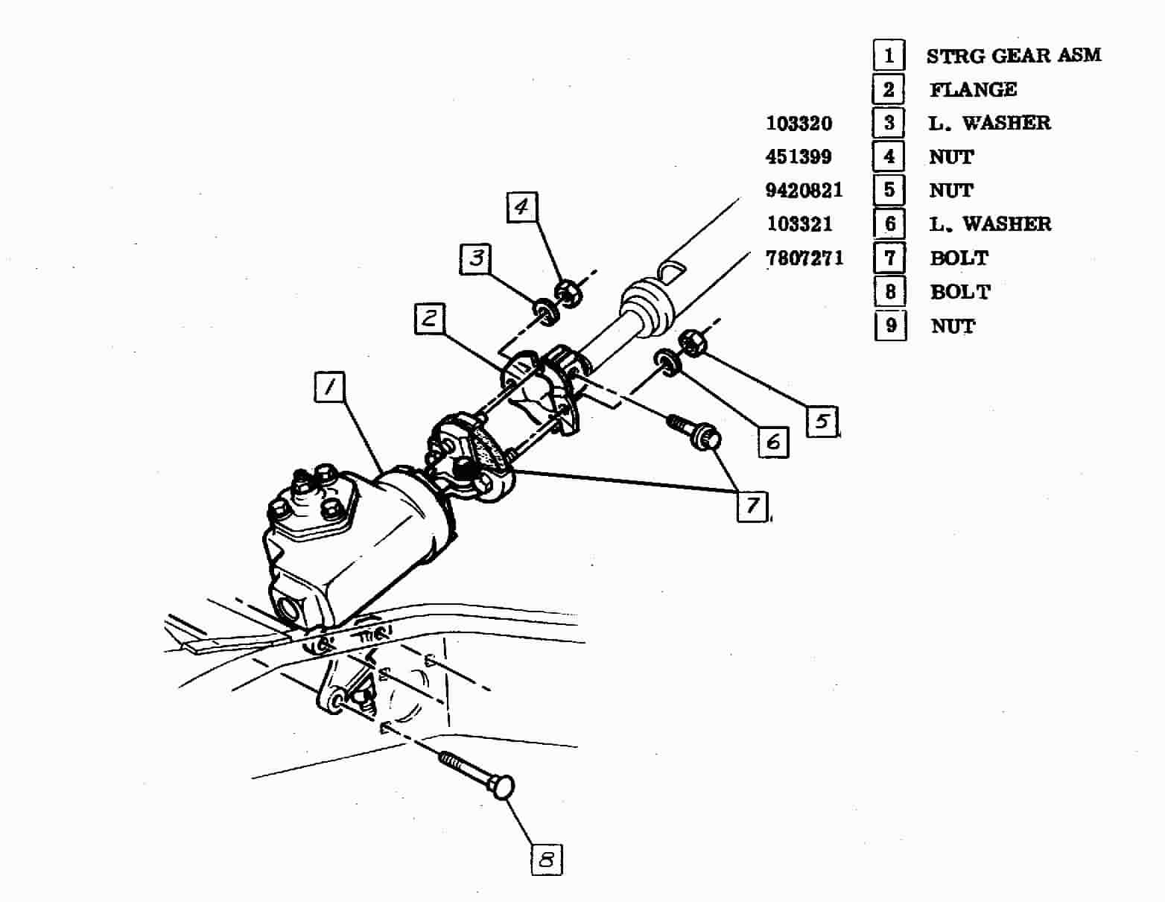

Figure B – TYPICAL STEERING GEAR TO STEERING COLUMN ATTACHMENTS

DESIGN BACKGROUND
The flexible coupling serves several purposes. One, it isolates steering system and engine compartment noise from entering the passenger compartment. Two, the rubber disc also provides some vibration isolation from harsh tire and road feedback. Third, the flexible coupling is used to accommodate the design angle between the steering column and the steering gear input shaft (5 degrees maximum). Fourth, the flexible coupling takes up minor dynamic movement of the vehicle body relative to the frame. I have seen flexible couplings that performed extremely well for over 100,000 miles as long as they were kept within their design limits and guidelines.

However, the flexible coupling was not designed to take up misalignment between the gear and the column. Here is the difference. The angle between the gear and the column is the angle in which the theoretical column centerline and the steering gear input shaft centerline intersect. The intersection point of the column and the gear should be right in the middle of the flexible coupling and should not exceed 5 degrees. Therefore, the laminated rubber disc flexes at the intersect angle.

A real problem arises if the column centerline and the gear input shaft centerline do not intersect. In other words the column doesn’t point directly at the gear. Now the flexible coupling has to stretch up, down, or to the side (as well as being placed at the design angle) just to attach the column to the gear. It is this stretching of the flexible coupling disc that quickly ends its useful life. This misalignment also causes the steering column flange to continually contact the stop pins. Over time, turning the steering wheel can actually cause the steering column flange to “saw” through the stop pins. Misalignment also puts a very high stress on the steering column lower bearing.

For this reason, Chevrolet specified a mandatory assembly sequence in their assembly plant AIM sheets and in their Chassis Service Manuals for all vehicle designs where the steering column connected directly to the steering gear. In a nutshell, the gear is hard mounted to the frame. The upper part of the steering column has a minor amount of adjustment to allow it to pass through the instrument cluster. The attaching plates on the lower end of the steering column were designed so that they could be adjusted so that the lower end of the steering column could be pointed right at the steering gear. Various car lines had slightly different attaching plates and tightening procedures. Please refer to the specific procedures outlined in your vehicle’s AIM sheets or shop manual instructions.

Misalignment of a large number of first generation energy absorbing steering columns caused a massive recall throughout General Motors in 1967. This was one of the main reasons that GM steering system designs were shifted to ones that incorporated separate intermediate steering shafts (I-shafts). The typical I-shaft had a “pot coupling” type universal joint at the steering column end and a flexible coupling at the steering gear. This two joint I-shaft system eliminated the possibility of any misalignment of the flexible coupling to the steering gear. I-shafts were incorporated into the 2nd generation F-cars (Camaros) and 1968 and later A-cars (Chevelles, El Caminos, etc).

SYSTEM INSPECTION AND DIAGNOSIS
Open the hood and look down at your steering gear. You should see the flexible coupling attached to the input shaft. If you closely inspect the stop pins you might see a minor amount of polish where the pins have contacted the window openings in the steering column flange (this would be considered normal). Even with manual steering, the pins should only contact the edges of the column flange windows under rare conditions such as turning the steering wheel with the car completely stopped and the brakes applied. If you see deep gouges in the sides of the stop pins, your flexible coupling needs to be replaced. The stop pin wear is caused by the steering column not being in correct alignment to the steering gear.

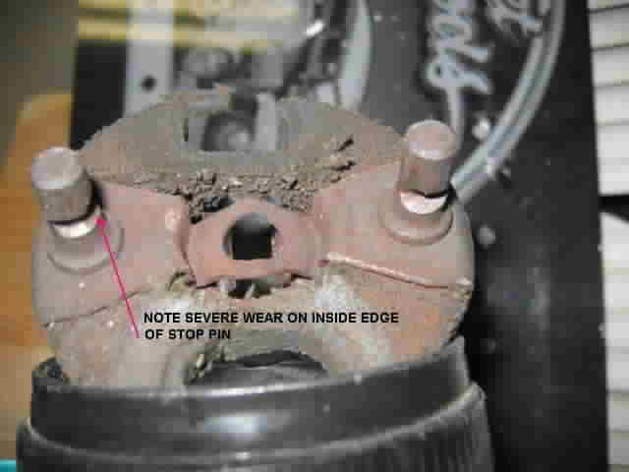
Figure C SEVERELY WORN FLEXIBLE COUPLING

If you are replacing a badly worn out flexible coupling, it is important to try to understand why it is in such condition. The body is mounted to the frame or stub frame in several places with some type of body mount. It is possible that through the years the body might have settled and thus moved the column out of alignment with the gear. Possibly the assembly plant didn’t properly align the column in the first place. Maybe “Bubba” had his hands on your steering components before you got there.

The important thing is that if your column and gear are out of alignment, you probably will see severe wear on the sides and inside edges of the stop pins. You may note that the rubber disc is torn. Both conditions can be seen in the above photograph, Figure C.
If your column was not aligned to the gear in the first place, just replacing the flexible coupling will result in the new part quickly wearing out as well.
SYSTEM INSPECTION AND DIAGNOSIS (Continued)
Now maybe things are in alignment but the reason you need to replace the flexible coupling is simply that the laminated neoprene rubber and cotton disc just gave up because of old age. Engine oil, brake fluid, engine compartment heat, road grime, etc. can cause the rubber to deteriorate over the years. Or maybe you just wanted to replace or refurbish parts with minor surface rust. If everything is in alignment, then installing the flexible coupling and reinstalling the column and/or the gear the way you found them should result in the coupling being aligned properly with a long projected future life.

REMOVING THE FLEXIBLE COUPLING
The reason that the flexible coupling flange and also the detachable flange on the steering column shaft are so difficult to remove is that they were designed to “wrap” around their respective shafts when their special attaching “pinch” bolt was tightened. There is a slot through the flange right through the middle where the special pinch bolt attaches it. This is called the "pinch bolt slot". When the special GM pinch bolt (#7807271) is tightened it actually forces the slot nearly closed causing the flange to wrap around the shaft. Add some 30 years of rust to the connections and you have parts that just do not want to come apart.

I would suggest that you soak the flange and shaft serrations with penetrating oil. Completely remove the pinch bolt, then take a screwdriver or fine chisel and slide it into the pinched (partially closed) slot in the flange. You want a tool that is small enough to fit into the slot and then twist it. This way you won't be pounding on the steering column or steering gear bearing that is right next to the flange. This should tend to spring the flange open just enough to make it much easier to remove.

I think that this is why so many people have such difficulty removing the steering flanges from the shafts. Saginaw engineers tried to make these very critical steering connections just as safe as they possibly could. They wanted to make sure that the assembly plant people, the mechanics, and the enthusiasts that worked on these components had connections that were as fool-proof as possible. Unfortunately, this meant that some of the connections are more difficult to assemble/disassemble than you would normally expect.

The flexible coupling and steering column flange connections overlap. In other words, you have to either disconnect and move the steering column rearward into the passenger compartment or loosen the steering gear, remove two bolts, and tip the gear in order to gain sufficient clearance to actually get the steering coupling flanges to disengage from their respective shafts. The way the components are designed, the steering components cannot disengage if only one critical fastener is missing. Also, the operator of the vehicle should have plenty of warning that something is not right.

The assembly manual describes two methods of gaining clearance to remove the flexible coupling. Begin by disconnecting the battery.

It is helpful to start the disassembly of the flexible coupling from the gear by making sure the steering wheel is rotated so that you have good access to the pinch bolt and the two nuts and lockwashers that attach the flexible coupling assembly to the column flange .
REMOVING THE ORIGINAL FLEXIBLE COUPLING (Continued)
Remove the two nuts and lockwashers. Now remove the special pinch bolt from the gear flange. You will need a 7/16 inch 12 point socket.

The first method is to remove two of the gear to frame attaching bolts and loosen the third. Now rotate the gear around until you gain clearance to remove the flexible coupling.

The other method is to remove the steering column attaching nuts and screws and carefully pull the column back into the car to gain axial clearance.

Remove the panels under the steering column. Remove the nuts and/or screws that connect the column to the toe pan (down by the floor); then unfasten the vertical screws, washers and/or nuts that connect the column under the dash. Let the steering column drop far enough so that you can pull the column rearward and disengage the column flange from the flexible coupling.

WARNING! Never let the steering column just hang under the dash with the vertical fasteners removed but with it still securely connected at the flexible coupling and at the toe pan. This will cause considerable loading on the steering column lower bearing and could cause it to fail.

Note! All 1969 Camaro steering columns (actually all GM function locking steering columns) have a lower lever on the steering column. The lever is attached to a linkage system that connects to a lever on the transmission. You will need to disconnect the linkage rod from the lever and rotate the lower lever to a position where it will pass through the hole in the floor pan as you are pulling the steering column back into the passenger compartment.

FLEXIBLE COUPLING INSTALLATION
Align the flexible coupling flange and slide it on the gear input shaft until it bottoms out. You should now be able to easily pass the special pinch bolt through one side of the flange, through the clearance notch on the gear input shaft, and begin threading it into the other side of the flange. The pinch bolt has a torque prevailing nylon patch on its 3/8-24 threads. Tighten it to 25–30 ft-lbs.

Remember, the flexible coupling goes all the way on the gear input shaft and is tightened in place. The detachable steering column flange is the part that is adjusted and then tightened to take up the build tolerance between the body and frame.

What If The Column Flange No Longer Reaches the Flexible Coupling?
A do-it-yourself magazine article recommended prying on the end of the steering column shaft in order to gain clearance to remove the flexible coupling from the gear. I strongly DO NOT recommend this approach. Prying on the steering column shaft will most likely collapse the shaft back into the column. This will result in the steering column flange not reaching flexible coupling when you reassemble the components.

What If The Column Flange No Longer Reaches the Flex Coupling? (Continued)
All GM energy absorbing steering columns (from 1967 onward) were designed to collapse and absorb energy in a severe frontal collision. The steering shafts were designed in two pieces so that they would telescope over each other. It is possible that the steering shaft can become compressed and pushed back up into the steering column. The lower shaft can be quite difficult to pull back out to its original length.

I do not recommend pounding on the lower shaft and flange since damage can occur to the upper column bearings that hold the steering shaft in position. With the column out of the car, a constant steady force should be applied to return it to its original length as specified above. There will most likely be an area on the steering shaft where rust begins and ends that may be an indication that the shaft is back to its original length.

STEERING COLUMN TO GEAR ALIGNMENT AIDS
In order to assist the assembly plant in assembling and aligning the column to the steering gear, Saginaw installed special plastic spacers on the flexible coupling stop pins. These spacers were designed to take up all the clearance between the stop pins and the window opening slots in the column flange, thus forcing the column to be in alignment with the gear. The plastic spacers were removed and thrown away after the assembly sequence (Figure D).

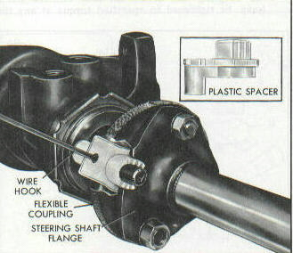

Figure D - FLEXIBLE COUPLING ALIGNMENT SPACERS

If you purchase a OEM flexible coupling, you should receive those special plastic alignment spacers already installed on the pins. If you purchase a rebuild kit in the aftermarket, you most likely won’t get those assembly aids. Since I am not sure if you will have the spacers, I came up with a substitute method of alignment described below.

PREPARING THE FLEXIBLE COUPLING FOR INSTALLATION
If the assembly plant needed the spacers to insure good alignment of the steering column to the steering gear, it follows that it might be helpful for you to create your own if the special plastic spacers didn’t come with your new replacement part.

I suggest that you use a roll of ½ inch wide masking tape and wrap each of the pins until you have about a 9/16 inch diameter roll of tape (about 1/8 inch thick on a side). Now when you bolt the column flange to the gear flange and coupling assembly, the pins will be held rigidly central in the window slots in the column flange. You can dig the masking tape off the pins when your installation is complete

ALIGNING THE STEERING COLUMN TO THE FLEXIBLE COUPLING
The vehicle should be on its wheels when reinstalling the steering column.

Very Important: Each vehicle has specific instructions as to positioning the steering column so that it is aligned to the steering gear. Please consult your AIM sheets or the appropriate shop manual for the exact procedure.

When the column is installed conduct a finish inspection. It may help to have a small mirror to aid with the inspection. Look at the coupling disc. It should remain relatively flat. Look at the stop pins in the steering column flange windows, they should be central and not be compressing the masking tape or the plastic spacers.

Remove the masking tape from the stop pins or pull the plastic spacers. Inspect both stop pins and insure that remain central in the flange slots. Turn the steering wheel 90 degrees. Inspect both pins again, insuring that they are central. If they are not central, you will need to go back and readjust the lower end of the steering column.

Reattach panels under the steering column. Reattach battery cable. You are ready to go!

FLEXIBLE COUPLING DESIGNS AND SERVICE PARTS – POWER GEARS
All GM power steering gears had 13/16 diameter input shafts up through the 1976 model year. I have not been able to find a service flexible coupling assembly with a 13/16 flange that is available through GM dealers. In 1977 and from then on, the power gear input shaft was changed to ¾ inch diameter. Flexible couplings for those gears are readily available.

I would think that there are probably A and F-car suppliers that may have NOS flexible coupling assemblies with 13/16 flanges available.

There was one other subtle change that was made to the design of the flexible coupling in the early 1970s. There was a usually an electrical ground device such as a wire or a ground strap that was positioned in the center of the coupling disc (Fig B). A grounding system was needed to provide a ground path for the horn. Later, a fine wire screen was laminated onto the face of the coupling disc to provide the electrical grounding path in place of the ground wire. Many enthusiasts have cursed the sharp ends of the small wires sticking out of the edges of the disc. The metal screen does not add any strength to the coupling disc.
FLEXIBLE COUPLING DESIGNS AND SERVICE PARTS – MANUAL GEARS
The GM manual gear input shafts up until early 1969 were ¾ inch diameter with 30 serrations all the way around (known as a “full round” input shaft). The flexible coupling had a full compliment of serrations to mate with that input shaft. The part is available from GM as #7806391. It is also available from Zip Products as SC-377. If you are going to remove the flexible coupling from the gear it is best to mark the coupling flange and the gear input shaft with chalk or a grease pencil so that you can reinstall the coupling assembly in the same orientation.

Sometime during the 1969 model year (and all years after that), a milled flat was added to the manual gear input shaft. With your road wheels pointing straight ahead and the steering gear on center, the flat should be at the 12 o’clock position. The design of the flexible coupling was changed at that time to also include a flat in the attaching flange so that it would mate correctly with the new input shaft. The second design flex coupling is available from GM as #7818568. This later design flex coupling is also available from several suppliers.

Note, because of the flat, this coupling assembly will only install on the gear one-way. Also this flexible coupling with the flat in the flange will NOT attach to earlier gear shafts that have full round serrations.

A WORD ABOUT REBUILD KITS
I am not in favor of the “do it yourself” flexible coupling rebuild kits that are available in the aftermarket. The OEM flexible coupling was manufactured with extremely secure hot riveted stop pins and special design shoulder bolts to attach the flexible coupling to the steering shaft flange. Don’t forget, this is a critically important part. This is the connection from the steering wheel to the road wheels on your car!

If you look carefully at your original equipment flexible coupling, you will note that the attaching bolts have shoulders. They are designed to bottom against the steering column flange. This results in a connection that tightens metal-to-metal (generating proper torque/tension in the bolted connection) and sandwiches the rubber disc in place with a controlled squeeze.

I cannot even try to monitor all the different types of parts that may be included in a “do it yourself” kit.

The problem I am having is that I know that some of them are not designed correctly. You should NEVER make a bolted connection through rubber. A bolted connection depends on bolt stretch and tension created when you torque the nut correctly. This causes compression in the joint and friction against the nut prevents it from loosening. When you bolt metal parts properly together, the metal parts are unyielding and tension in the bolt keeps the joint secure for life. This is what happens when you try and bolt through a joint with rubber. First of all, you never build adequate tension in the bolt. Over time the rubber relaxes even more and all tension in the bolt is lost, and the nut can then back off.

A WORD ABOUT REBUILD KITS (Continued)
Even if you double nut, use lockwashers, use torque prevailing nuts, or if you Loctite® the nuts to the bolts, you still never had correct bolt tension in the bolted rubber connection. Eventually all tension in the bolt will be lost since the rubber will relax. A loose bolt will eventually begin to rock and come apart even though the nut hasn’t moved on the bolt threads.
I have seen pictures of kits that provided just straight common bolts. If you must use one of those kits, please use the shoulder bolts from your original flexible coupling regardless as to how rusty they might be.

On the plus side, most of the kits that I have reviewed do include replacement bolt-on stop pins that have shoulders where they attach to the input shaft flange.
I purchased a kit a while back in order to look at the parts. This kit actually bolted together correctly. It had stop pins with shoulders and it had separate metal bushings that were inserted into the two rubber disc holes for the coupling bolts. The metal bushings would affect a metal to metal connection while sandwiching the rubber disc in place.

I have also found that there is a polyurethane rubber flexible coupling disc that has the same basic dimensions as the OEM rubber disc. It therefore can be installed to replace the production laminated rubber disc. You may be aware that urethane rubber bumper Corvettes have a problem with their bumpers splitting and “crumbling” with age. It may take 30 years but I still cannot recommend steering a car through a disc made of a material that can eventually “crumble.” Also note that my same basic concerns about the need to use shoulder bolts apply to discs made of this material as well.
One other thing, the OEM flexible couplings have a method of conducting electrical grounding current from one side to the other so that you can operate your horn. A grounding method is typically overlooked in the repair kits that I have reviewed.

A Word About the Author
I am a retired steering system engineer from Delphi Saginaw Steering Systems, (formerly Saginaw Steering Gear Division, GMC). Back in the early 1970s I was responsible for the flexible coupling assembly and the power steering hoses for all GM passenger cars and light trucks. So I have very first hand knowledge about these products. I also worked closely with other Saginaw engineers that had responsibility for the power and manual steering gears, power steering pumps, as well as the T&T, tilt, and standard (non-adjustable) steering columns. I still keep in contact with Saginaw engineers (both active and retired) who help me with the various papers that are posted on Terry Rudy’s www.corvettefaq.com and www.corvettefaq.com/A-car.asp websights.

FlexibleCplgInstall1967Chevelle02JA2006.doc
JIML82@aol.com

