28JA2005

CONTROL VALVE REBUILD TIPS

I have always been concerned about the number of people that report that they used a kit to rebuild their control valve only to find that it leaked shortly after the rebuild. Here is the first tip. If your valve is leaking power steering fluid (make sure it is not grease) from your ball stud area, you have a fluid leak at your Annulus Seal #15. If you find power steering fluid inside the valve housing dust cap, you have a leak at the Vee Block Seal #3.
I thought that a lot of valve leaks could have been caused by people installing the Annulus Seal and/or the Block Vee Seal incorrectly or possibly not replacing the valve parts in the correct order. I made some freehand sketches of the seals as part of this control valve cutaway drawing to assist in the rebuild process.
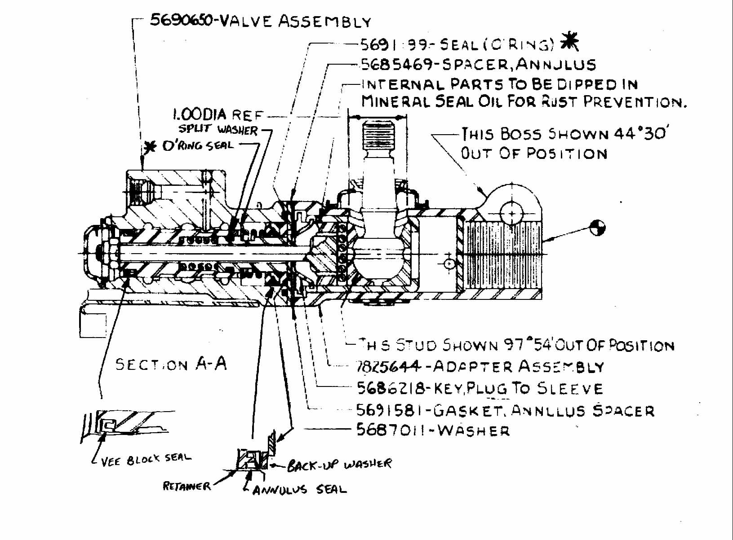
This control valve cutaway drawing can also be found on Terry Rudy's corvettefaq.com websight.
http://www.corvettefaq.com/c3/ControlValveCutaway.doc
You need to remember that the seal lips need to be pointing at the fluid pressure in order to seal correctly < fluid pressure >.

I apologize for the quality of the above drawing.
There has been a recent discovery of some minor discrepancies in the control valve blowup drawing that is shown in most GM or Chevrolet Shop Manuals. You will need to reference the following exploded view drawing or look it up in your own shop manual:
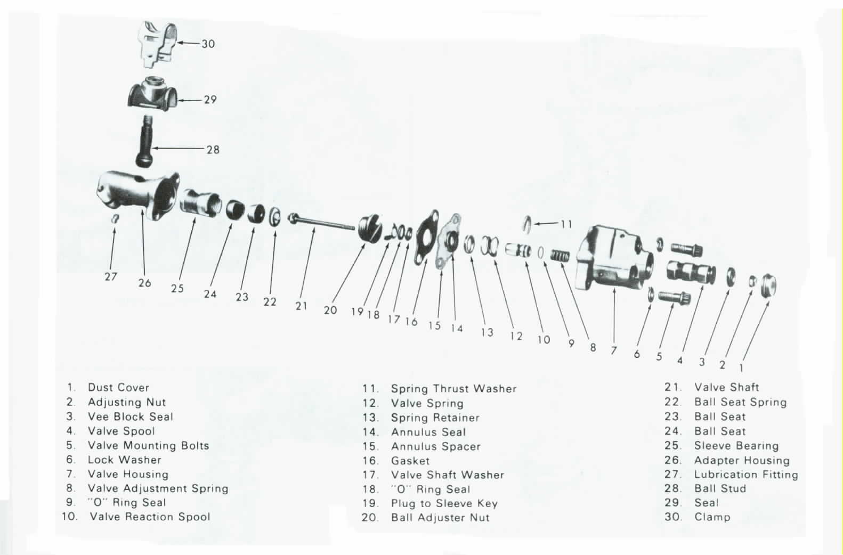
This exploded view drawing can also be found on Terry Rudy's corvettefaq.com websight.
http://www.corvettefaq.com/c3/ControlValveOverhaul4.doc
The #15 Annulus Spacer is a rather thick spacer that sits right up against the face of the Valve Housing #7. Next is Gasket #16. It is thinner and seals against the Adapter Housing #26.
There is a part called an "O"ring Seal #18 on the drawing, that seems to be sandwiched between the Plug to Sleeve Key #19 and the Valve Washer #17. My information does not show any "O"ring in that area.
There should be a 1.3 inch diameter groove machined in the face of the Valve Housing #7. There should be an "O"ring of that same approximate size that fits in that groove. The "O"ring will seal the Housing #7 and the Annulus Spacer #15.
The control valve cutaway assembly drawing shows a back-up washer that should be seated directly against the back of the annulus seal. This washer is not shown on the exploded view drawing. It would be placed between #14 and #15 on that drawing. I show that back-up washer on the control valve cutaway drawing.
Finally, new seals can quickly wear and leak if they have to operate on a scratched or corroded surface. They can also leak if contaminants are allowed to get under the lips of the seal. Obviously, a leak can occur if a seal lip is cut as the valve is being assembled. Before reassembling the control valve, the housing bore should be inspected at both ends to make sure that it is not corroded, gouged, or excessively worn. If it shows any of these types of problems, most likely the housing will need to be discarded and another valve used. Check the entrance of the valve housing bores to make sure that there are no burrs or sharp edges that could cut the seals.
The GM shop manual makes mention that after installing and balancing the control valve on the car, a small amount of grease should be placed in the valve housing bore before installing the dust cap the final time.

JIML82@aol.com
ControlValveRebuildingTips.doc

