Last Revised: 24JN2005

CHEVROLET A & F-CAR STEERING UPGRADE TO A FAST RATIO POWER STEERING GEAR

INTRODUCTION
This paper is written to assist Chevrolet Chevelle, El Camino, Monte Carlo and Camaro owners in locating parts and components that can be used to install a fast ratio or a replacement power steering gear in their vehicles. This information is most likely valid for other GM makes of A, G, and F-cars as well.

Most A-car and F-car vehicles that were built in the 1960s through the 1970s time frame came from the factory with Saginaw Steering Gear Division model 700 power steering gears. Most had gear ratios in the 15:1 range. A listing of 1964 through 1974 Chevelle power steering gears with ratios, efforts, t-bar size, and travel is available from the websight where you obtained this paper. Camaro power steering gear listings from 1967 through 1993 are also available at that same sight.

With modern radial tires and performance suspension enhancements, many enthusiasts would like to improve their steering gear ratio to a rapid 12.7:1. The steering ratio of a steering gear is the number of degrees that you rotate the steering wheel (and therefore the gear input shaft) in order for the output shaft to rotate one degree. The lower the ratio number, the faster the steering. This paper is written to assist owners in swapping their slower ratio power steering gears for a fast ratio 12.7:1 model 700 power steering gear.

Please note, there is a new Saginaw model 600 power steering gear that is also available with a 12.7:1 ratio. However, this gear is not interchangeable with the model 700 gear.

Replacement model 700, 12.7:1 ratio, Saginaw recirculating ball, integral power steering gears are listed on the following Excel spread sheets:
1985 – 1996 Caprice, Monte Carlo, & Buick Fast Ratio Gear Chart
1992-98 Jeep Grand Cherokee Fast Ratio Gear Chart
1982-93 Camaro Fast Ratio Gears are listed on the 1967-93 Camaro Chart

I do not recommend interchanging F-car and A-car steering gears because the F-car gears were designed with less pitman shaft travel and generally have higher steering efforts. This will result in very heavy steering efforts and turning circles like a Greyhound bus if you install a F-car gear into an A-car. The F-car gear can be disassembled and the travel restrictors removed but that is best left to someone very familiar with rebuilding Saginaw power steering gears. Using an A-car gear in a F-car will result in the front tires rubbing against fenders and frame rails when the steering wheel is turned near full lock.

THE SAGINAW RECIRCULATING BALL POWER STEERING GEAR
The Delphi Saginaw Steering (formerly Saginaw Steering Gear Division, GMC) recirculating ball, model 700, integral power steering gear is a marvel of longevity. The basic concept and most major components that make up the gear assembly started production in the early 1960s. They are still being manufactured today and many parts are interchangeable with the original steering gears.

There are a couple of interface areas that have remained the same from 1964 to the present. Let’s look at the two attachment areas that you will not have to worry about if you decide to make a fast ratio gear installation. The first is gear mounting. There are three tapped holes in the gear housing that are used to mount your gear to the frame. They are in the same location and are the same thread (7/16-14 UNC) all the way from the middle 1960’s right through today! The other is the pitman shaft connection. The pitman shaft serrations and the pitman arm lock nut are also still the same. So this gear will bolt up right to your frame and your power steering pitman arm and pitman shaft nut will assemble as well.

Some of the interface changes that did occur are as follows:
1). The input shaft was reduced in diameter from 13/16 inch OD to ¾ inch OD in 1977. 2). Starting with the 1980 model year, the ports on the gear were converted from conventional 45 degree flare fittings with 5/8-18 UNF (return port) and 11/16-18 UNS (pressure port) female threads to o-ring connections with 16x1.5mm (return) and 18x1.5mm (pressure) female threads.

All of the fast ratio steering gears that we are looking to swap into our cars were produced between 1982 and 1998. Therefore, in order to install a fast ratio gear in your pre-1980 cars, you will need to accommodate one or both of the above listed changes.

Let’s review the interface parts one by one:

GEAR INPUT SHAFT TO FLEXIBLE COUPLING
The original steering gear in the 1964-1976 cars had a 13/16 inch OD input shaft with splines and a flat. The new fast ratio gear has a ¾ inch OD input shaft. We will need a new flexible coupling to connect to the smaller shaft on the new gear. The following vehicles (with power steering) were produced with flexible couplings that will attach to the new gear:

1977 thru 1982 Chevrolet and GMC C/K (2 wheel and 4 wheel drive) Pickup Trucks
1977 and 1978 Camaro, Firebird, and Nova
1979 Nova
1983 thru 1986 Chevrolet and GMC C (2 wheel drive only) Pickup Trucks

I have found a flexible coupling in the GM parts system that will connect to a ¾ input shaft. It is available through GM dealers. It is part number 7826542. It is fairly expensive (around $80 list) but it is brand new. There are probably other A and F-car suppliers that have this flexible coupling available as well.
GEAR INPUT SHAFT TO FLEXIBLE COUPLING (Continued)
You will most likely require the attaching pinch bolt, nuts, and lock washers in order to attach your new flexible coupling. The correct special pinch bolt is GM #7807271. This bolt can be purchased from any GM dealer. Please note, if the flange on the steering column or the flange on the separate intermediate steering shaft (I-shaft) is also detachable, this same special pinch bolt is used to attach that flange as well.

STEERING COLUMN TO FLEXIBLE COUPLING
Another thing that we have to take into account is that the steering column and the connection to the flexible coupling went through a couple of design changes between 1964 and the 1970s. These differences will also need to be addressed.

EARLY STEERING COLUMNS
The 1964 - 66 Chevelle steering columns had a long steering shaft that extended from the end of the steering column down toward the steering gear. Some of them had a detachable column flange, others had a stamped flange that was permanently staked in place. The column flange attached to the flexible coupling with nuts and lockwashers.

The 1967, 68, & 69 F-car steering columns bolted directly to the flexible coupling. Tilt columns had a detachable flange, standard (non-adjustable) columns had a stamped flange that was permanently staked in place.

The early flexible coupling was somewhat different from the new flexible coupling. The old design coupling had two different diameter stop pins and two same sized special 5/16-24 UNF attaching bolts. The newer flexible coupling has different sized attaching bolts (one 5/16-24 UNF and the other a 3/8-24 UNF) along with equal sized stop pins. In order to attach the new flexible coupling to the old design column flange you have two areas that require modifications. One involves the mounting bolts; the other requires additional clearance to one of the stop pins.

IF YOUR DETACHABLE FLANGE HAS SAME SIZE BOLT HOLES
MAKE THE FOLLOWING MODIFICATIONS

BOLTED CONNECTION - BOLT HOLE MODIFICATION
Remove the flange from the steering column or I-shaft. Place the flange on a table so that the face that mounts to the flexible coupling is down. Place the pinch bolt slot at the 12 o’clock position. You want to drill out the hole that is at the 9 o’clock position to 0.381 inch diameter (See Figure #1). Do not enlarge the hole too much. The 3/8-24 bolt on the new flexible coupling has a fairly narrow shoulder that must seat against the face of the column flange. Just enlarge the hole until the threads on the 3/8-24 bolt just pass through. I don’t even recommend chamfering the flex coupling side of the new enlarged bolt hole, just remove any burrs. Now the column flange will only assemble to the flexible coupling one way and you don’t run the risk of having your steering column attached so that your steering wheel is upside down.

DETACHABLE COLUMN FLANGE - STOP PIN SLOT MODIFICATION
The last modification that you will have to make is to open up the smaller stop pin clearance notch on the column flange. With the column flange place on a table (in the same position describe above) take a look at the smaller stop pin clearance notch located at the 6 o’clock position. You will need to take a file or a high speed grinding tool and increase the size of the notch by 0.070 inch around its entire shape (See Figure #1). This will gain you clearance around the stop pin on the new coupling and both clearance notches should now be about the same size.

IF YOUR STAKED, PERMANENTLY ATTACHED STAMPED FLANGE HAS SAME SIZE BOLT HOLES – MAKE THE FOLLOWING MODIFICATIONS
You basically are going to modify this stamped flange similar to the instructions above for the detachable flange. You will have to remove the column (or I-shaft) from your car in order to gain access to the flange. You will be working from the flexible coupling side of the flange (opposite from the detachable instructions).

STAKED COLUMN FLANGE - BOLT HOLE MODIFICATION
Looking at the flange from the flex coupling side, locate the bolt hole that is counterclockwise from the smaller stop pin notch and drill it out to 0.381 inch diameter. Do not enlarge the hole too much. The 3/8-24 bolt on the new flexible coupling has a fairly narrow shoulder that must seat against the face of the column flange. Just enlarge the hole until the threads on the 3/8-24 bolt just pass through. I don’t even recommend chamfering the flex coupling side of the new enlarged bolt hole, just remove any burrs.

STAKED COLUMN FLANGE – STOP PIN SLOT MODIFICATION
You will have to open up the smaller of the two stop pin notches by the same 0.070 inch (same as above).

1967 THROUGH 1974 STEERING COLUMNS
These steering columns either had collapsible steering shafts that connected directly to the steering gear or they had separate I-shafts that bolted to the column up by the dash. In either case, both type steering shafts have column flanges that attach to the flexible coupling. These column flanges should have two different sized bolt holes and clearance notches for two large rivets. (If they don’t modify the flanges as described above.) Otherwise, they should be compatible with your new flexible coupling without any modifications. (See Figure #2)

POWER STEERING PUMP – PRESSURES AND FLOWS
Where the Saginaw model 700 gear is known for its longevity, the Saginaw power steering P-pump has been around an equally long time. You most likely want to use your original pump with its reservoir and pulley. The good news is that your power steering pump can be quite easily upgraded for pressure and flow to work with your new fast ratio gear. The fitting on the back of the pump regulates the amount of oil flow from the pump. The flow control plunger, (located inside the pump directly behind the fitting) controls the pressure relief. These parts are very interchangeable between various Saginaw P-pumps.

POWER STEERING PUMP – PRESSURES AND FLOWS (Continued)
Most GM power steering pumps before 1970 had relatively low pressure relief settings (950 psi). With modern wide footprint tires, you will probably require more system pressure to have full power assist when parking. If you have one of those early vehicles, you will probably want to increase the pressure relief setting of your pump. 1970 and later pumps had pressure relief settings of 1400 psi, so they should be very adequate.

Also, from 1964 through 1969 most Chevrolet power steering pump outlets incorporated a male fitting and therefore required a pressure hose with a female nut to connect to it. Starting in 1970 the fitting was converted to a 5/8-18 UNF female port with a 45 degree flare seat (the same as the rest of GM). Since your new fast ratio gear has metric ports you might even consider getting rid of either of the previous fittings that you have in your original pump and converting to a 16x1.5mm metric discharge fitting as well.

If you can obtain the pump that originally came with your fast ratio steering gear, this is the safest and best approach toward obtaining the discharge fitting and the flow control plunger that will give adequate flows and pressures for your steering system.

Another approach is find a P-pump used in Chevrolet and GMC C/K trucks that were built after 1979. Also the new lines of GM light duty pickups and SUV vehicles have P-pump fittings that can be used. These are the trucks with Chevrolet 4.3L V6, small block, or big block V8s. These pumps will all have 16x1.5mm metric discharge fittings.

However, if you have an early P-pump (1964 through 1969) and still want a 5/8-18 UNF female fitting with a 1400 psi pressure relief , you will need to find a P-pump from a 1976 through 1979 four wheel drive K-truck (not the two wheel drive C-truck).

Once you have the pump that you want, you will need to remove the discharge fitting that screws into the back of the pump. Then, you need to probe inside the discharge cavity and using a magnet or by just tipping the pump you should be able to remove the flow control plunger (See Figure #3). This is the device that sets the pressure relief and it will interchange right into your original pump. First assemble the spring then the flow control plunger. Note, make sure that you orient the plunger so that the screen side of the plunger goes into the pump first (next to the spring).

POWER STEERING HOSES
I don’t have any expertise with aftermarket power steering hoses. So I am not familiar with what types of end configurations, bends, etc that might be available. If you are able to get the set of hoses from the vehicle that supplied your fast ratio gear, you might get lucky. They just might fit your car!!! One word of caution, after attaching your new hoses, always have someone turn your steering wheel from full lock to full lock while your observe any motion of the hoses and particularly the motion of the steering linkage. You do not want your hoses resting or rubbing against any stationary or moving parts underhood.

POWER STEERING HOSES (Continued)
Here is another possibility. Lee Manufacturing sells small aluminum inserts that can be press fitted into steering gears with metric pressure and return ports. You then can use the original hoses with the 11/16-18 UNS and 5/8-18 UNF nuts and 45 degree flared ends. Since the metric and conventional threads are very close to each other you will find that the 5/8 nut screws very easily into the 16mm port, the 11/16 nut may need a little persuasion but it also will screw into the 18mm port. The face of the Lee insert is cut at a 45 degree angle, so the old hoses will seal against it. There are two different inserts (#40620 – pressure) and (#40630 – return) and he sells them at a reasonable price.

Lee Manufacturing
11661 Pendelton St.
Sun Valley, CA 91352
818-768-0371 (talk to Tom Lee or his wife)

As described in the pump section, you can also quite easily modify your pump for either a female 16x1.5mm o-ring port or to a female 5/8-18 UNF 45 degree flare port by finding the appropriate pickup truck P-pump.

SOME WORDS CONCERNING POWER STEERING FLUID
I strongly recommend refilling your power steering system with genuine GM power steering fluid. There are fluids that are labeled power steering fluid, but there is only one used by General Motors as original factory fill. The amber colored fluid, available from any GM dealer was specifically formulated to work in the Saginaw power steering pump. For maximum durability use GM steering fluid GM #89020661 for a 32oz container. The previous GM part number for power steering fluid was #1050017. (Either one is acceptable.)

SOME PARTING THOUGHTS
I have (to the best of my ability) gathered the this information from engineering drawings and by speaking to people that worked on the power steering systems used in your car. If you have a problem with any information in this paper, do other owners a favor and get back with me so I can update this paper and make it as accurate as possible.
Also, you should always follow procedures, instructions, and torque recommendations provided in shop manuals and other reliable sources when assembling and disassembling the components in your power steering system.

A WORD ABOUT SAGINAW POWER STEERING GEAR NOMENCLATURE
Back in the days when passenger cars and trucks all had recirculating ball power steering gears, Saginaw Division devised a numbering system to identify the different models.

Model 700 was the base power gear for passenger cars. It had a 70mm diameter bore.
Model 708 was the higher capacity pass car power gear with a 80mm diameter bore.
Model 800 was the base gear for light duty pickup trucks. It had a 70mm diameter bore.
Model 808 was the higher capacity power truck gear for heavy duty pickups. It had a 80mm diameter bore.
SAGINAW NOMENCLATURE (Continued)
Today, there are no longer passenger cars with recirculating ball power gears (they are all rack & pinion.) So Saginaw renamed their power gear lineup.
The power gear for light duty pickups, SUVS, etc is now called the model 700 gear with the 70mm diameter bore.
Heavy duty pickups, SUVS, etc use the model 708 power gear with the 80mm diameter bore.

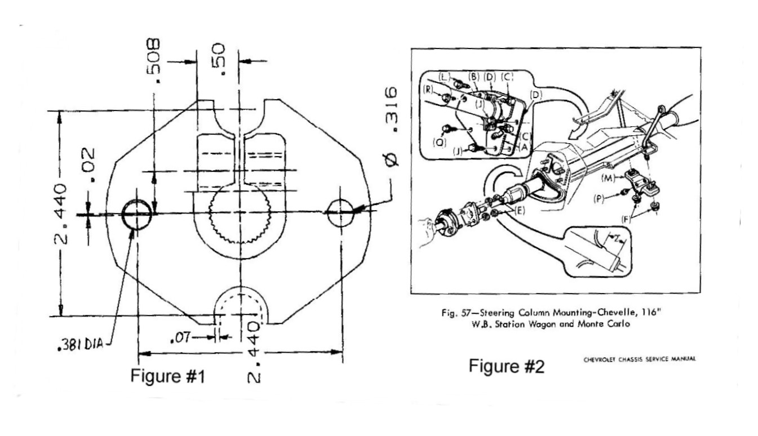
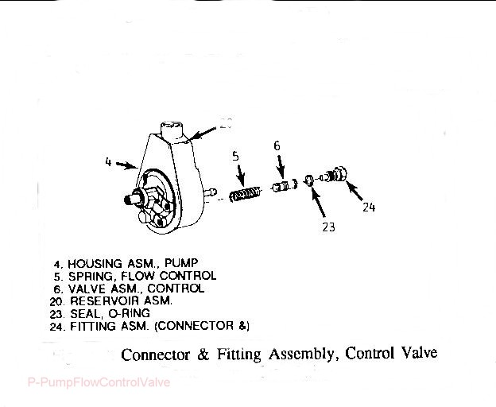
Figure #3

A&F-CarFastRatioGearRev24JN05.doc
JIML82@aol.com

