Last Revised: 01FE2005

INSTALLING A 1977 THRU 1982 C3 STEERING COLUMN INTO A EARLIER 1969 THRU 1976 MODEL CORVETTE

Why Even Try To Make This Installation
Starting in 1977 and carrying thru 1982 the Corvette steering column was shortened so that the steering wheel was about two inches further away from the driver as compared to the 1969 thru 1976 steering columns. A shortened column allows easier entrance and egress from your Corvette and most drivers find the added reach to the steering wheel to be more comfortable. These columns also had a headlamp dimmer switch that was actuated by the turn signal lever. The trouble prone transmission shift interlock system was eliminated and replaced by a key release lever next to the ignition key on the column. The 1977 column is unique for that one year in that it has a windshield wash/wipe switch as part of the steering column. It is integral with the headlamp dimmer and turn signal lever.

General Information About The Installation
Based upon my analysis, the 1977 Corvette steering column (both the standard non-adjustable and the T&T) will fit directly in the older (1969 thru 1976) C3 models. The 1978 through 1982 columns must have a minor modification of the column shroud in order to fit the older vehicles.

Starting at the breakaway capsule mounts (where the two vertical bolts attach the column to the dash), the 77-82 steering columns from that point forward (toward the engine) are dimensionally the same as the older columns. From the capsules rearward (toward the driver), the 77-82 column is about 2 inches shorter. Most drivers appreciate the added reach to the steering wheel. Also, entering and exiting your C3 should be easier.

The first Corvette steering column with a dimmer switch was the 1977 model. The 1977 Corvette instrument cluster was the same as earlier models. The 1977 steering column will bolt right into the early C3s with no modifications.

The 1978 thru 1982 steering columns were designed to fit into a redesigned instrument cluster. In order to fit these columns into early C3s the plastic shroud right behind the tilt head must be modified to resemble the 1977 steering column. The shroud needs to be cut off to a 2.20 inch dimension. Please refer to the drawing at the end of this paper.

The Following Are Comparisons of the Various Functions and Interfaces, Old Versus New Steering Columns.

Ignition Switches
All standard column ignition switches and all T&T column ignition switches are the same for all model years 1969 to 1982. However, the standard column and the T&T column ignition switches are not interchangeable. The wiring harness in the car fits either one. You merely have to twist the wiring harness connector so that it rotates 180 degrees to go from one to the other.

Comparisons of the Various Functions (Continued)

Key Inhibitor Lever
With the introduction of the function locking steering column in 1969, General Motors decided that from a safety standpoint, it should be difficult for anyone to turn off the ignition and inadvertently lock the steering wheel. So a system was devised whereby the ignition can be turned off, but the key cannot be rotated to the off-lock position unless the shifter was in Park (automatic transmissions) or in Reverse (manual transmissions.) This was accomplished by a back drive system where a cable from the transmission pushed up on a lever on the lower end of the steering column when the manual transmission was shifted into reverse or when the automatic transmission was placed in the park position. The steering column lever was attached to a tube inside the steering column that rotated. With the lever all the way up, this opened a gate inside the steering column and allowed the lock cylinder and key to rotate all the way to the off-lock position. All 1969 through 1976 Corvettes had this system.

The 1977 thru 82 Corvette columns have what is called a key inhibitor lever next to the ignition key that replaces the trouble prone back drive system. A driver can turn the ignition off but cannot continue to the off-lock ignition position until he/she trips the inhibitor lever with their finger. There is no lever on the lower end of the column and the back drive cable from the transmission is not necessary.

Windshield Wash/Wipe Switch
The 1977 model year C3 is the only one where a wash/wipe switch was built into the column. The switch is actuated by a twisting motion of the turn signal lever. This same wash/wipe switch was also used on Chevette steering columns. Since this was a “one year only” design for the Corvette, if you obtain a 1977 column be sure to get the turn signal lever as well. Even if you don’t want to use the wash/wipe feature, the lever is unique to that one year.

The wash wipe/switch in the 1977 column is called a three wire switch. The switch on the Corvette dash is also a three wire switch so they are compatible. Wiring: Dark Blue 18 gage to washer pump; Light Blue 18 gage to wiper motor – low speed; Black/White 18 gage to wiper motor – high speed.

Early C3s (1969 thru 1972) with Hidden Wipers
I reviewed the electrical circuit diagrams on the early C3 wiper systems with the vacuum operated wiper doors. The windshield wiper/washer switch has three wires and the wiper door operation is not connected to the switch at all. The wire colors to the switch are very close to the later year wire colors: Dark Blue 18 gage terminates at an unnamed device which I am quite sure is a washer pump; Light Blue 18 gage to a windshield wiper solenoid and then to the wiper motor; Black 18 gage to the windshield washer door relay and then Light Green 18 gage to the wiper motor. Therefore, I conclude that the 1977 column with the wash/wipe switch should work in these applications.

Since the basic steering column housing is the same from 1977 to 1982, the 1977 wash wipe switch along with its integral pivot can be installed in any of them.

Cruise Control Switch Location
Cruise control became available as an option on the 1977 Corvette. For that first year only, the cruise control was actuated by a button on the end of the tilt lever. This special tilt lever screws into the column and is very rare.

1978 thru 1982 Corvettes had the cruise control switch button on the end of the turn signal lever. This lever “plugs-in” to the steering column. It will not fit the 1977 or any of the older C3 columns.

Headlamp Dimmer Switch
You can continue to use the dimmer switch on the floor or you can convert your car to use the column mounted dimmer. I think the electrical connector to the floor mounted dimmer switch will also plug into the column mounted dimmer switches from 1977 to 1982. Just in case it doesn’t, the Packard part number for the connector is 8917693. You will most likely have to add extra wiring to reach the steering column.

Looking at the switch as it is installed on the side of the steering column you will see three blades clustered in a triangle. If the dimmer switch has a fourth blade neglect it. It is for a “flash to pass” feature (with hidden headlights, you don’t need it). The blade at the 3 o’clock position (nearest the driver) is the feed from the light switch (Light Blue 14 gage wire). The blade at the 7 o’clock position is the low beam (Tan 18 gage wire). The blade at the 10 o’clock position is for high beams (Light Green 16 gage wire).

Ignition Lock Cylinders
Steering column lock cylinders can be interchanged between all steering columns from 1969 thru early 1979 production. The lock cylinder has a spring loaded, hardened wedge that engages a rectangular slot in the column housing. Introduced during the 1979 model year and included in all later steering columns, security was improved by retaining the lock cylinder with a cross bolt. So if you are going to install a 1979 or later column in an older C3, be sure that the lock cylinder and the keys are included with the column.

Turn Signal Switch Connector
The turn signal switch connector on the later steering columns may not snap into the body wiring harness connector in the older C3s. If this is the case with your steering column, swap the connector from the old column to the new one. Use a thin bladed screwdriver to reach in from the contact side to depress the metal tangs (one on each side) and release each wire with its contact. Be sure to insert the switch wires into the old connector in the same order as the original. One other hint, when you are done, the turn signal switch wire colors should match the wire colors of the body wiring harness.

A final note, 1980 through 1982 Corvettes had front end cornering lights. The turn signal switch wiring for those year Corvettes will have three extra wires in the A, B, and C connector positions. Just neglect them.

Column Removal Procedure
Disconnect the battery ground cable. Remove the steering wheel.

Remove the 7/16 - 12 point pinch bolt from the steering column side of the flexible coupling. Use a screwdriver to pry open the flange at the split where the pinch bolt went through. The coupling should now be loose at the column but don’t try to remove it yet. .

Disconnect the back drive linkage from the steering column lever. Place the lever in the full up position. Disconnect the steering column turn signal wiring connector from the body wiring harness.

Remove the floor pan trim cover. Remove the two nuts securing the steering column lower bracket to the floor pan. Remove the instrument panel trim cover screws and remove the cover.

Remove the two vertical steering column capsule bracket screws and carefully rotate and lower the steering column. Disconnect the wiring harness from the ignition switch. Pull the column rearward in the car, being careful to guide the lower steering column lever as it passes through the slot in the floor pan opening.

Remove the 7/16 – 12 point pinch bolt from the steering gear side of the flexible coupling. Again, use a screwdriver to pry it open at the split in the flange. You can now remove the coupling.

MANDATORY STEERING COLUMN INSTALLATION SEQUENCE
The following is paraphrased from the Chevrolet Corvette shop and AIM manuals.

To install a new steering column or to reinstall an original column into your Corvette it is necessary to make sure that the column is aligned to the steering gear. The flexible coupling connection between the steering column and the steering gear can wear out very quickly if the column is improperly installed. That is why Chevrolet engineering specified a mandatory steering column installation sequence in the assembly plant when your Corvette was originally assembled and this is why they continue to specify a very similar sequence for service in the field.

Some Flexible Coupling Background
The flexible coupling consists of a steering gear flange with hot riveted stop pins that hold a laminated rubber coupling disc to it. The pins run through the disc and extend rearward in the car. There are also two bolts extending through the coupling disc with their threaded ends facing rearward. There is a mating steering column flange that is attached to the rest of the flexible coupling by means of those two bolts along with appropriate nuts, and lock washers. The column flange also has window openings through which the pins extend. The pins must be central in the window openings with about 1/8 inch clearance on all sides.

Some Flexible Coupling Background (Continued)
When your Corvette was originally assembled in St. Louis (or Bowling Green) there was an assembly aid that was incorporated in the flexible coupling to help align the steering column to the steering gear. The stop pins had plastic spacers on them. These spacers forced the stop pins to be central in the steering column flange openings. Thus insuring that the steering column was aligned to the steering gear when the column was assembled to the Corvette body. The plastic spacers were molded with a split in them so that they could be hooked with a tool, pulled off, and thrown away after the column assembly sequence was complete.

If you have purchased a new flexible coupling it usually comes with the orange plastic spacers installed on the stop pins. However, if you are using a flexible coupling that does not have spacers you can use the following directions to align your column to the gear.

Preparing the Flexible Coupling for Installation
If the assembly plant needed the spacers to insure a good assembly, it follows that it might be helpful for you to create your own spacers if needed to help in the alignment process. Disassemble the flexible coupling assembly by removing the two nuts and lock washers. You now have access to the stop pins.

I suggest that you use a roll of ½ inch wide masking tape and wrap each of the pins until you have about a 9/16 inch diameter roll of tape (about 1/8 inch thick on a side). Now as you bolt the column flange to the rest of the coupling, the pins are held rigidly central in the window slots in the column flange. You can dig the masking tape off the pins when your installation is complete. Reassemble the column flange to the coupling and tighten the two nuts with their lock washers to 20 ft lbs.

Flexible Coupling Installation
If you are working on an early 1969 C3 it is probable that you have a steering gear with 30 serrations all the way around the input shaft. The mating flexible coupling will have full serrations as well. Since there are 30 serrations on the input shaft, there will be 30 possible locations for the flex coupling to be assembled. However, there is only one location for the flex coupling to be assembled correctly.

Here is how to do it: You will need to place the steering gear right on center. You do this by counting the exact number of rotations of the steering gear input shaft when turning from full lock to full lock. The exact number of revolutions is (X). Now with the gear at full lock, rotate back exactly X/2 revolutions. This will place your steering gear exactly on center. Now, orient the flexible coupling so that the stop pins are aligned vertically (at the 6 and 12 o’clock positions) and the pinch bolt is passing through the 9 o’clock position. The head of the bolt will be pointing straight up when you are bending over your fender and looking down at the steering gear. Now slide the flexible coupling onto the gear until it bottoms out. Tighten the pinch bolt to 25-30 ft lbs.

Flexible Coupling Installation (Continued)
On all other C3 Vettes the assembly of the flex coupling is much easier. There are serrations and a section that is milled flat on the steering gear input shaft. The flexible coupling has matching serrations and a flat section. It will only go on the gear, one way. Align the coupling and slide it on the gear shaft until it bottoms out. Tighten the pinch bolt to 25–30 ft lbs.

Position the steering column in the vehicle and slide the column shaft into the flexible coupling. There are mating splines and a flat on this attachment as well, so it will only assemble one way. Do not tighten this pinch bolt at this time. Have someone inside the car to hold the column in roughly the installed position. Make all the electrical connections to the column.

Aligning the Steering Column To The Instrument Panel
The vehicle should be on its wheels for the following steps.

There is a large intermediate bracket up under the dash that is held in place by four nuts. Its purpose is to allow side to side adjustment of the steering column as it passes through the instrument panel and some fore and aft adjustment as well. It can be loosened and shifted around to adjust the position of the steering column. Assuming that the original column was aligned correctly this bracket should not need to be loosened as part of installing the steering column.

Slide the lower end of the column onto the two bolts that are sticking through the floor pan. Tighten the two nuts to hold the lower end of the column in place. Start the two vertical steering column support bolts into the intermediate bracket and tighten them to 15 ft lbs.

Aligning the Steering Column to the Flexible Coupling
Now go back and loosen the two nuts holding the lower end of the column. You can now move the lower end of the column around to align the flexible coupling. Look at the coupling disc, it should remain relatively flat. Look at the stop pins in the flange windows, they should be central. Tighten the column flange pinch bolt to 25-30 ft lbs. Tighten the two floor pan nuts to 10 ft lbs.

Remove the masking tape from the stop pins. Inspect both stop pins again and insure that they are central in the flange slots. Turn the steering wheel 90 degrees. Inspect both pins again, insuring that they are central. If they are not central, you will need to go back and readjust the lower end of the steering column to align it properly.

Install the steering wheel. Reattach panels under the steering column. Reattach battery cable. You should be ready to go!
A DISCLAIMER
I have (to the best of my ability) gathered this information from engineering drawings, Chevrolet shop manuals, AIM books, and by speaking to people that worked on the various steering components used in the C3 Corvette. Please be aware, a lot of this information is 25 to 30 years old. Also, you should always supplement these instructions with additional information from certified shop manuals.

General Motors probably had more than 40 different styles and types of steering columns in the mid-seventies. Memories can fade, even the best engineering information could have small errors that have crept in over the years. If you have a problem, do other owners a favor and be sure to get back with me so I can update the information and keep this paper as current and as accurate as possible.

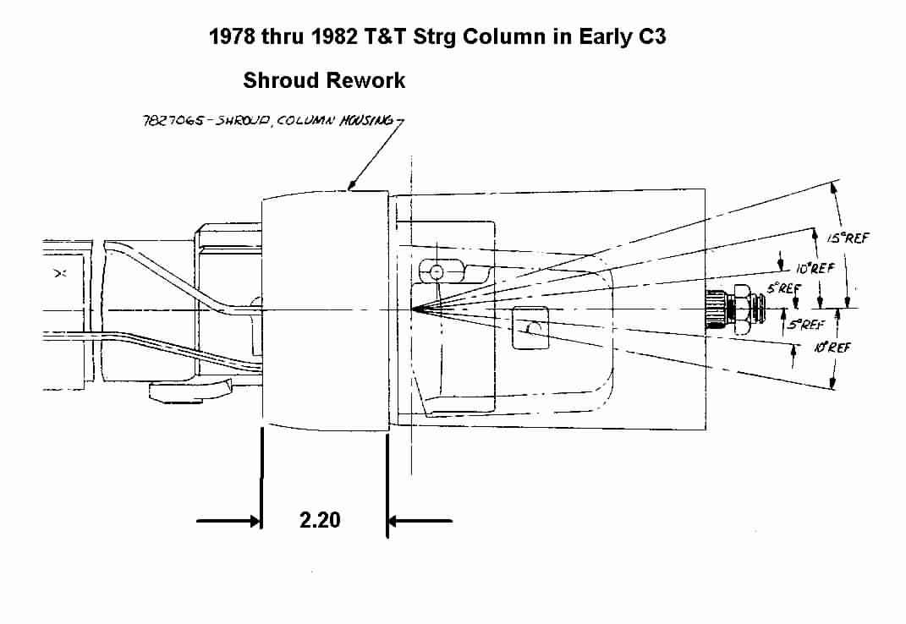
Jim Shea
77+ColumnIntoEarlyC3Rev01FE2005
JIML82@aol.com

